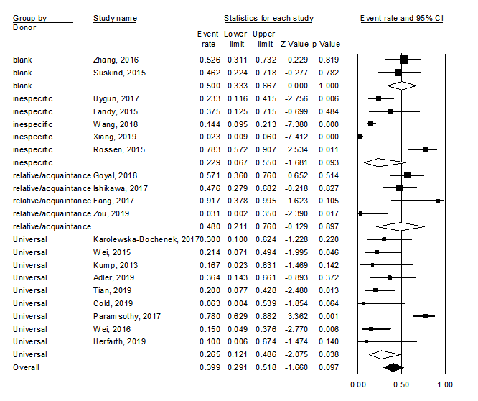
Figure S13. Any adverse event - subgroup analysis by donor type.

