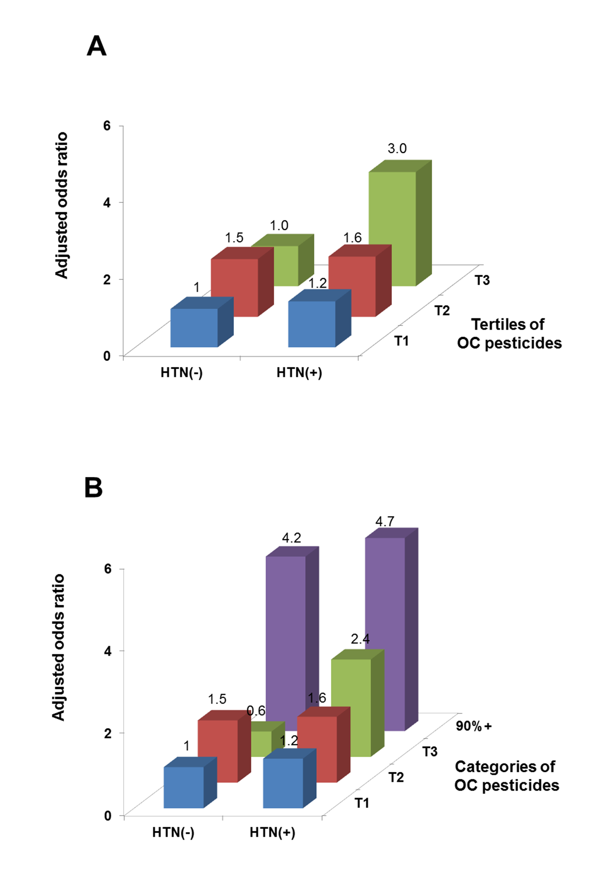
Supplementary figure 1. Associations of hypertension (HTN) and summary measure of organochlorine (OC) pesticides with the risk of low cognitive score. Different from Figure 1, adjusted odds ratios were estimated after considering the design variables and sample weight of National Health and Nutrition Examination Survey (NHANES)

