ABO polymorphism and SARS-CoV-2 infection - a meta-analysis

1.Eligibility Criteria

The inclusion criteria were as follows:
Population: The unit of analysis of this review is studies published in health-related journals with original data or results.
Interventions/exposures: We included studies that describe the distribution of AB0 blood groups in SARS-CoV-2 positive.
Comparator: ABO blood group distribution among either the general healthy or COVID-19 negative population of the related geographic area.
Outcome measures: To be included, studies had to report or allow to calculate Odds Ratios (ORs) for the association of testing positive for SARS-CoV-2 and having a specific blood group (A, B, AB, or O).
Study design: Experimental studies (e.g. nonrandomized studies or cohort studies), observational studies, case series, and case studies.
Publication type: We included original research papers, including scientific meeting abstracts or research letters, if they contained sufficient information to fill the extraction forms.

2.Search strategy

(search date: July 16, 2020)

Search strategy | Output
(COVID-19 OR SARS-CoV-2) AND (“blood group” OR “ABO”) | MEDLINE (n= 42)
”COVID-19” OR “SARS-CoV-2” AND “blood group” OR “ABO” | LITCOVID (n=13)
TOTAL | n=55

3.Content

Table S1. Quality of studies assessment: Newcastle Ottawa Scale

 | Li  1 | Zietz  2 | Göker  3 | Wu  4 | Ellinghaus  5a,5b | Leaf  6a,6b,6c,6d | Dzik  7
Selection
1) Is the case definition adequate?  a) yes, with independent validation *  b) yes, eg record linkage or based on self reports  c) no description | b | b | b | b | b | b | b
2) Representativeness of the cases  a) consecutive or obviously representative series of cases *  b) potential for selection biases or not stated | b | b | b | b | b | b | b
3) Selection of Controls  a) community controls *  b) hospital controls  c) no description | a | a | a | b | a | a | b
4) Definition of Controls  a) no history of disease (endpoint) *  b) no description of source | a | a | a | a | a | a | a
Comparability
1) Comparability of cases and controls on the basis of the design or analysis  a) study controls for_______ (Select the most important factor.) *  b) study controls for any additional factor * (This criteria could be modified to indicate specific control for a second important factor.) | a | a | a | a | a | a | a
Exposure
1) Ascertainment of exposure  a) secure record (eg surgical records) *  b) structured interview where blind to case/control status *  c) interview not blinded to case/control status  d) written self report or medical record only  e) no description | a | a | a | a | a | a | a
2) Same method of ascertainment for cases and controls  a) yes *  b) no | a | a | a | a | a | a | a
3) Non-Response rate  a) same rate for both groups *  b) non respondents described  c) rate different and no designation | N/A | N/A | N/A | N/A | N/A | N/A | N/A
TOTAL (OUT OF 8) | 5 | 5 | 5 | 4 | 5 | 5 | 4
SCORE % | 62.5 | 62.5 | 62.5 | 50.0 | 62.5 | 62.5 | 50.0

4.Sensitivity analysis (leave-one-out approach)

Table S2. Results from sensitivity analysis leave-one-out method: pooled OR and 95% confidence interval calculated omitting each study in turn

 | A vs AB·B·0 |  | B vs A·AB·0 |  | AB vs A·B·0 |  | 0 vs A·B·AB
Study omitted | pooled OR | 95%CI | pooled OR | 95%CI | pooled OR | 95%CI | pooled OR | 95%CI
1a (Li) | 1·232 | 1·067 - 1·423 | 1·042 | 0·935 - 1·161 | 1·079 | 0·904 - 1·287 | 0·779 | 0·676 - 0·897
1b (Li) | 1·226 | 1·074 - 1·398 | 1·060 | 0·965 - 1·164 | 1·065 | 0·915 - 1·239 | 0·776 | 0·677 - 0·890
1c (Li) | 1·225 | 1·071 - 1·400 | 1·052 | 0·953 - 1·162 | 1·085 | 0·923 - 1·275 | 0·777 | 0·676 - 0·893
2 (Zietz) | 1·253 | 1·091 - 1·439 | 1·037 | 0·938 - 1·146 | 1·124 | 0·975 - 1·296 | 0·755 | 0·653 - 0·874
3 (Göker) | 1·185 | 1·054 - 1·332 | 1·068 | 0·979 - 1·166 | 1·110 | 0·956 - 1·288 | 0·786 | 0·687 - 0·900
4 (Wu) | 1·215 | 1·066 - 1·385 | 1·049 | 0·951 - 1·158 | 1·110 | 0·957 - 1·288 | 0·777 | 0·677 - 0·892
5a (Ellinghaus) | 1·207 | 1·061 - 1·372 | 1·078 | 0·987 - 1·176 | 1·067 | 0·911 - 1·250 | 0·779 | 0·676 - 0·897
5b (Ellinghaus) | 1·228 | 1·071 - 1·408 | 1·038 | 0·947 - 1·138 | 1·055 | 0·917 - 1·214 | 0·783 | 0·682 - 0·899
6a (Leaf) | 1·234 | 1·073 - 1·419 | 1·049 | 0·949 - 1·160 | 1·055 | 0·904 - 1·230 | 0·771 | 0·667 - 0·891
6b (Leaf) | 1·252 | 1·091 - 1·437 | 1·039 | 0·938 - 1·152 | 1·121 | 0·968 - 1·297 | 0·755 | 0·653 - 0·873
6c (Leaf) | 1·247 | 1·093 - 1·422 | 1·039 | 0·949 - 1·139 | 1·072 | 0·919 - 1·251 | 0·777 | 0·677 - 0·891
6d (Leaf) | 1·265 | 1·110 - 1·441 | 1·080 | 0·999 - 1·168 | 1·090 | 0·932 - 1·275 | 0·741 | 0·654 - 0·840
7 (Dzik) | 1·277 | 1·143 - 1·426 | 1·039 | 0·938 - 1·150 | 1·084 | 0·919 - 1·279 | 0·746 | 0·658 - 0·846
None | 1·234 | 1·087 - 1·400 | 1·052 | 0·960 - 1·153 | 1·086 | 0·936 - 1·259 | 0·769 | 0·674 - 0·879

5.Subgroup analysis

Figure S1. Forest plot from random effects analysis: OR of being blood group A in SARS-CoV-2+ group versus control group, by type of Control population.

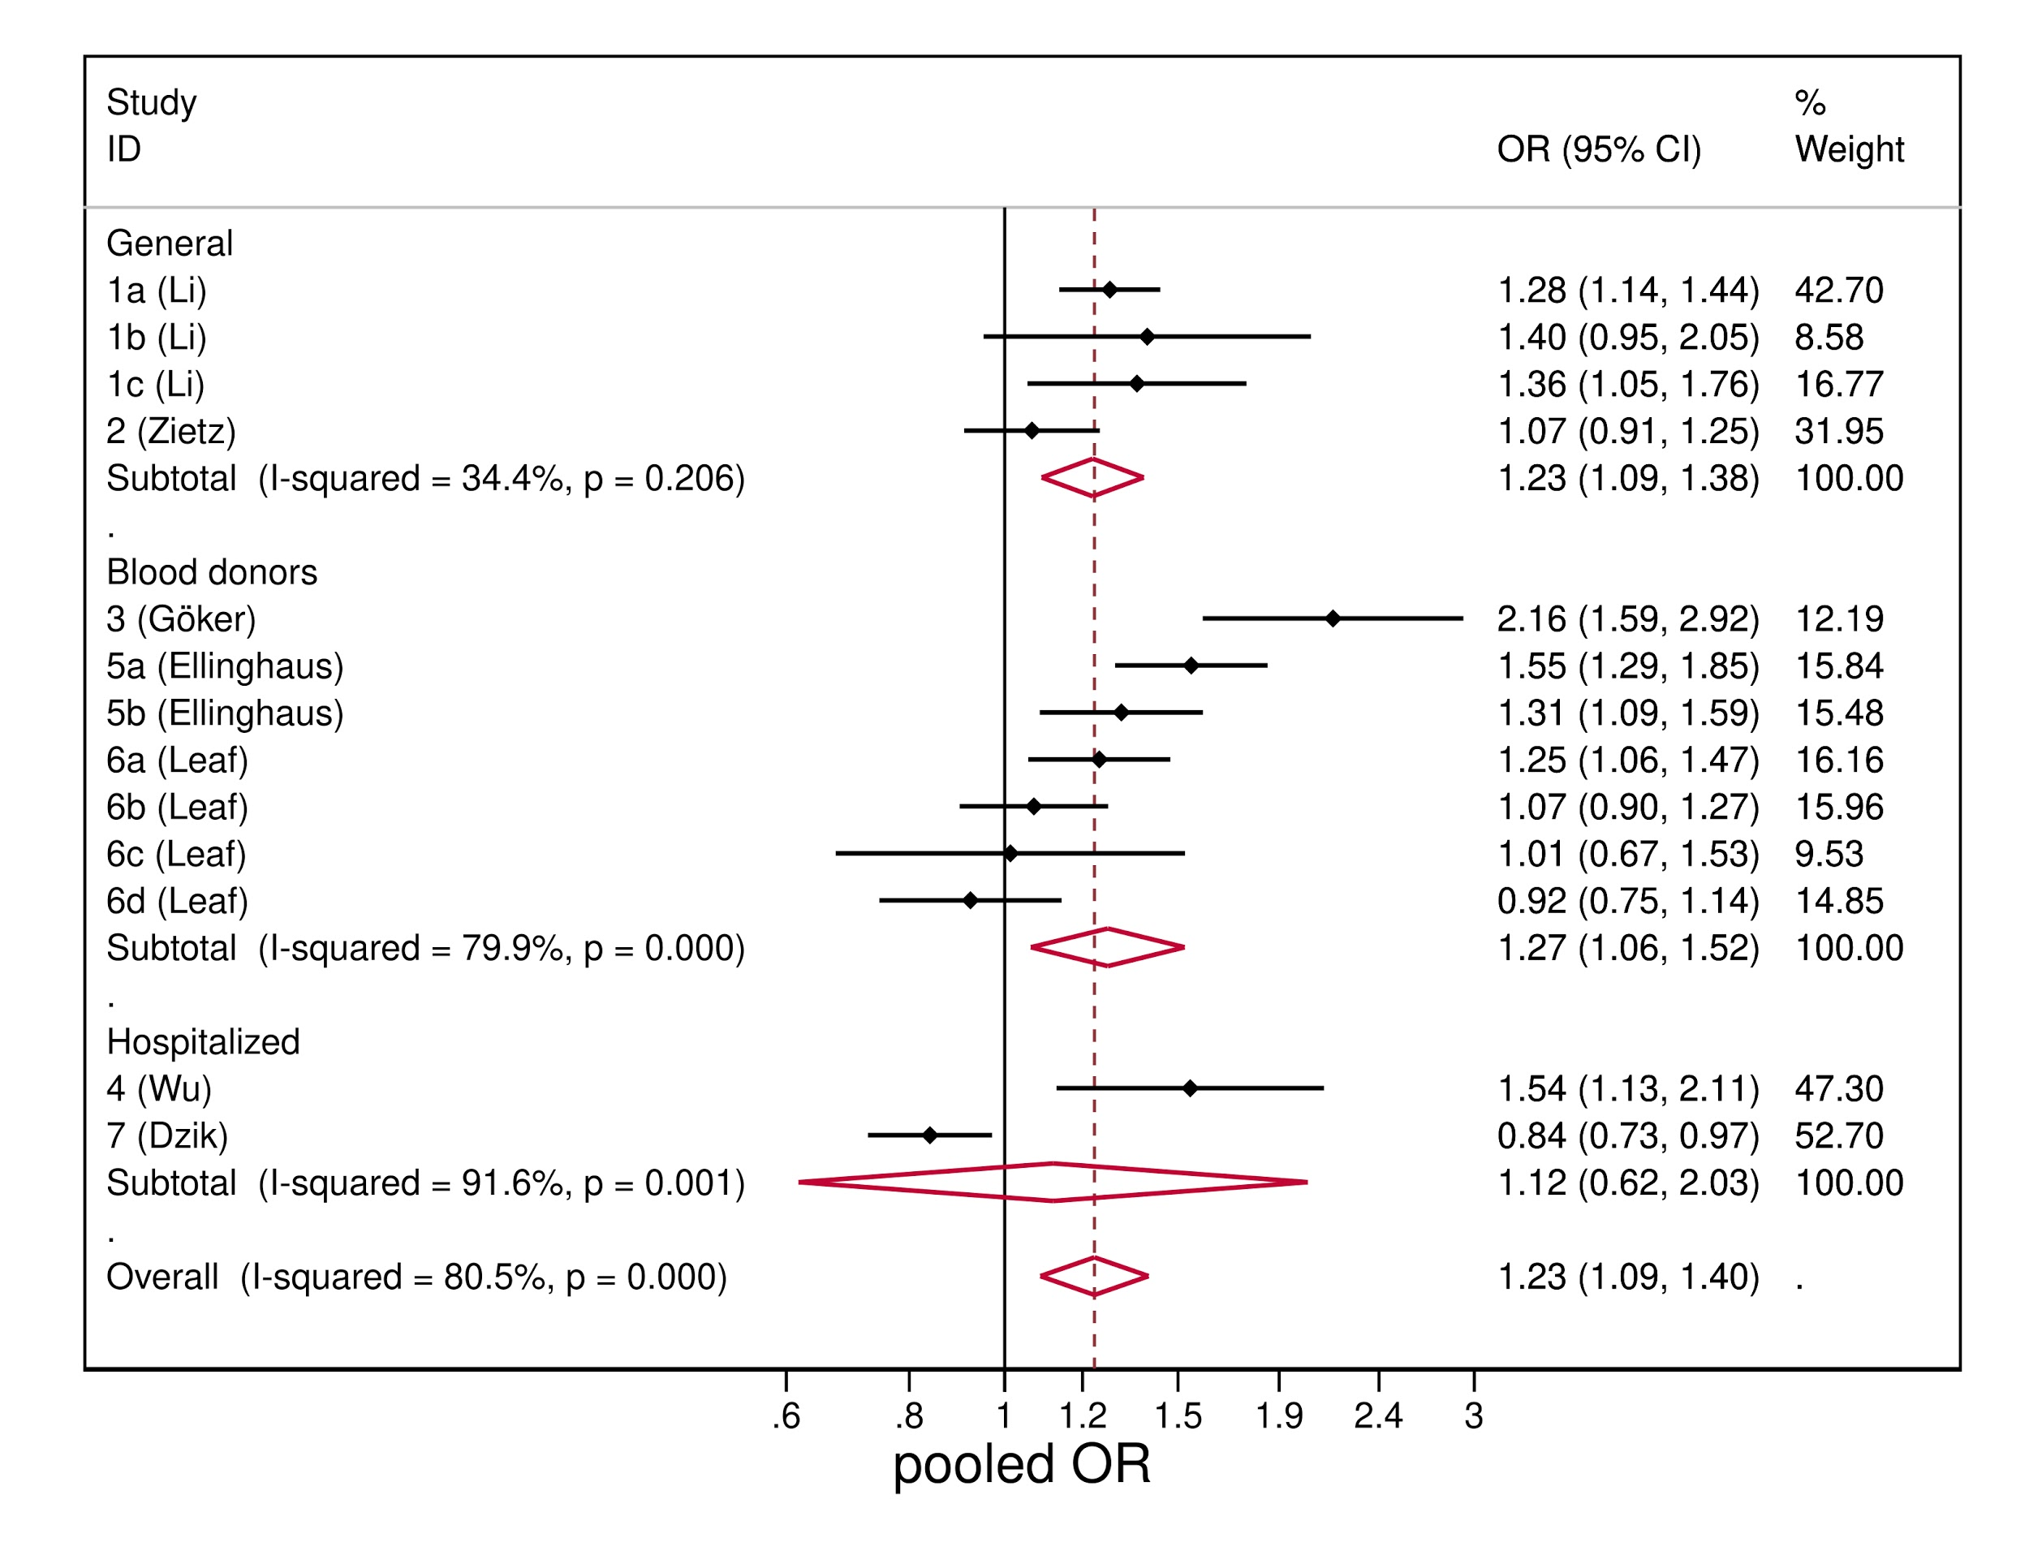

Figure S2. Forest plot from random effects analysis: OR of being blood group A in SARS-CoV-2+ group versus control group, by Country.
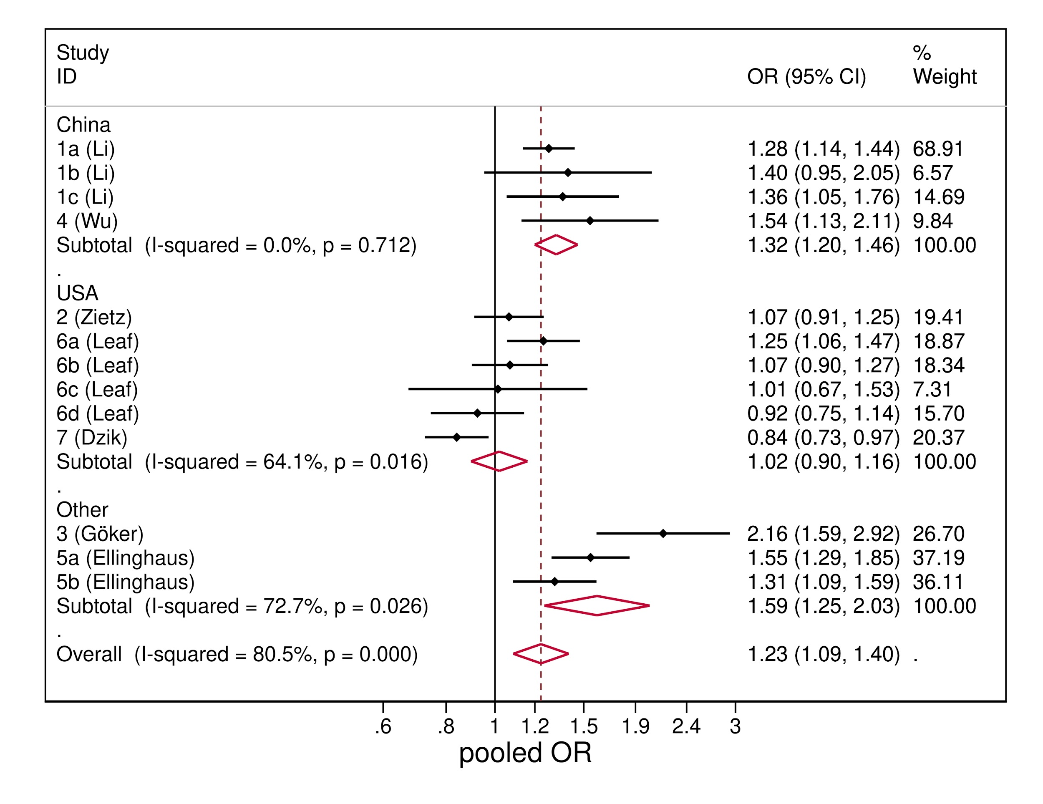

Figure S3. Forest plot from random effects analysis: OR of being blood group 0 in SARS-CoV-2+ group versus control group, by type of control population.

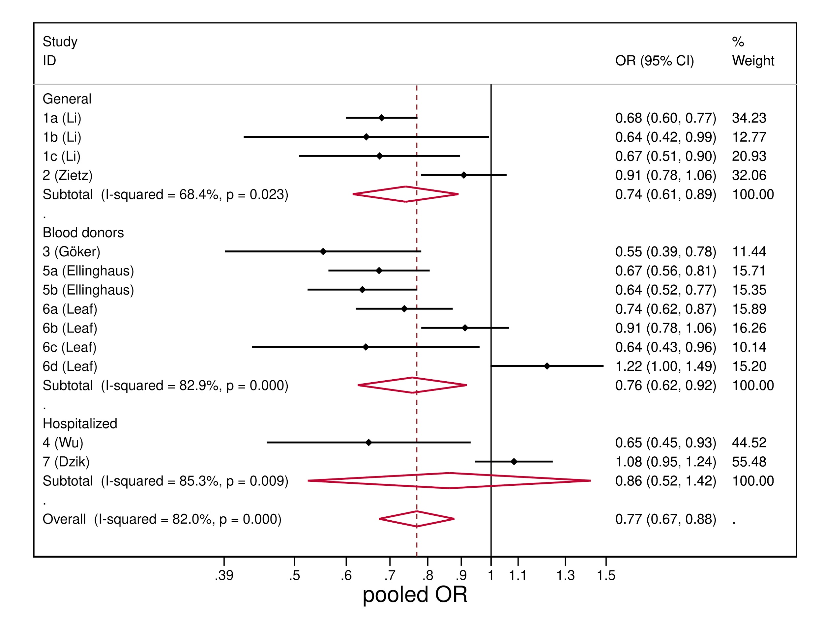
Figure S4. Forest plot from random effects analysis: OR of being blood group 0 in SARS-CoV-2+ group versus control group, by Country.
