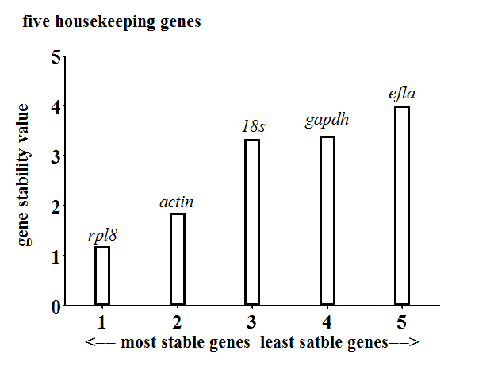
S1 Fig. Gene expression stability of the five candidate reference genes analyzed by the geNorm program. Pairwise variation analysis between the normalization factors NFn and NFn+1 was used to determine the optimal number of control genes for normalization.

