MGMT Methylation Status

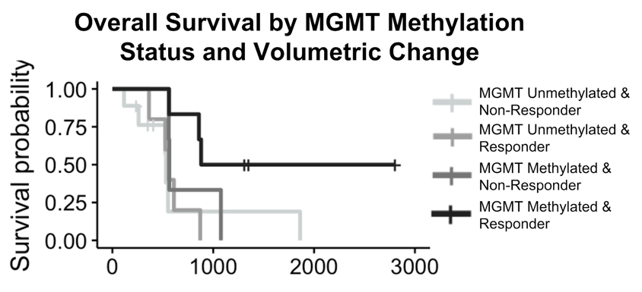
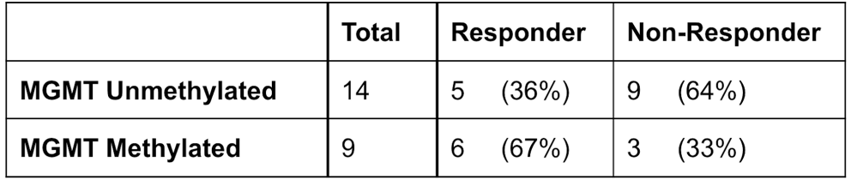

Supplemental Figure S4. MGMT methylation status and volumetric change for subcohort with methylation status available. Although the small sample size limits the statistical power of this comparison, methylated responders tended to have the best survival outcomes compared to other groups, followed by methylated non-responders, unmethylated responders, and unmethylated non-responders.

