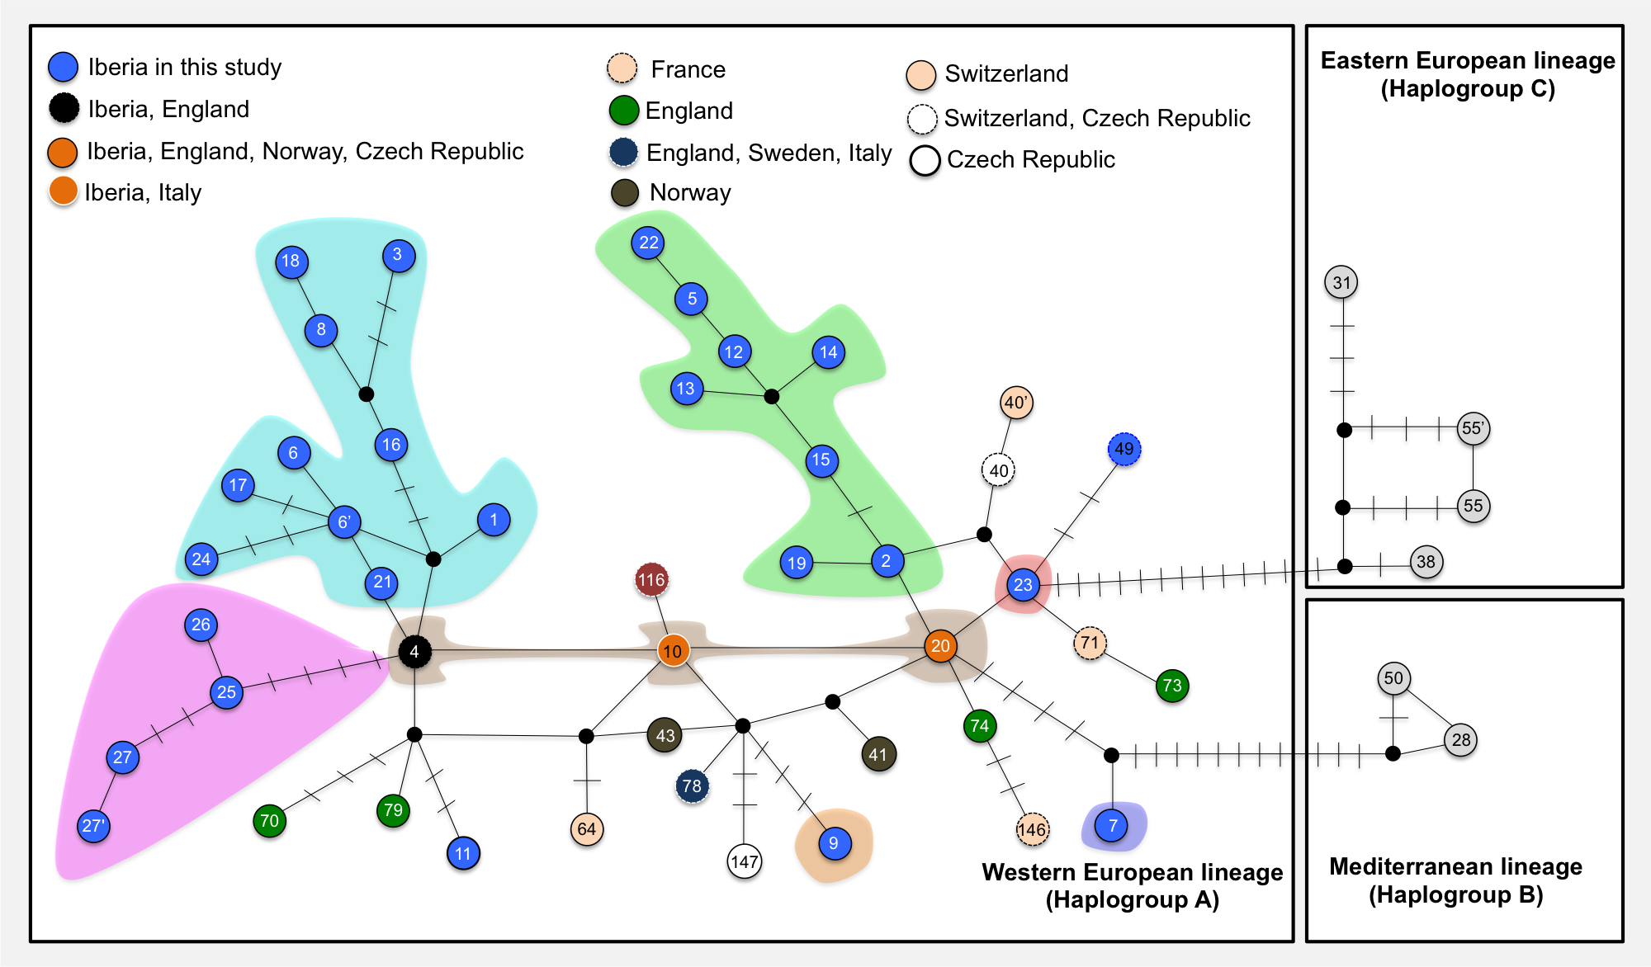
S5 Fig. Median joining network showing the evolutionary relationship of D-loop haplotypes found in this study (670 bp fragment size) for the red deer in Europe. Numbers within circles correspond to haplotype name described in the main manuscript for the 329bp haplotypes (see details in S1 Table). A bar in each solid line represents a mutational step; small black circles show undetected/extinct intermediate haplotype states; color codes within the circles are depicted for western European lineage (haplogroup A) and represent the country where the haplotypes were found. The Iberian sub-lineages are grouped by colored shading following Fig 6.

