S4 Fig: Genetic divergence between genes from reference and non-model organisms.
Distribution of the genetic divergence between Parachondrostoma toxostoma and Danio rerio for the 18,519 orthologous genes identified. The x-axis displays the p-distance and the y-axis displays the density of genes observed. 5.90% of the genes display a divergence greater than 0.3 (red line), and 35.66% greater than 0.2 (orange line).

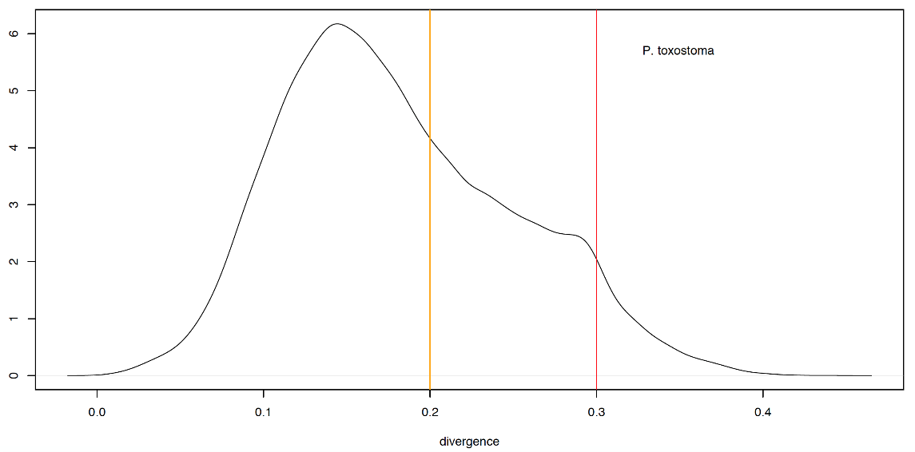
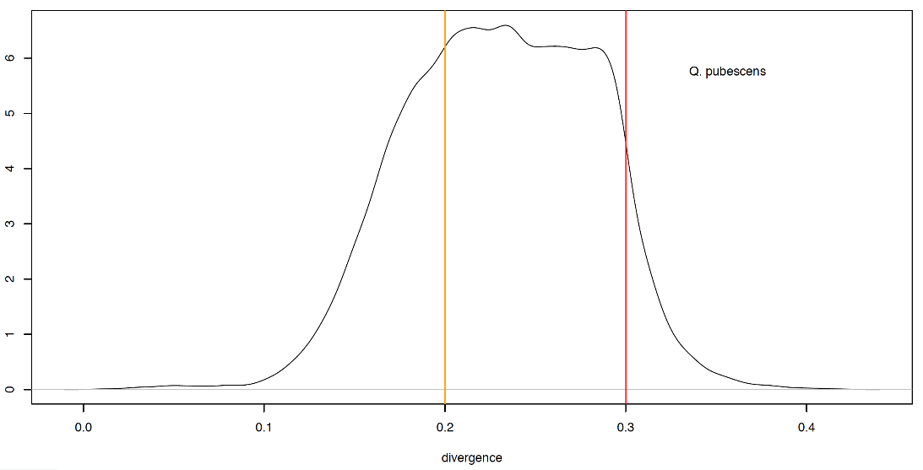
Distribution of the genetic divergence between Quercus pubescens and Vitis vinifera for the 16,326 orthologous genes identified. The x-axis displays the p-distance and the y-axis displays the density of genes observed. 7.74% display a divergence greater than 0.3 (red line) and 70.54% greater than 0.2(orange line).

