S7 Supporting information
Analysis of pathway activation profile overlaps between tissue specific and systemic response

In order to check whether the pathways identified in PBMC were also activated in the target tissues of organ-specific autoimmune disorders, we have downloaded gene expression datasets from target tissue samples for type 1 diabetes (T1D), multiple sclerosis (MS), ulcerative colitis (UC), Sjogren's syndrome (SS), which were available in GEO (Table S7.1).

Table S7.1 Description of tissue specific datasets
GEO Accession ID | Disease | Abbreviation | Tissue
GSE72492 | Type I diabetes | T1D | Pancreatic tissue
GSE26927 | Multiple sclerosis | MS | Brain tissue
GSE36807 | Crohn's disease | CD | Colon biopsy
GSE36807 | Ulcerative colitis | UC | Colon biopsy
GSE40568 | Sjogren's syndrome | SS | Salivary gland

We have downloaded gene expression matrix files, performed reverse-log transformation if data were in log scale, and computed the fold change values of disease versus control samples, taking as reference the the gene-wise mean expression values of all the controls. The fold changes were then used for pathway signal flow (PSF) analysis in the same way, as performed for PBMCs. Then, the pathway-wise mean PSF values for diseased samples in PBMCs and target tissues were compared, to identify overlapping up-regulated pathways, by setting an arbitrary threshold of 1.5-fold PSF difference in disease versus controls.

The size of overlap was 42% for T1D, 59% for MS, 34% for CD, 47% for UC and 53% for SS. The Venn diagrams and the pathways found in the overlaps are presented in the figures and tables below. The results suggest that there is considerable overlap in pathway activation profiles between PBMCs and target tissues of organ-specific autoimmune disorders.

Type I diabetes
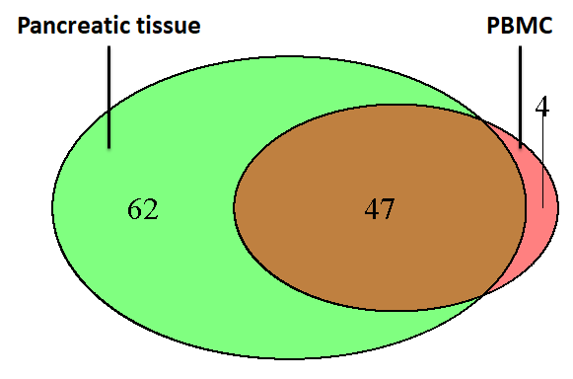
Figure S7.1. The venn diagram showing the overlap between up-regulated pathways in PBMCs (red) and in Pancreatic tissue (green) in type I diabetes. The up-regulated pathways have been filtered with PSF cut-off >= 1.5.

Overlapping upregulated pathways

Adipocytokine signaling pathway | Intestinal immune network for IgA production
Adrenergic signaling in cardiomyocytes | Leukocyte transendothelial migration
Apoptosis | Long-term potentiation
Arachidonic acid metabolism | MAPK signaling pathway
Axon guidance | Melanogenesis
B cell receptor signaling pathway | Natural killer cell mediated cytotoxicity
Cardiac muscle contraction | Neurotrophin signaling pathway
Cell adhesion molecules (CAMs) | NF-kappa B signaling pathway
Chemokine signaling pathway | NOD-like receptor signaling pathway
Complement and coagulation cascades | Notch signaling pathway
Cytokine-cytokine receptor interaction | Osteoclast differentiation
Dopaminergic synapse | p53 signaling pathway
ErbB signaling pathway | PI3K-Akt signaling pathway
Estrogen signaling pathway | Prolactin signaling pathway
Fc epsilon RI signaling pathway | Pyrimidine metabolism
Fc gamma R-mediated phagocytosis | Ras signaling pathway
FoxO signaling pathway | Regulation of actin cytoskeleton
Galactose metabolism | Tight junction
Glycine, serine and threonine metabolism | TNF signaling pathway
GnRH signaling pathway | Toll-like receptor signaling pathway
HIF-1 signaling pathway | Tryptophan metabolism
Hippo signaling pathway | Vascular smooth muscle contraction
Insulin signaling pathway | VEGF signaling pathway
 | Wnt signaling pathway

Multiple Sclerosis

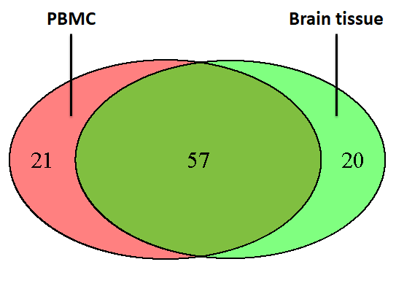
Figure S7.2. The venn diagram showing the overlap between up-regulated pathways in PBMCs (red) and in brain tissue (green) in multiple sclresis. The up-regulated pathways have been filtered with PSF cut-off >= 1.5.

Overlapping upregulated pathways in MS

Adipocytokine signaling pathway | Insulin secretion
Adrenergic signaling in cardiomyocytes | Insulin signaling pathway
Antigen processing and presentation | Intestinal immune network for IgA production
Apoptosis | Leukocyte transendothelial migration
Arachidonic acid metabolism | Long-term potentiation
Axon guidance | MAPK signaling pathway
B cell receptor signaling pathway | Melanogenesis
Cell adhesion molecules (CAMs) | Metabolism of xenobiotics by cytochrome P450
Cell cycle | mTOR signaling pathway
Chemokine signaling pathway | Neuroactive ligand-receptor interaction
Circadian entrainment | Neurotrophin signaling pathway
Complement and coagulation cascades | NF-kappa B signaling pathway
Cytokine-cytokine receptor interaction | Osteoclast differentiation
Cytosolic DNA-sensing pathway | Ovarian steroidogenesis
Dopaminergic synapse | p53 signaling pathway
ECM-receptor interaction | PI3K-Akt signaling pathway
ErbB signaling pathway | Progesterone-mediated oocyte maturation
Estrogen signaling pathway | Prolactin signaling pathway
Fc epsilon RI signaling pathway | Rap1 signaling pathway
Fc gamma R-mediated phagocytosis | Ras signaling pathway
Focal adhesion | Salivary secretion
FoxO signaling pathway | Sulfur metabolism
Gap junction | T cell receptor signaling pathway
Gastric acid secretion | Taste transduction
Glutamatergic synapse | Thyroid hormone signaling pathway
GnRH signaling pathway | Tight junction
HIF-1 signaling pathway | TNF signaling pathway
Hippo signaling pathway | Toll-like receptor signaling pathway
 | Wnt signaling pathway

Crohn's Disease
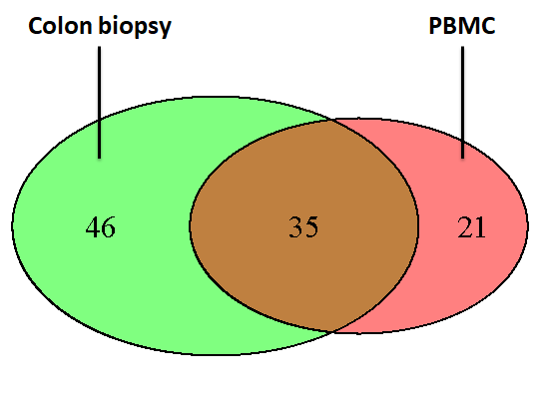
Figure S7.3. The venn diagram showing the overlap between up-regulated pathways in PBMCs (red) and in colon tissue (green) in Crohn's disease. The up-regulated pathways have been filtered with PSF cut-off >= 1.5.

Overlapping upregulated pathways in CD

Apoptosis | Leukocyte transendothelial migration
Bile secretion | MAPK signaling pathway
Cell adhesion molecules (CAMs) | Metabolism of xenobiotics by cytochrome P450
Chemokine signaling pathway | Natural killer cell mediated cytotoxicity
Complement and coagulation cascades | Neuroactive ligand-receptor interaction
Cytokine-cytokine receptor interaction | Neurotrophin signaling pathway
ECM-receptor interaction | NF-kappa B signaling pathway
ErbB signaling pathway | p53 signaling pathway
Estrogen signaling pathway | PI3K-Akt signaling pathway
Fc epsilon RI signaling pathway | Primary bile acid biosynthesis
Fc gamma R-mediated phagocytosis | Retinol metabolism
Focal adhesion | Steroid hormone biosynthesis
Glutathione metabolism | Thyroid hormone signaling pathway
Glycosaminoglycan degradation | Toll-like receptor signaling pathway
GnRH signaling pathway | Vascular smooth muscle contraction
HIF-1 signaling pathway | VEGF signaling pathway
Inflammatory mediator regulation of TRP channels | Wnt signaling pathway
Insulin signaling pathway

Ulcerative Colitis

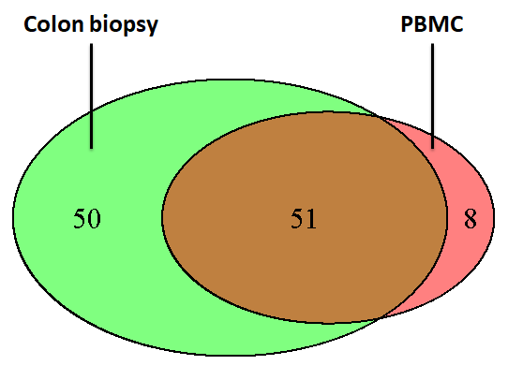
Figure S7.4. The venn diagram showing the overlap between up-regulated pathways in PBMCs (red) and in colon tissue (green) in ulcerative colitis. The up-regulated pathways have been filtered with PSF cut-off >= 1.5.

Overlapping upregulated pathways in UC

Adipocytokine signaling pathway | Insulin secretion
Adrenergic signaling in cardiomyocytes | Intestinal immune network for IgA production
Antigen processing and presentation | Leukocyte transendothelial migration
Apoptosis | MAPK signaling pathway
Arachidonic acid metabolism | Melanogenesis
Axon guidance | Metabolism of xenobiotics by cytochrome P450
Bile secretion | Natural killer cell mediated cytotoxicity
Cholinergic synapse | Neuroactive ligand-receptor interaction
Complement and coagulation cascades | Neurotrophin signaling pathway
Cytokine-cytokine receptor interaction | NF-kappa B signaling pathway
Drug metabolism - other enzymes | NOD-like receptor signaling pathway
ECM-receptor interaction | Osteoclast differentiation
ErbB signaling pathway | p53 signaling pathway
Estrogen signaling pathway | Primary bile acid biosynthesis
Fc epsilon RI signaling pathway | Pyrimidine metabolism
Fc gamma R-mediated phagocytosis | Rap1 signaling pathway
Focal adhesion | Ras signaling pathway
Galactose metabolism | Retinol metabolism
Glutathione metabolism | Salivary secretion
Glycine, serine and threonine metabolism | Steroid hormone biosynthesis
Glycolysis / Gluconeogenesis | Thyroid hormone signaling pathway
Glycosaminoglycan degradation | Tight junction
GnRH signaling pathway | Toll-like receptor signaling pathway
HIF-1 signaling pathway | Vascular smooth muscle contraction
Inflammatory mediator regulation of TRP channels | VEGF signaling pathway
 | Wnt signaling pathway

Sjogren's syndrome

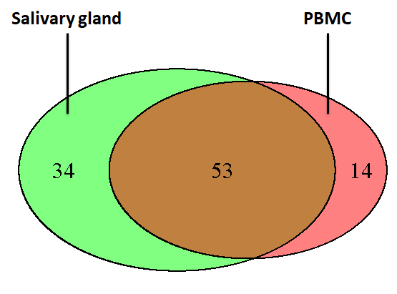
Figure S7.5. The venn diagram showing the overlap between up-regulated pathways in PBMCs (red) and in salivary gland (green) in Sjogren's syndrome. The up-regulated pathways have been filtered with PSF cut-off >= 1.5.

Overlapping upregulated pathways in SS

Adipocytokine signaling pathway | Jak-STAT signaling pathway
Aminoacyl-tRNA biosynthesis | Leukocyte transendothelial migration
Apoptosis | MAPK signaling pathway
B cell receptor signaling pathway | Melanogenesis
Calcium signaling pathway | Mineral absorption
Cell adhesion molecules (CAMs) | mTOR signaling pathway
Cell cycle | Mucin type O-Glycan biosynthesis
Chemokine signaling pathway | Natural killer cell mediated cytotoxicity
Cholinergic synapse | Neuroactive ligand-receptor interaction
Circadian entrainment | Neurotrophin signaling pathway
Complement and coagulation cascades | NF-kappa B signaling pathway
Cytokine-cytokine receptor interaction | NOD-like receptor signaling pathway
Cytosolic DNA-sensing pathway | Osteoclast differentiation
Dopaminergic synapse | p53 signaling pathway
Endocrine and other factor-regulated calcium reabsorption | Pancreatic secretion
ErbB signaling pathway | PI3K-Akt signaling pathway
Estrogen signaling pathway | Prolactin signaling pathway
Fc epsilon RI signaling pathway | Rap1 signaling pathway
Fc gamma R-mediated phagocytosis | Ras signaling pathway
Focal adhesion | RIG-I-like receptor signaling pathway
Folate biosynthesis | Salivary secretion
GnRH signaling pathway | T cell receptor signaling pathway
HIF-1 signaling pathway | Thyroid hormone signaling pathway
Hippo signaling pathway | TNF signaling pathway
Insulin signaling pathway | Toll-like receptor signaling pathway
Intestinal immune network for IgA production | VEGF signaling pathway
 | Wnt signaling pathway

