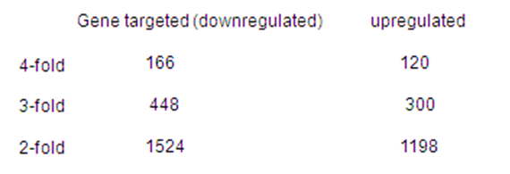

Table S2. The number of genes changed over 2-fold by miR-147.

