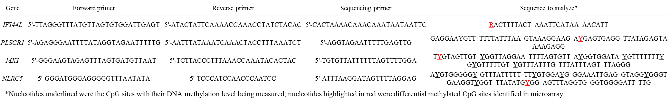
TableS2: Assay design of bisulfite pyrosequencing

