Age | N | Mean (StDev) | Median (IQR)
Admissions | 422 | 53.88 (19.65) | 59.00 (31.25)
HDU | 977` | 58.42 (16.87 | 61.00 (23.50)

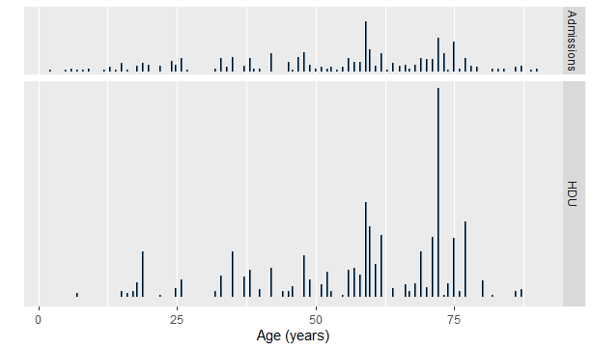

Age | N | Mean (StDev) | Median (IQR)
All patients | 1399 | 57.05 (17.87) | 60.00 (25.00)

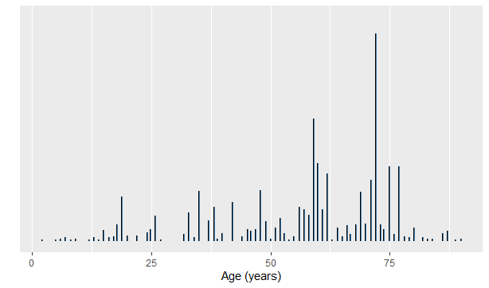

The distribution of age of the whole sample and also when considered, the two groups separately, is negatively skewed. Median was used to discuss the central tendency; interquartile range was used to discuss how dispersed (varied) the random variable is.

