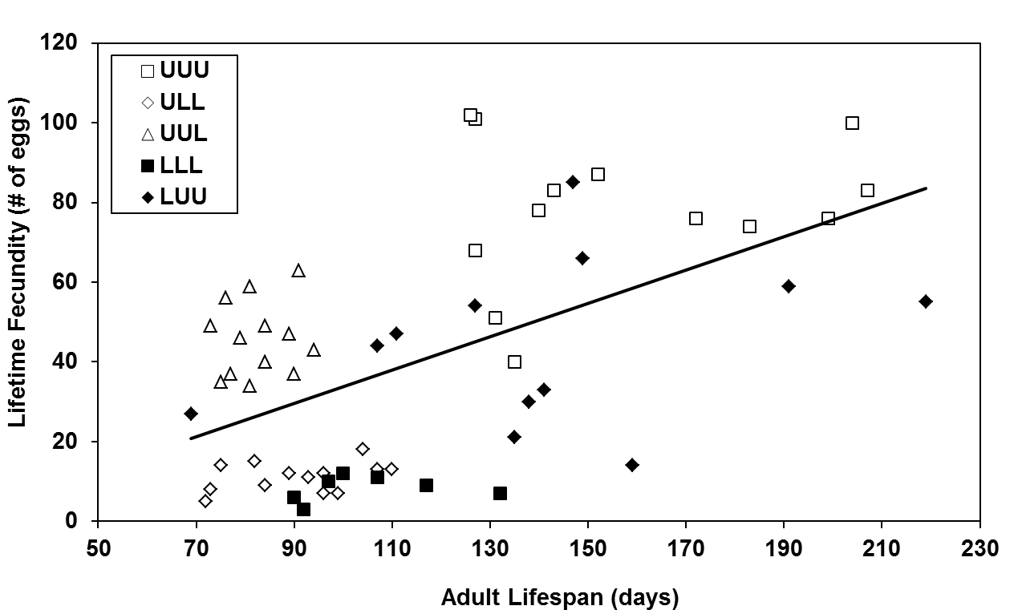
y = 0.418x – 7.999
F_{1,56} = 25.67, p < 0.0001,
R² = 0.302

Figure S11. Relationship between fecundity and the duration of adult lifespan (days) for all insects that oviposited (n = 58) as determined by least squares linear regression. U = unlimited access to food, L = limited access to food.

