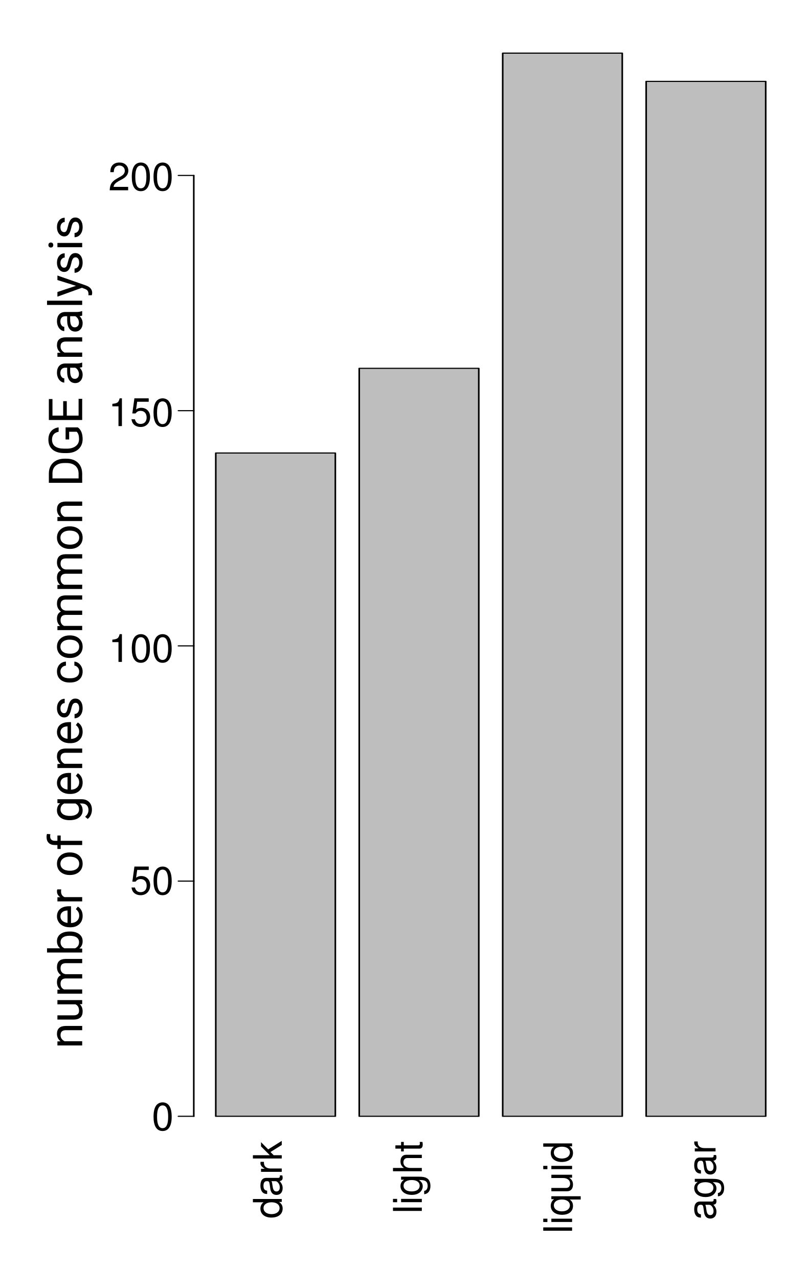

S8 Fig. Comparison of 250 top-contributing genes according to surprisal analysis and differential gene expression analysis (DGE). The columns denote the number of top-contributing genes according to surprisal analysis which are also present among the significantly differentially expressed genes upregulated in respectively dark, light, liquid and agar as obtained by the two available pairwise DGE comparisons.

