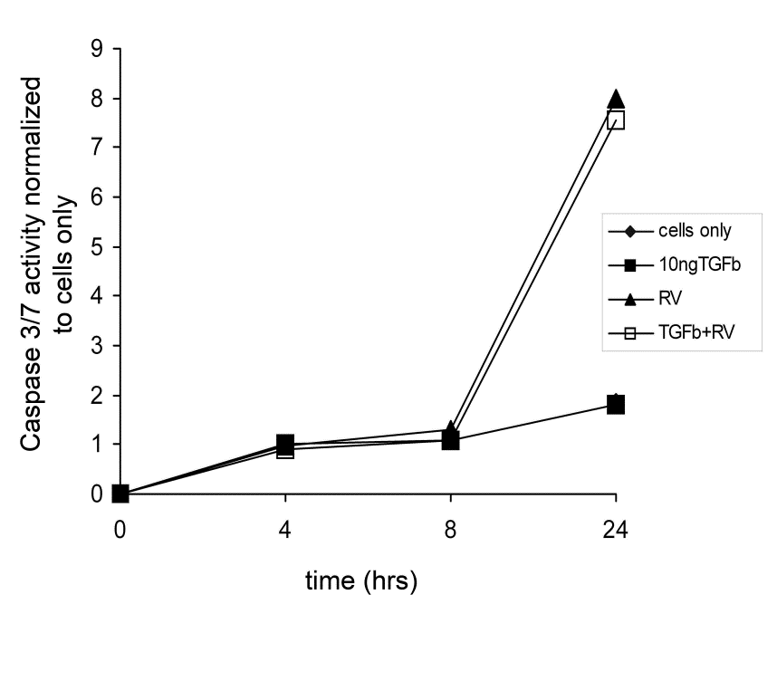

Online Supplement Figure S2
Caspase 3/7 activity of RV1B-infected PBEC in the presence or absence of TGF-β. PBECs from a healthy donor were seeded into a collagen-coated 96-well plate and incubated overnight at 37ºC. Cells were then pre-treated with TGF-β₂ (10 ng/ml) and incubated for 24 hrs after which they were infected with RV1B (MOI=0.05) for 1 hour, washed, and further incubated in media for 4, 8, and 24 hrs in the absence or presence of TGF-β₂. After each time point, a luminogenic caspase-3/7 substrate was added to each sample and incubated for 1 hour. Luminescence was measured on a TopCount plate reader.

