Effects of nature-adapted lighting solutions (“Virtual Sky”) on subjective and objective correlates of sleepiness, well-being, visual and cognitive performance at the workplace
Supplementary Material

- Light Conditions

Table S.1 Overview of the irradiance-derived light characteristics for the three
experimental light conditions. Values were calculated using the luox app [1].
Condition | SL | SC | DC
Illuminance (lx) | 296.15 | 306.86 | 303.25
CIE 1931 xy chromaticity [x] | 0.37 | 0.30 | 0.30
CIE 1931 xy chromaticity [y] | 0.34 | 0.30 | 0.30
CIE 1964 x₁₀y₁₀ chromaticity [x₁₀] | 0.37 | 0.31 | 0.31
CIE 1964 x₁₀y₁₀ chromaticity [y₁₀] | 0.34 | 0.30 | 0.30
S-cone-opic irradiance (mW ⋅ m⁻²) | 187.91 | 310.43 | 300.87
M-cone-opic irradiance (mW ⋅ m⁻²) | 372.19 | 438.58 | 430.64
L-cone-opic irradiance (mW ⋅ m⁻²) | 482.47 | 498.83 | 493.46
Rhodopic irradiance (mW ⋅ m⁻²) | 287.63 | 423.33 | 413.01
Melanopic irradiance (mW ⋅ m⁻²) | 241.33 | 398.83 | 388.23
S-cone-opic EDI (lx) | 229.92 | 379.83 | 368.13
M-cone-opic EDI (lx) | 255.66 | 301.26 | 295.81
L-cone-opic EDI (lx) | 296.19 | 306.24 | 302.94
Rhodopic EDI (lx) | 198.41 | 292.01 | 284.90
Melanopic EDI (lx) | 181.97 | 300.73 | 292.74
CCT (K) - Ohno, 2013 | 4056.75 | 7743.15 | 7420.95
CCT (K) - Robertson, 1968 | 4056.76 | 7742.15 | 7419.81
Colour Rendering Index [Ra] | 85.50 | 80.63 | 81.88
TM30 - Colour Fidelity Index [Rf] | 78.56 | 74.87 | 75.89

2. All Outcome Variables
Table S2. Descriptive sample statistics. Repeated measures were median aggregated within each subject.
Test/Instrument  Outcome (Unit/Range) | N | Mean | SD | Median | Skew | Transform
Karolinska Drowsiness Test (KDT)
Alpha Band Power F (µV²) | 18 | 7.61 | 8.07 | 4.62 | 1.73 | log_{e}(x)
Alpha Band Power C (µV²) | 18 | 9.71 | 9.52 | 5.89 | 1.30 | log_{e}(x)
Alpha Band Power P (µV²) | 18 | 13.89 | 14.49 | 7.81 | 1.18 | log_{e}(x)
Alpha Band Power O (µV²) | 18 | 7.08 | 7.50 | 5.09 | 1.75 | log_{e}(x)
Combined Alpha Band Power (µV²) | 18 | 28.98 | 16.47 | 23.94 | 1.32 | 1/√x
Psychomotor Vigilance Test (PVT)
Response Latency (ms) | 18 | 283.17 | 24.28 | 280 | 0.26 | 1/x
Go-NoGo
Omission Errors (%) | 18 | 4.07 | 3.26 | 3.59 | 0.81 | log_{e}(x)
Commission Errors (%) | 18 | 37.14 | 14.56 | 38.24 | -0.55
Word Pair Learning Test (WPLT)
Mislabeled new Word Pairs (%) | 18 | 16.53 | 12.66 | 10 | 0.83 | log_{e}(x)
Mislabeled old Word Pairs (%) | 18 | 28.89 | 13.56 | 30 | 0.74 | √x
Recognized new Word Pairs (%) | 18 | 66.94 | 13.30 | 65 | 0.15
Recognized old Word Pairs (%) | 18 | 55.83 | 14.88 | 60 | -0.42
Uncertain Response to new Word Pairs (%) | 17 | 15.74 | 7.44 | 15 | 0.58 | log_{e}(x)
Uncertain Response to old Word Pairs (%) | 17 | 14.56 | 8.58 | 12.50 | 0.69 | log_{e}(x)
Discrimination Index d’ (z) | 18 | 1.24 | 0.66 | 1.15 | 0.70
n-Back
0-Back Error Rate (%) | 18 | 2.16 | 1.06 | 2.20 | 0.57 | √x
2-Back Error Rate (%) | 18 | 4.33 | 2.10 | 4 | 1.50 | √x
3-Back Error Rate (%) | 18 | 6.98 | 2.44 | 6.70 | 0.38
Trust Game
Stake (CHF) | 18 | 6.25 | 2.64 | 6 | -0.09
Test for Creative Thinking – Drawing Production (TCT-DP)
Score (0 – 72) | 18 | 30.28 | 7.27 | 31 | 0.004
Karolinska Sleepiness Scale (KSS)
Reported Sleepiness (1 – 9) | 18 | 5.33 | 1.71 | 5.50 | -0.23
Visual Comfort Scale (VCS)
Pleasantness of Condition (-2 – 2) | 18 | 0.06 | 0.94 | 0 | -0.51
Pleasantness of Brightness (-2 – 2) | 18 | 0.11 | 0.47 | 0 | 0.38 | √x
Pleasantness of Color (-2 – 2) | 18 | 0.06 | 1.06 | 0 | -0.67
Perceived Glare (1 – 5) | 18 | 1.94 | 0.94 | 2 | 0.10 | 1/√x
Influence on Alertness (-2 – 2) | 18 | 0.44 | 0.70 | 1 | -0.77
Influence on Focus (-2 – 2) | 18 | 0.22 | 0.81 | 0 | -1.01 | x²
Mental Effort Rating Scale (RSME)
Perceived Given Effort (%) | 18 | 69.37 | 15.10 | 71.51 | -0.44 | x²
Satisfaction With Performance (%) | 18 | 44.23 | 17.79 | 42.35 | 0.13 | √x
Focussing Effort (%) | 18 | 73.69 | 13.28 | 74.59 | 0.04 | x²
Exhaustion (%) | 18 | 64.55 | 13.01 | 66.40 | -0.20
Motivation (%) | 18 | 57.89 | 23.45 | 55.99 | 0.24
Effort Relative to Previous Testings (%) | 18 | 64.21 | 17.70 | 61.52 | 0.08
Subjective Mood and Well-Being
Momentary Tension (%) | 18 | 37.78 | 13.16 | 34.16 | 0.79 | √x
Physical Comfort (%) | 18 | 64.42 | 13.57 | 66.78 | -0.34 | x²
Momentary Fatigue (%) | 18 | 53.63 | 11.09 | 53.22 | -0.29
Momentary Sleepiness (%) | 18 | 61.04 | 8.56 | 58.81 | 0.77
Current Mood (%) | 18 | 62.10 | 12.79 | 58.73 | 0.71
Mars Letter Contrast Sensitivity Test (MARS)
Sensitivity to Contrast (0.04 – 1.92) | 18 | 1.81 | 0.08 | 1.84 | -1.10 | 1/√(2 - x)
Pittsburgh Sleep Questionnaire
Score (0 – 5) | 18 | 3.17 | 1.20 | 3 | -0.69 | x²
Munich Chronotype questionnaire (MCTQ)
Midsleep on Free Days, adjusted (hrs) | 18 | 4.38 | 0.97 | 4.37 | 0.07
Note. SD: standard deviation; log_{e}: natural logarithm; √: square root

3. Statistical Analysis
Statistical analyses were performed using the R statistical computing environment (Version 4.0.3, R Core Team, 2020). The packages lmerTest (v3.1-3, Kuznetsova et al., 2017) and lme4 (v1.1-27.1, Bates et al., 2015) were employed for the linear mixed models, as well as the non-linear mixed modelling of the salivary cortisol data. For model diagnostics and performance evaluation the package performance (v0.7.0, Lüdecke et al., 2020) was used.
LMM fixed effects were tested for significance by one- or two-factorial analysis of deviance (AoD) Wald-type chi squared (Χ²) statistics provided by the Anova function of the car package (v3.0-12, Fox & Weisberg, 2019).
Cohen’s omega squared (ω²) as calculated by the effectsize package (v0.4.5, Ben-Shachar et al., 2020) is provided as effect size measure for the LMM fixed effects; it can be interpreted as follows: very small effect: ω² < .01 small effect: ω² ≥ .01, medium effect: ω² ≥ .06, large effect: ω² ≥ .14 (analogous to eta squared, Cohen, 1988); for models with more than one fixed effect, partial omega squared (ω_{p}²) is reported, the same interpretation applies. Contrast testing of significant AoD fixed effects was performed using the emmeans package (v1.5.4, Lenth, 2021) with Šidák and Tukey adjustment for multiple testing; only simple main effects were of interest.
In case of unmet LMM assumptions of homoscedasticity and homogeneity of variances the respective dependent variable was submitted to a Box-Cox analysis [10] and a common power transformation was applied to the DV depending on lambda value (λ). Extremely left skewed distributions were mirrored prior to transformation by subtracting all values from the first whole number larger than the maximum value.
If unresolvable heteroscedasticity, heterogeneous group variances, or autocorrelation were still present in the selected model, AoD and contrast analysis were performed using a cluster-robust variance-covariance matrix (CR2 adjustment for small samples) as provided by the R-package clubSandwich (v 0.5.3, Pustejovsky & Tipton, 2018).

4. Results

Supplementary Figures

Cognitive Performance
A)

B)

C)
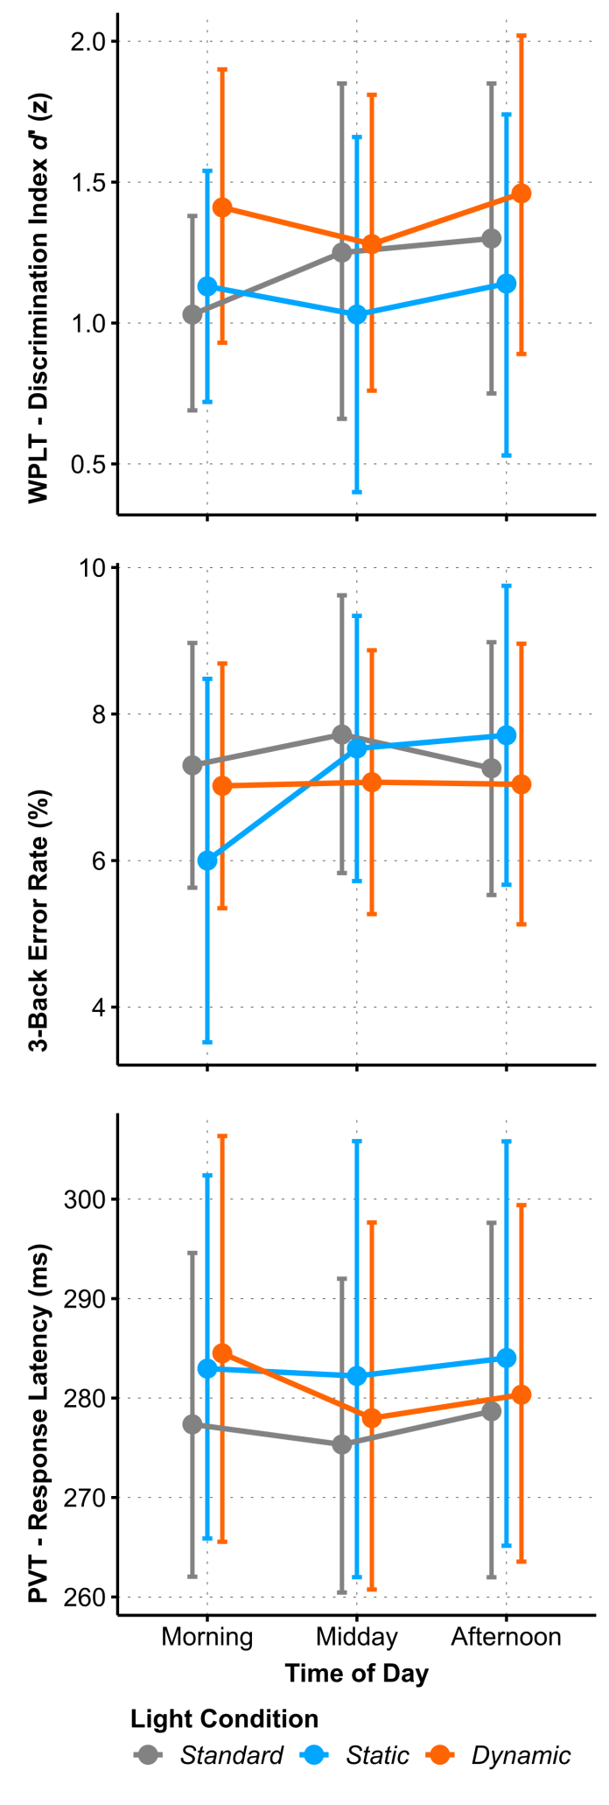
Figure S1. Interaction plots of estimated means for A) WPLT Discrimination Index d’ (z), B) 3-Back Error Rate (%), and C) Response Latency in the Psychomotor Vigilance Task (PVT, ms) between Light Conditions across Time of Day. Error bars indicate adjusted 95 % confidence intervals.

Subjective Sleepiness – Karolinska Sleepiness Scale (KSS)
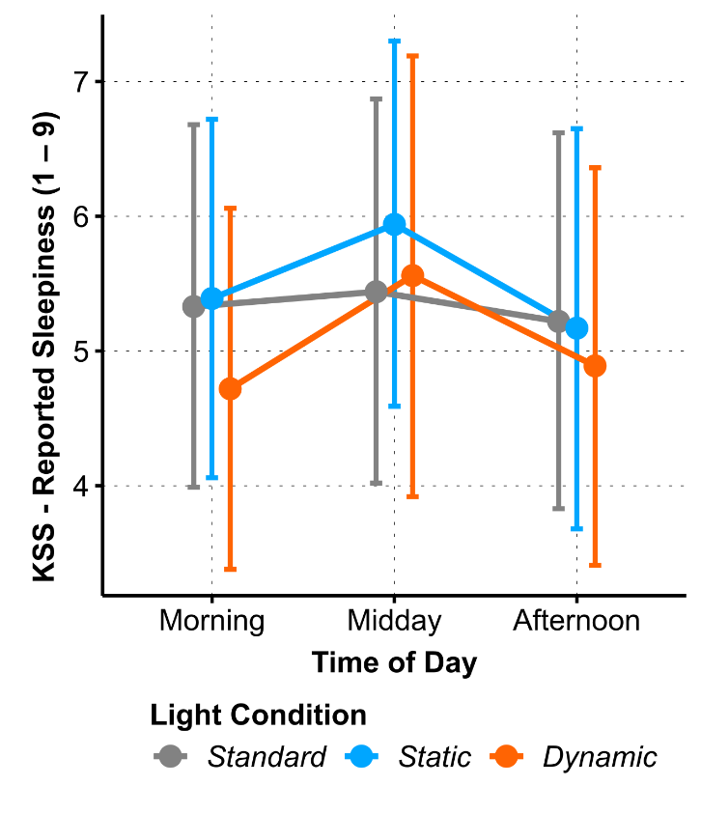
Figure S2. Interaction plots of estimated means of Subjective Sleepiness Ratings (KSS 1-9) between Light Conditions across Time of Day. Error bars indicate adjusted 95 % confidence intervals.

Karolinska Drowsiness Test (KDT) – FFT Profiles
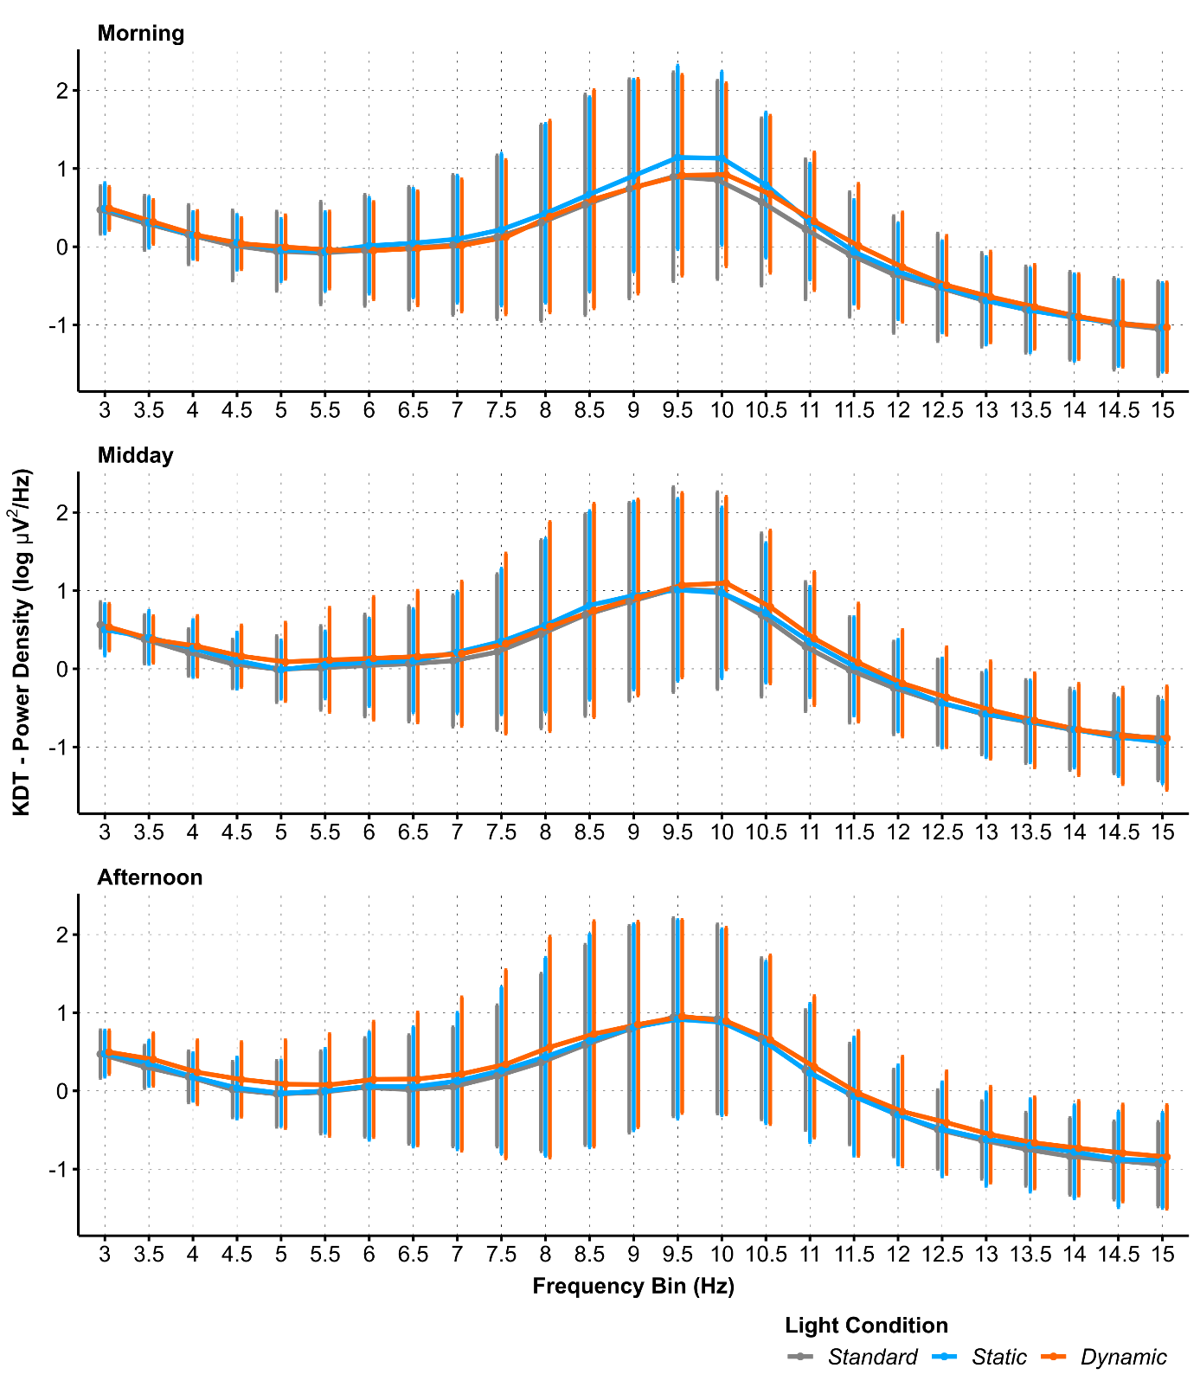
Figure S3. KDT EEG power density profiles (3 – 15 Hz) at the combined parietal electrodes (P3, Pz, P4) for the three Light Conditions (lines) measured at three Times of Day (panels). Power density scale is log-transformed; vertical bars indicate ± standard deviation.

Analysis of Deviance Model Parameters
This section assembles tables with the analysis of deviance (AoD) parameters of all linear mixed models. For outcome variables with significant effects, the selected model as reported in the main article is displayed. All AoDs are represented by the fully crossed model.

KDT
Table S3. AoD model parameters of the KDT Alpha Band Power Band for regions F, C, P, and O .
Outcome (Unit) Effect | Χ² | Df | p | ω_{p}² | ω_{p}²  Interpret. | R²  cond. | R²  marg. | ICC
Alpha Band Power F (µV²)
(Intercept) | 58.71 | 1 | <.001 |  |  | 0.88 | 0.01 | 088
Light Condition | 2.07 | 2 | .36 | 0.01 | small
Time of Day | 2.70 | 2 | .26 | -0.002 | very small
Light Condition × Time of Day | 2.14 | 4 | .71 | -0.02 | very small
Alpha Band Power C (µV²)
(Intercept) | 71.99 | 1 | <.001 |  |  | 0.93 | <0.01 | 0.93
Light Condition | 2.27 | 2 | .32 | 0.02 | small
Selected Model: Time of Day | 9.14 | 2 | .01 | 0.02 | small
(Intercept) | 71.99 | 1 | <.001 |  |  | 0.93 | 0.01 | 0.93
Light Condition | 2.27 | 2 | .32 | 0.02 | small
Time of Day | 9.14 | 2 | .01 | 0.02 | small
Light Condition × Time of Day | 7.29 | 4 | .12 | -0.01 | very small
Alpha Band Power P (µV²)
(Intercept) | 68.91 | 1 | <.001 |  |  | 0.95 | <0.01 | 0.95
Light Condition | 1.13 | 2 | .57 | 0.006 | very small
Time of Day | 6.70 | 2 | .04 | 0.02 | small
Light Condition × Time of Day | 9.69 | 4 | .046 | -0.01 | very small
Alpha Band Power O (µV²)
(Intercept) | 50.48 | 1 | <.001 |  |  | 0.91 | <0.01 | 0.91
Selected Model: Time of Day | 7.09 | 2 | .03 | 0.01 | very small
(Intercept) | 50.48 | 1 | <.001 |  |  | 0.91 | 0.00 | 0.91
Light Condition | 0.72 | 2 | .70 | 0.00 | very small
Time of Day | 7.09 | 2 | .029 | 0.01 | very small
Light Condition × Time of Day | 0.84 | 4 | .93 | -0.02 | very small
Note. Df: degrees of freedom of Χ²; ICC: intra class correlation, variance proportion of random effects

Subjective Sleepiness (KSS), Momentary Sleepiness (VAS), Mood and Well-Being
Table S4. AoD model parameters of Subjective Sleepiness (KSS), Momentary Sleepiness (VAS), and Subjective Mood and Well-Being.
Outcome (Unit) Effect | Χ² | Df | p | ω_{p}² | ω_{p}²  Interpret. | R²  cond. | R²  marg. | ICC
KSS
(Intercept) | 248.13 | 1 | <.001 |  |  | 0.40 | 0.03 | 0.39
Light Condition | 1.37 | 2 | .50 | < 0.01 | very small
Time of Day | 3.27 | 2 | .19 | 0.01 | small
Light Condition × Time of Day | 1.67 | 4 | .80 | -0.02 | very small
Momentary Sleepiness (%)
(Intercept) | 687.30 | 1 | <.001 |  |  | 0.21 | 0.02 | 0.20
Selected Model: Time of Day | 6.15 | 2 | .046 | 0.01 | small
(Intercept) | 687.30 | 1 | <.001 |  |  | 0.22 | 0.03 | 0.19
Light Condition | 1.22 | 2 | .54 | 0.00 | very small
Time of Day | 6.15 | 2 | .046 | 0.01 | small
Light Condition × Time of Day | 1.48 | 4 | .83 | -0.02 | very small
Momentary Tension (%)
(Intercept) | 1111.31 | 1 | <.001 |  |  | 0.24 | 0.06 | 0.19
Light Condition | 9.56 | 2 | .008 | 0.05 | small
Time of Day | 1.73 | 2 | .42 | < 0.01 | very small
Light Condition × Time of Day | 1.43 | 4 | .84 | -0.02 | very small
Physical Comfort (%)
(Intercept) | 161.64 | 1 | <.001 |  |  | 0.42 | 0.02 | 0.41
Light Condition | 1.47 | 2 | .48 | < 0.01 | very small
Time of Day | 0.02 | 2 | .99 | -0.01 | very small
Light Condition × Time of Day | 5.71 | 4 | .22 | -0.01 | very small
Momentary Fatigue (%)
(Intercept) | 705.77 | 1 | <.001 |  |  | 0.25 | 0.06 | 0.20
Selected Model: Time of Day | 13.41 | 2 | .001 | 0.07 | medium
(Intercept) | 705.77 | 1 | <.001 |  |  | 0.26 | 0.08 | 0.20
Light Condition | 0.20 | 2 | .91 | -0.01 | very small
Time of Day | 13.41 | 2 | .001 | 0.08 | medium
Light Condition × Time of Day | 5.71 | 4 | .22 | 0.00 | very small
Current Mood (%)
(Intercept) | 509.31 | 1 | <.001 |  |  | 0.51 | 0.03 | 0.50
Selected Model: Time of Day | 17.93 | 2 | <.001 | 0.04 | small
(Intercept) | 509.31 | 1 | <.001 |  |  | 0.51 | 0.03 | 0.49
Light Condition | 0.39 | 2 | .82 | -0.01 | very small
Time of Day | 17.93 | 2 | <.001 | 0.04 | small
Light Condition × Time of Day | 6.64 | 4 | .16 | -0.01 | very small
Note. Df: degrees of freedom of Χ²; ICC: intra class correlation, variance proportion of random effects

Cognitive Performance
Table S5. AoD model parameters of the cognitive performance variables.
Outcome (Unit) Effect | Χ² | Df | p | ω_{p}² | ω_{p}²  Interpret. | R²  cond. | R²  marg. | ICC
n-Back - 0-Back Error Rate (%)
(Intercept) | 353.97 | 1 | <.001 |  |  | 0.53 | 0.02 | 0.52
Light Condition | 2.03 | 2 | .36 | < 0.01 | very small
Time of Day | 5.03 | 2 | .08 | 0.01 | small
Light Condition × Time of Day | 4.14 | 4 | .39 | -0.01 | very small
n-Back - 2-Back Error Rate (%)
(Intercept) | 403.00 | 1 | <.001 |  |  | 0.52 | 0.02 | 0.51
Light Condition | 0.67 | 2 | .72 | < 0.01 | very small
Time of Day | 0.62 | 2 | .73 | -0.01 | very small
Light Condition × Time of Day | 4.53 | 4 | .34 | 0.01 | very small
n-Back - 3-Back Error Rate (%)
(Intercept) | 201.95 | 1 | <.001 |  |  | 0.56 | 0.03 | 0.55
Light Condition | 0.67 | 2 | .72 | < 0.01 | very small
Time of Day | 4.71 | 2 | .09 | 0.01 | small
Light Condition × Time of Day | 7.57 | 4 | .11 | 0.01 | small
PVT - Response Latency (ms)
(Intercept) | 2715.52 | 1 | <.001 |  |  | 0.72 | 0.01 | 0.72
Light Condition | 2.68 | 2 | .26 | 0.02 | small
Time of Day | 1.88 | 2 | .39 | < 0.01 | very small
Light Condition × Time of Day | 2.22 | 4 | .69 | -0.02 | very small
Go-NoGo - Omission Errors (%)
(Intercept) | 113.19 | 1 | <.001 |  |  | 0.63 | 0.02 | 0.62
Light Condition | 2.64 | 2 | .27 | 0.01 | very small
Time of Day | 5.14 | 2 | .08 | 0.03 | small
Light Condition × Time of Day | 2.41 | 4 | .66 | -0.02 | very small
Go-NoGo - Comission Errors (%)
(Intercept) | 117.39 | 1 | <.001 |  |  | 0.71 | 0.01 | 0.70
Selected Model: Time of Day | 6.21 | 2 | .045 | 0.04 | small
(Intercept) | 117.02 | 1 | <.001 |  |  | 0.70 | 0.02 | 0.70
Light Condition | 2.02 | 2 | .36 | 0.00 | very small
Time of Day | 6.17 | 2 | .046 | 0.04 | small
Light Condition × Time of Day | 0.41 | 4 | .98 | -0.03 | very small
WPLT - Mislabelled new Word Pairs (%)
(Intercept) | 284.23 | 1 | <.001 |  |  | 0.61 | 0.02 | 0.60
Light Condition | 3.54 | 2 | .17 | 0.02 | small
Time of Day | 2.90 | 2 | .24 | 0.01 | small
Light Condition × Time of Day | 1.14 | 4 | .89 | -0.03 | very small
WPLT - Mislabelled old Word Pairs (%)
(Intercept) | 362.48 | 1 | <.001 |  |  | 0.51 | 0.02 | 0.50
Light Condition | 0.20 | 2 | .90 | -0.01 | very small
Time of Day | 2.86 | 2 | .24 | < 0.01 | very small
Light Condition × Time of Day | 3.48 | 4 | .48 | < 0.01 | very small
WPLT - Recognized new Word Pairs (%)
(Intercept) | 411.91 | 1 | <.001 |  |  | 0.58 | 0.02 | 0.57
Light Condition | 2.37 | 2 | .31 | 0.01 | small
Time of Day | 4.30 | 2 | .12 | 0.01 | small
Light Condition × Time of Day | 4.12 | 4 | .39 | -0.02 | very small
WPLT - Recognized old Word Pairs (%)
(Intercept) | 261.96 | 1 | <.001 |  |  | 0.53 | 0.03 | 0.52
Light Condition | 2.68 | 2 | .26 | 0.01 | very small
Time of Day | 0.38 | 2 | .83 | -0.01 | very small
Light Condition × Time of Day | 9.11 | 4 | .06 | 0.01 | very small
WPLT - Discrimination Index d' (sd)
(Intercept) | 76.53 | 1 | <.001 |  |  | 0.56 | 0.03 | 0.54
Light Condition | 5.36 | 2 | .07 | 0.04 | small
Time of Day | 1.66 | 2 | .44 | < 0.01 | very small
Light Condition × Time of Day | 7.43 | 4 | .11 | -0.01 | very small
Note. Df: degrees of freedom of Χ²; ICC: intra class correlation, variance proportion of random effects

Test for Creative Thinking – Drawing Production (TCT-DP) & Trust Game
Table S6. AoD model parameters of the Test for Creative Thinking – Drawing Production (TCT-DP) & Trust Game. These Tests were performed only once per light condition.
Outcome (Unit) Effect | Χ² | Df | p | ω_{p}² | ω_{p}²  Interpret. | R²  cond. | R²  marg. | ICC
Test for Creative Thinking (0 – 72)
(Intercept) | 330.32 | 1 | <.001 |  |  | 0.34 | 0.004 | 0.33
Light Condition | 0.31 | 2 | .86 | -0.05 | very small
Trustgame - Stake (CHF)
(Intercept) | 114.13 | 1 | <.001 |  |  | 0.69 | 0.02 | 0.68
Light Condition | 3.19 | 2 | .20 | 0.04 | very small
Note. Df: degrees of freedom of Χ²; ICC: intra class correlation, variance proportion of random effects

Subjective Effort Rating (RSME)
Table S7. AoD model parameters of the Subjective Effort Rating measures (RSME).
Outcome (Unit) Effect | Χ² | Df | p | ω_{p}² | ω_{p}²  Interpret. | R²  cond. | R²  marg. | ICC
Perceived Given Effort (%) (-2 – 2)
(Intercept) | 130.96 | 1 | <.001 |  |  | 0.59 | 0.03 | 0.57
Selected Model: Time of Day | 9.08 | 2 | .01 | 0.07 | medium
(Intercept) | 130.96 | 1 | <.001 |  |  | 0.59 | 0.05 | 0.57
Light Condition | 3.56 | 2 | .17 | 0.01 | small
Time of Day | 9.08 | 2 | .011 | 0.08 | medium
Light Condition × Time of Day | 4.45 | 4 | .35 | -0.01 | very small
Satisfaction With Performance (%)
(Intercept) | 615.33 | 1 | <.001 |  |  | 0.34 | 0.02 | 0.33
Light Condition | 0.69 | 2 | .71 | -0.01 | very small
Time of Day | 2.50 | 2 | .29 | < 0.01 | very small
Light Condition × Time of Day | 3.37 | 4 | .50 | -0.02 | very small
Focussing Effort (%)
(Intercept) | 140.92 | 1 | <.001 |  |  | 0.67 | 0.03 | 0.66
Selected Model: Light Condition | 12.71 | 2 | .002 | 0.08 | medium
(Intercept) | 140.92 | 1 | <.001 |  |  | 0.67 | 0.03 | 0.66
Light Condition | 12.71 | 2 | .002 | 0.08 | medium
Time of Day | 0.60 | 2 | .74 | -0.01 | very small
Light Condition × Time of Day | 6.20 | 4 | .18 | -0.01 | very small
Exhaustion (%)
(Intercept) | 627.22 | 1 | <.001 |  |  | 0.27 | 0.05 | 0.23
Selected Model: Time of Day | 7.18 | 2 | .03 | 0.06 | small
(Intercept) | 627.22 | 1 | <.001 |  |  | 0.28 | 0.07 | 0.22
Light Condition | 0.98 | 2 | .61 | 0.00 | very small
Time of Day | 7.18 | 2 | .028 | 0.06 | medium
Light Condition × Time of Day | 4.72 | 4 | .32 | -0.01 | very small
Motivation (%)
(Intercept) | 130.00 | 1 | <.001 |  |  | 0.73 | 0.04 | 0.71
Selected Model: Time of Day | 31.36 | 2 | <.001 | 0.12 | medium
(Intercept) | 129.49 | 1 | <.001 |  |  | 0.72 | 0.04 | 0.71
Light Condition | 0.05 | 2 | .98 | -0.01 | very small
Time of Day | 30.65 | 2 | <.001 | 0.13 | medium
Light Condition × Time of Day | 4.08 | 4 | .40 | -0.01 | very small
Effort Relative to Prev. Testings (%)
(Intercept) | 325.60 | 1 | <.001 |  |  | 0.33 | 0.01 | 0.32
Light Condition | 2.71 | 2 | .26 | < 0.01 | very small
Time of Day | 0.41 | 1 | .52 | -0.01 | very small
Light Condition × Time of Day | 0.01 | 2 | 1.00 | -0.02 | very small
Note. Df: degrees of freedom of Χ²; ICC: intra class correlation, variance proportion of random effects

Visual Comfort and Contrast Sensitivity
Table S8. AoD model parameters of the Visual Comfort and Contrast Sensitivity measures.
Outcome (Unit) Effect | Χ² | Df | p | ω_{p}² | ω_{p}²  Interpret. | R²  cond. | R²  marg. | ICC
VCS - Pleasantness of Conditions (-2 – 2)
(Intercept) | 0.14 | 1 | .71 |  |  | 0.65 | 0.09 | 0.62
Light Condition | 9.71 | 2 | .008 | 0.10 | medium
Time of Day | 1.37 | 2 | .50 | -0.01 | very small
Light Condition × Time of Day | 14.92 | 4 | .005 | 0.08 | medium
VCS - Pleasantness of Brightness (-2 – 2)
(Intercept) | 253.19 | 1 | <.001 |  |  | 0.87 | 0.04 | 0.86
Light Condition | 3.04 | 2 | .22 | 0.12 | medium
Time of Day | 1.41 | 2 | .49 | < 0.01 | very small
Light Condition × Time of Day | 2.92 | 4 | .57 | -0.07 | very small
VCS - Pleasantness of Color (-2 – 2)
(Intercept) | 0.00 | 1 | .98 |  |  | 0.74 | 0.03 | 0.74
Light Condition | 4.66 | 2 | .10 | 0.10 | medium
Time of Day | 0.47 | 2 | .79 | -0.02 | very small
Light Condition × Time of Day | 2.85 | 4 | .58 | -0.04 | very small
VCS - Perceived Glare (1 – 5)
(Intercept) | 529.05 | 1 | <.001 |  |  | 0.51 | 0.01 | 0.51
Light Condition | 0.19 | 2 | .91 | -0.01 | very small
Time of Day | 0.41 | 2 | .81 | -0.01 | very small
Light Condition × Time of Day | 6.50 | 4 | .17 | -0.01 | very small
VCS - Influence on Alertness (-2 – 2)
(Intercept) | 2.55 | 1 | .11 |  |  | 0.56 | 0.06 | 0.53
Light Condition | 3.78 | 2 | .15 | 0.06 | medium
Time of Day | 2.69 | 2 | .26 | -0.01 | very small
Light Condition × Time of Day | 9.66 | 4 | .047 | -0.02 | very small
VCS - Influence on Focus (-2 – 2)
(Intercept) | 82.16 | 1 | <.001 |  |  | 0.67 | 0.07 | 0.65
Selected Model: Light Condition | 10.53 | 2 | .005 | 0.15 | large
(Intercept) | 82.41 | 1 | <.001 |  |  | 0.66 | 0.08 | 0.63
Light Condition | 11.39 | 2 | .003 | 0.16 | large
Time of Day | 3.35 | 2 | .19 | -0.01 | very small
Light Condition × Time of Day | 8.04 | 4 | .09 | -0.02 | very small
MARS - Contrast Sensitivity (0.04 – 1.92)
(Intercept) | 812.66 | 1 | <.001 |  |  | 0.50 | 0.05 | 0.48
Light Condition | 1.24 | 2 | .54 | < 0.01 | very small
Time of Day | 4.06 | 2 | .13 | < 0.01 | very small
Light Condition × Time of Day | 37.08 | 4 | <.001 | 0.05 | small
Note. Df: degrees of freedom of Χ²; ICC: intra class correlation, variance proportion of random effects

False Discovery Rate
Table S9. On the level of the linear mixed models, a q-value based analysis of false discovery rate (FDR; Storey, 2002 [12]) using the p-values for a total of 81 tested AoD effects was conducted. FDR π0 of was 0.475. The table shows only the 11 tests that were significant with p < .05, sorted by ascending p-values; eliminated effects in bold; p-values and q-values < .05 in red.
Outcome | Effect | Χ² | Df | p-value | omega² | effect size | q-value
RSME - Motivation | Time of Day | 31.36 | 2 | <.001 | 0.124 | medium | <0.0001
MARS - Contrast Sensitivity | Light Condition × Time of Day | 37.08 | 4 | <.001 | 0.052 | small | <0.0001
Current Mood | Time of Day | 17.93 | 2 | <.001 | 0.042 | small | 0.002
Momentary Fatigue | Time of Day | 13.41 | 2 | .001 | 0.074 | medium | 0.012
RSME - Focussing Effort | Light Condition | 12.71 | 2 | .002 | 0.075 | medium | 0.013
VCS - Pleasantness of Conditions | Light Condition × Time of Day | 14.92 | 4 | .005 | 0.079 | medium | 0.029
VCS - Influence on Focus | Light Condition | 10.53 | 2 | .005 | 0.155 | large | 0.029
Momentary Tension | Light Condition | 9.76 | 2 | .008 | 0.051 | small | 0.033
VCS - Pleasantness of Conditions | Light Condition | 9.71 | 2 | .008 | 0.105 | medium | 0.033
KDT - Alpha Band Power C | Time of Day | 9.14 | 2 | .010 | 0.023 | small | 0.038
RSME - Perceived Given Effort | Time of Day | 9.08 | 2 | .011 | 0.074 | medium | 0.038
RSME - Exhaustion | Time of Day | 7.18 | 2 | .028 | 0.059 | small | 0.09
KDT - Alpha Band Power O | Time of Day | 7.09 | 2 | .029 | 0.006 | very small | 0.09
KDT - Alpha Band Power P | Time of Day | 6.70 | 2 | .035 | 0.018 | small | 0.10
Go-NoGo - Commission Errors | Time of Day | 6.21 | 2 | .045 | 0.039 | small | 0.10
KDT - Alpha Band Power P | Light Condition × Time of Day | 9.69 | 4 | .046 | -0.006 | very small | 0.10
VAS - Momentary Sleepiness | Time of Day | 6.15 | 2 | .046 | 0.014 | small | 0.10
VCS - Influence on Alertness | Light Condition × Time of Day | 9.66 | 4 | .047 | -0.017 | very small | 0.10

5. References
1. Spitschan M, Mead J, Roos C, Lowis C, Griffiths B, Mucur P, et al. luox: validated reference open-access and open-source web platform for calculating and sharing physiologically relevant quantities for light and lighting. Wellcome Open Res. 2022;6: 69. doi:10.12688/wellcomeopenres.16595.3
2. R Core Team. R: A language and environment for statistical computing. R Foundation for Statistical Computing. Vienna, Austria; 2020.
3. Kuznetsova A, Brockhoff PB, Christensen RHB. lmerTest Package: Tests in Linear Mixed Effects Models. J Stat Softw. 2017;82. doi:10.18637/jss.v082.i13
4. Bates D, Mächler M, Bolker B, Walker S. Fitting Linear Mixed-Effects Models Using lme4. J Stat Softw. 2015;67: 1–48. doi:10.18637/jss.v067.i01
5. Lüdecke D, Makowski D, Waggoner P, Patil I. performance: Assessment of Regression Models Performance. CRAN. 2020. doi:10.5281/zenodo.3952174
6. Fox J, Weisberg S. An R Companion to Applied Regression. Third edition. Los Angeles: SAGE; 2019.
7. Ben-Shachar MS, Lüdecke D, Makowski D. effectsize: Estimation of Effect Size Indices and Standardized Parameters. J Open Source Softw. 2020;5: 2815. doi:10.21105/joss.02815
8. Cohen J. Statistical power analysis for the behavioral sciences. 2nd ed. Hillsdale, N.J: L. Erlbaum Associates; 1988.
9. Lenth RV. emmeans: Estimated Marginal Means, aka Least-Squares Means. 2021. Available: https://CRAN.R-project.org/package=emmeans
10. Box GEP, Cox DR. An Analysis of Transformations. J R Stat Soc Ser B Methodol. 1964;26: 211–252.
11. Pustejovsky JE, Tipton E. Small-Sample Methods for Cluster-Robust Variance Estimation and Hypothesis Testing in Fixed Effects Models. J Bus Econ Stat. 2018;36: 672–683. doi:10.1080/07350015.2016.1247004
12. Storey JD. A Direct Approach to False Discovery Rates. J R Stat Soc Ser B Stat Methodol. 2002;64: 479–498. doi:10.1111/1467-9868.00346

