Figure S1. Results of hierarchical STRUCTURE analysis in Mesoamerican jaguars. The optimal number of genetic clusters (K) in Mesoamerican jaguars using STRUCTURE, version 2.3.4 [47] was chosen based on posterior probability (mean L(K), A) and delta K (ΔK, mean (|L”(K)|)/SD(L(K)), D) for each K value. Bayesian clustering analysis was conducted for jaguars detected in (a) Guatemala, Belize, and Honduras (n = 72), (b) Honduras and Costa Rica (n = 43), (c) Guatemala and Belize (n = 65), and (d) Costa Rica (n = 36). SD, standard deviation; L’(K), mean rate of change of the likelihood distribution (B); |L”(K)|, absolute value of the 2nd order rate of change of the likelihood distribution (C).

(a)

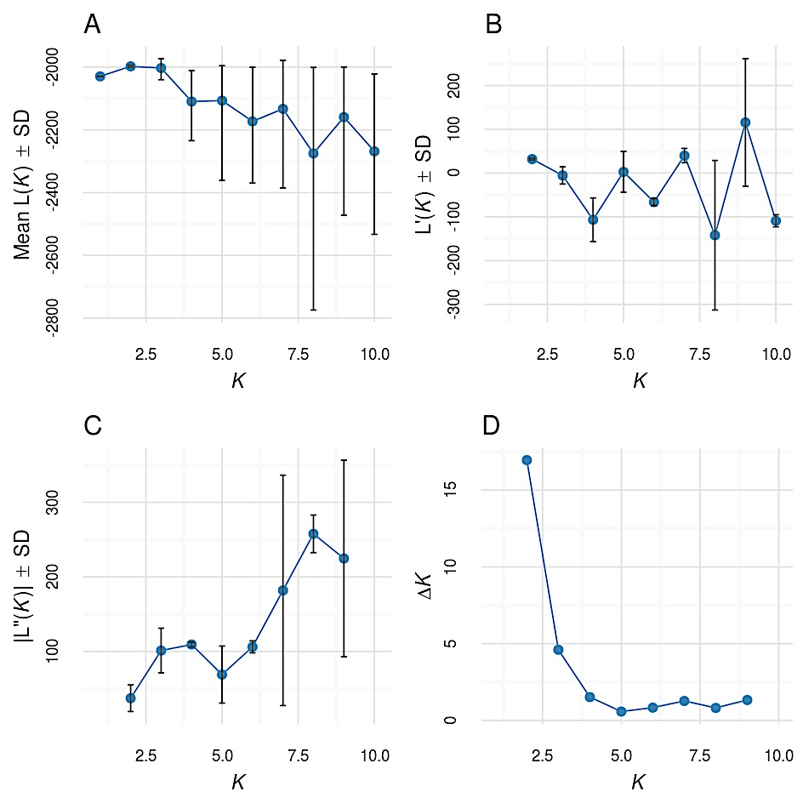

(b)

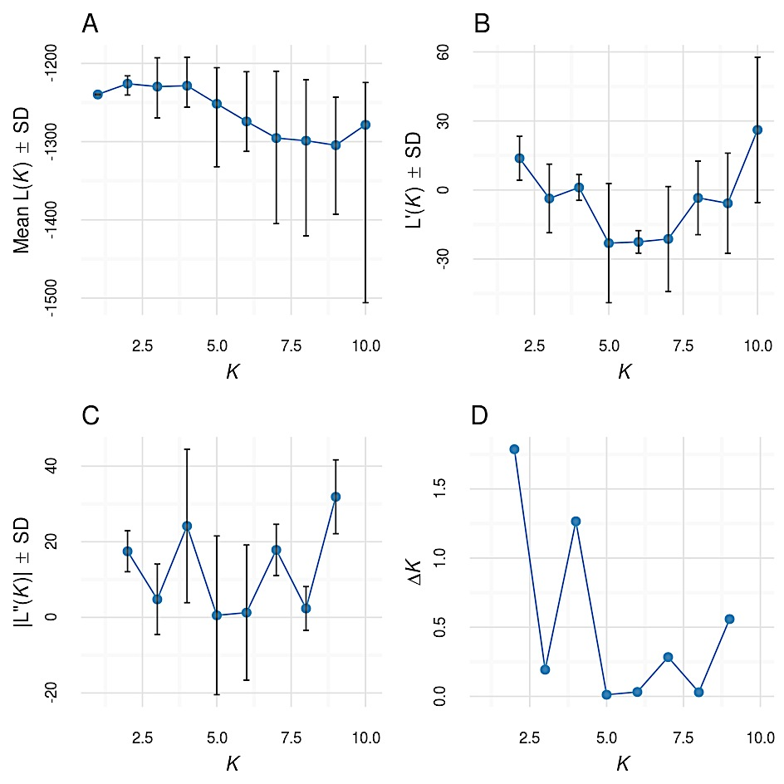

(c)

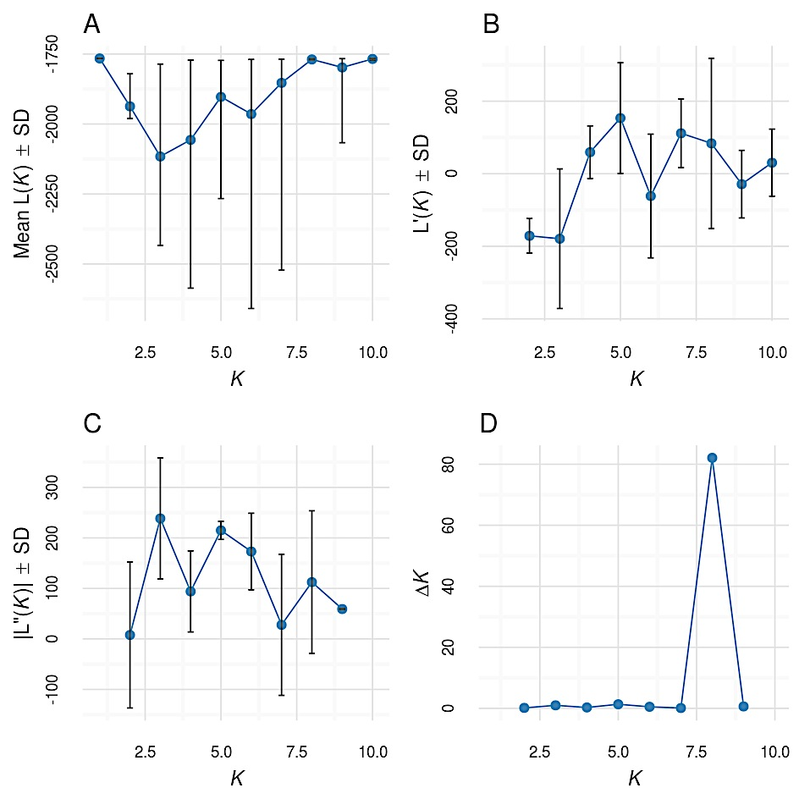

(d)

