Appendix 3: Distribution of conditional probabilities of the cities to belong to each profile
a)  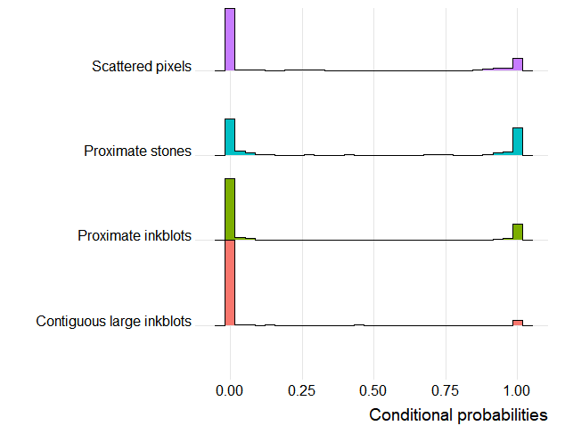 | b)  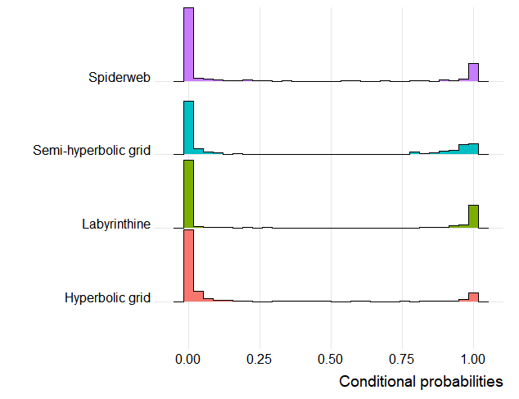
Distribution of the conditional probabilities of 370 cities is plotted in bars, where bigger bars reflect a higher proportion of cities. a) urban landscape profiles and b) street design profiles.

