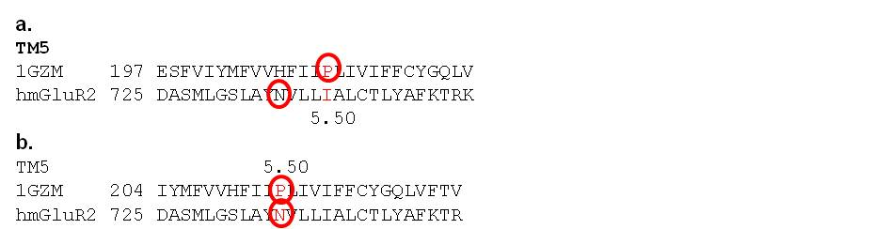
Figure S10. Alignment comparison. Comparison of the new (A) and the old (B) alignment for the TM5.

