Fig S4. Mediation Model of the Contributions of Preschool Fluid Abilities and Crystallized Abilities to School Achievement in the QLSCD (Two missing value condition).
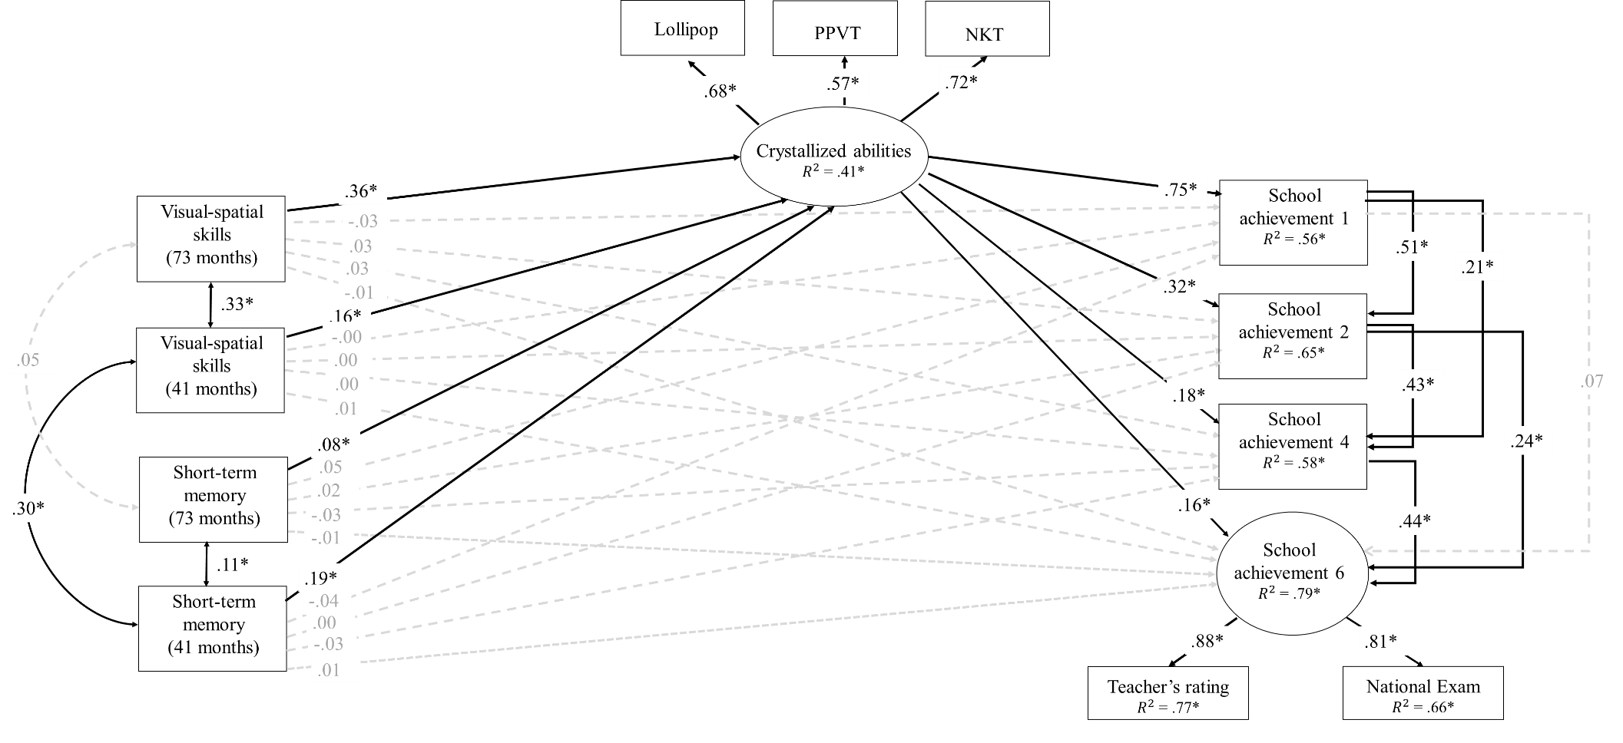
Note. χ²(37) = 158.57 p < .001; RMSEA = .06, 90% CI [.05, .07]; CFI = .97, TLI =.91. Nonsignificant contributions are indicated with dashed lines. Contributions of control variables (mother’s education, family income and sex) are not indicated to simplify the model. PPVT = Peabody Picture Vocabulary Scale, NKT = Number Knowledge test.

