S1 File: Supplementary Materials
Precision hospital performance: describing phenotypes by applying big data analytics

Nicholas S. Downing, Alexander Cloninger, Arjun K. Venkatesh, Angela Hsieh,

Elizabeth E. Drye, Ronald R. Coifman, Harlan M. Krumholz*

*Corresponding author
E-mail: harlan.krumholz@yale.edu (HMK)

Fig A. Instructions provided to experts in quality measurement.
Objective: To characterize similarities and differences in the profiles of performance of 32 performance profiles that synthesize the full spectrum of hospital performance on the Hospital Compare measures
Approach: Please follow this two-step process to define the anchors that supervise our model (see key principles for each step below)
- Review the profile of performance for each illustrative hospital and classify performance in each domain of quality
- Assign an integer from 1 (lowest) to 10 (highest) that summarizes the overall performance of each illustrative hospitals across domains

Step 1: Principles to inform the classification of performance by domain
- Five categories of performance:
  - ↑↑: Best performance in the domain across all illustrative hospitals (most measures in the domain, on average, are approximately 1 S.D. greater than the mean)
  - ↑: Better performance in the domain (most measures in the domain, on average, fall between the mean and mean + 1 S.D.)
  - Par: Average performance in the domain (most measures close to the mean, or similar proportions of measures above/below the mean)
  - ↓: Worse performance in the domain (most measures in the domain, on average, fall between the mean and mean - 1 S.D.)
  - ↓↓: Worst performance in the domain across all illustrative hospitals (most measures in the domain, on average, are approximately 1 S.D. less than the mean)
- Classification should reflect the aggregate performance across the entire domain, favoring consistent performance over outliers
- It is acceptable (and expected) that several performance profiles will have the same (or very similar) classifications across domains, and these hospitals can be grouped in the subsequent ranking step

Step 2: Principles to inform the assignment of an integer summarizing overall performance
- Relative hierarchy of domains is consistent with CMS’ FY17 Value-Based Purchasing weightings
  - Mortality
  - Experience//Readmission
  - Surgical//Safety (HAI)//Value
  - Process
- It is acceptable for multiple illustrative hospitals to receive the same ranking, even if profiles of performance differ

Fig B. Materials provided to experts in quality measurement, including all 32 performance profiles generated from the coupled diffusion process and partition trees.
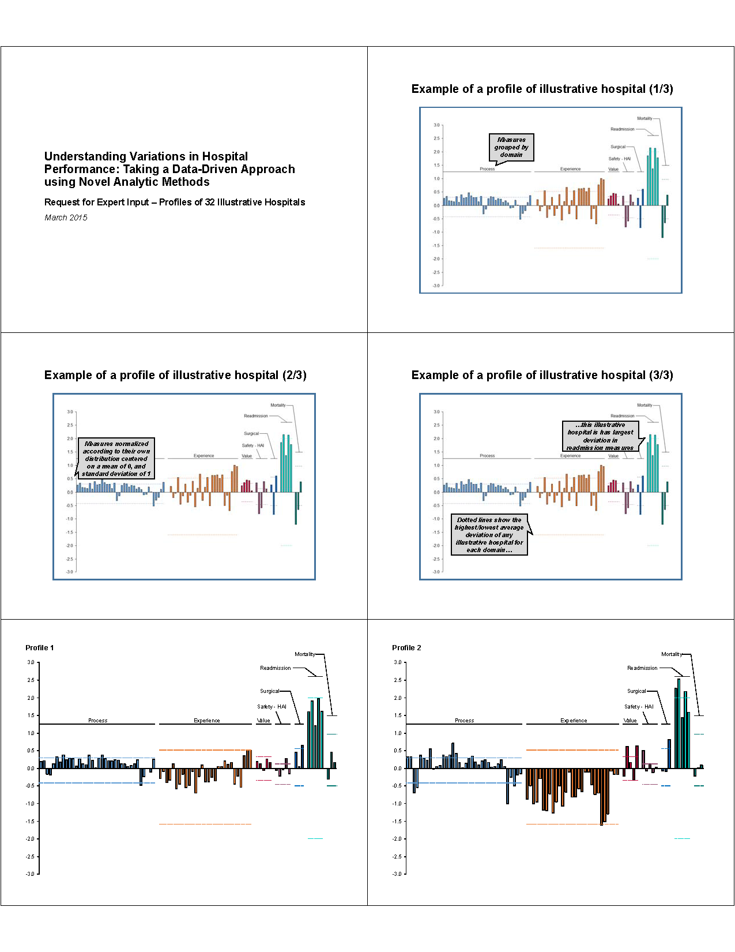

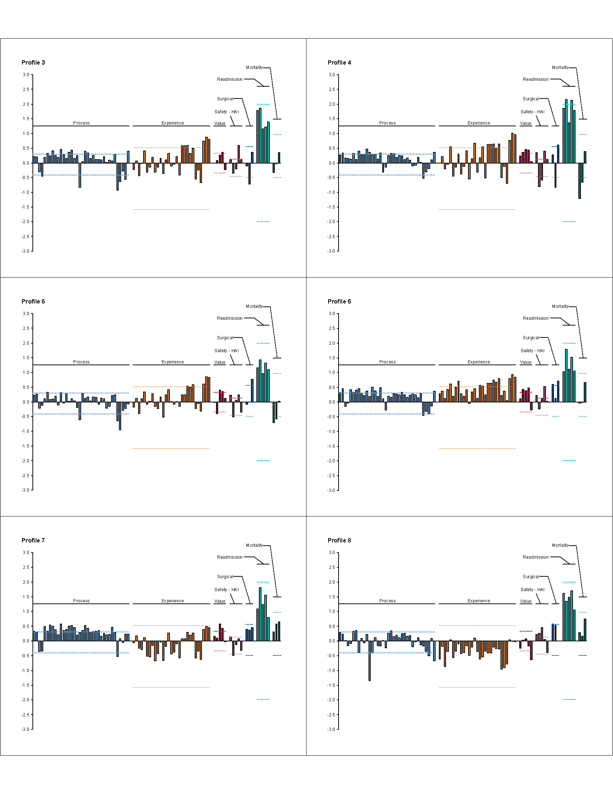

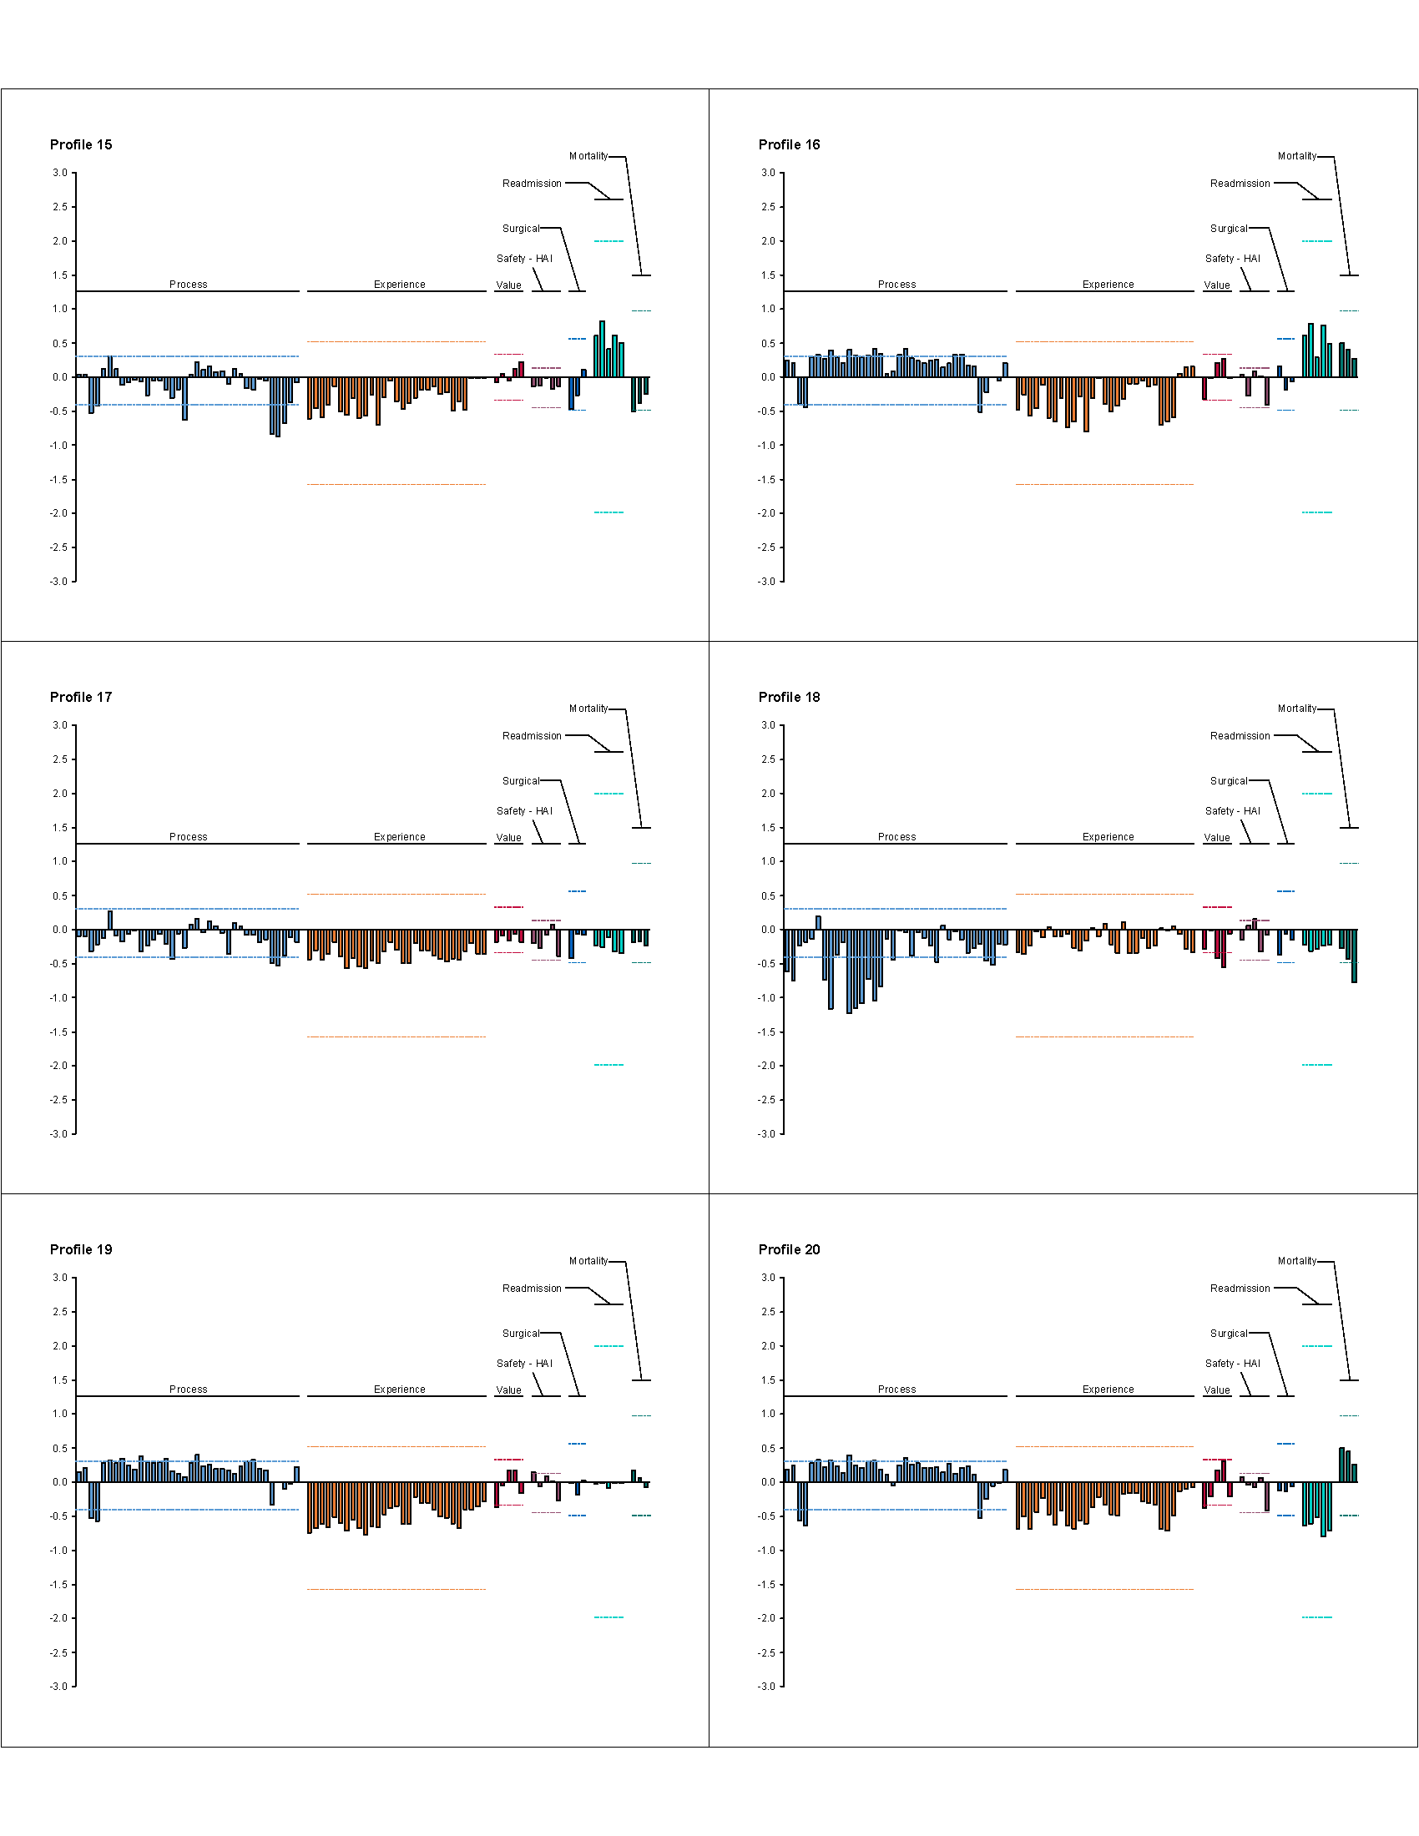

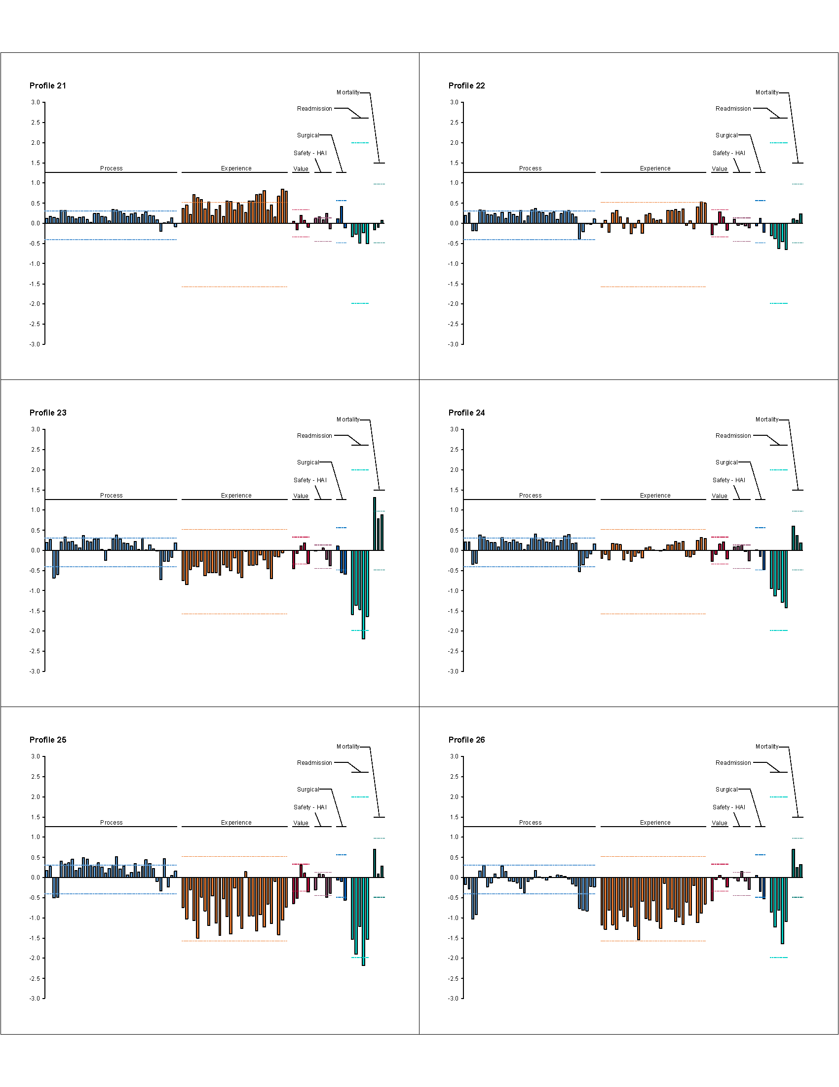

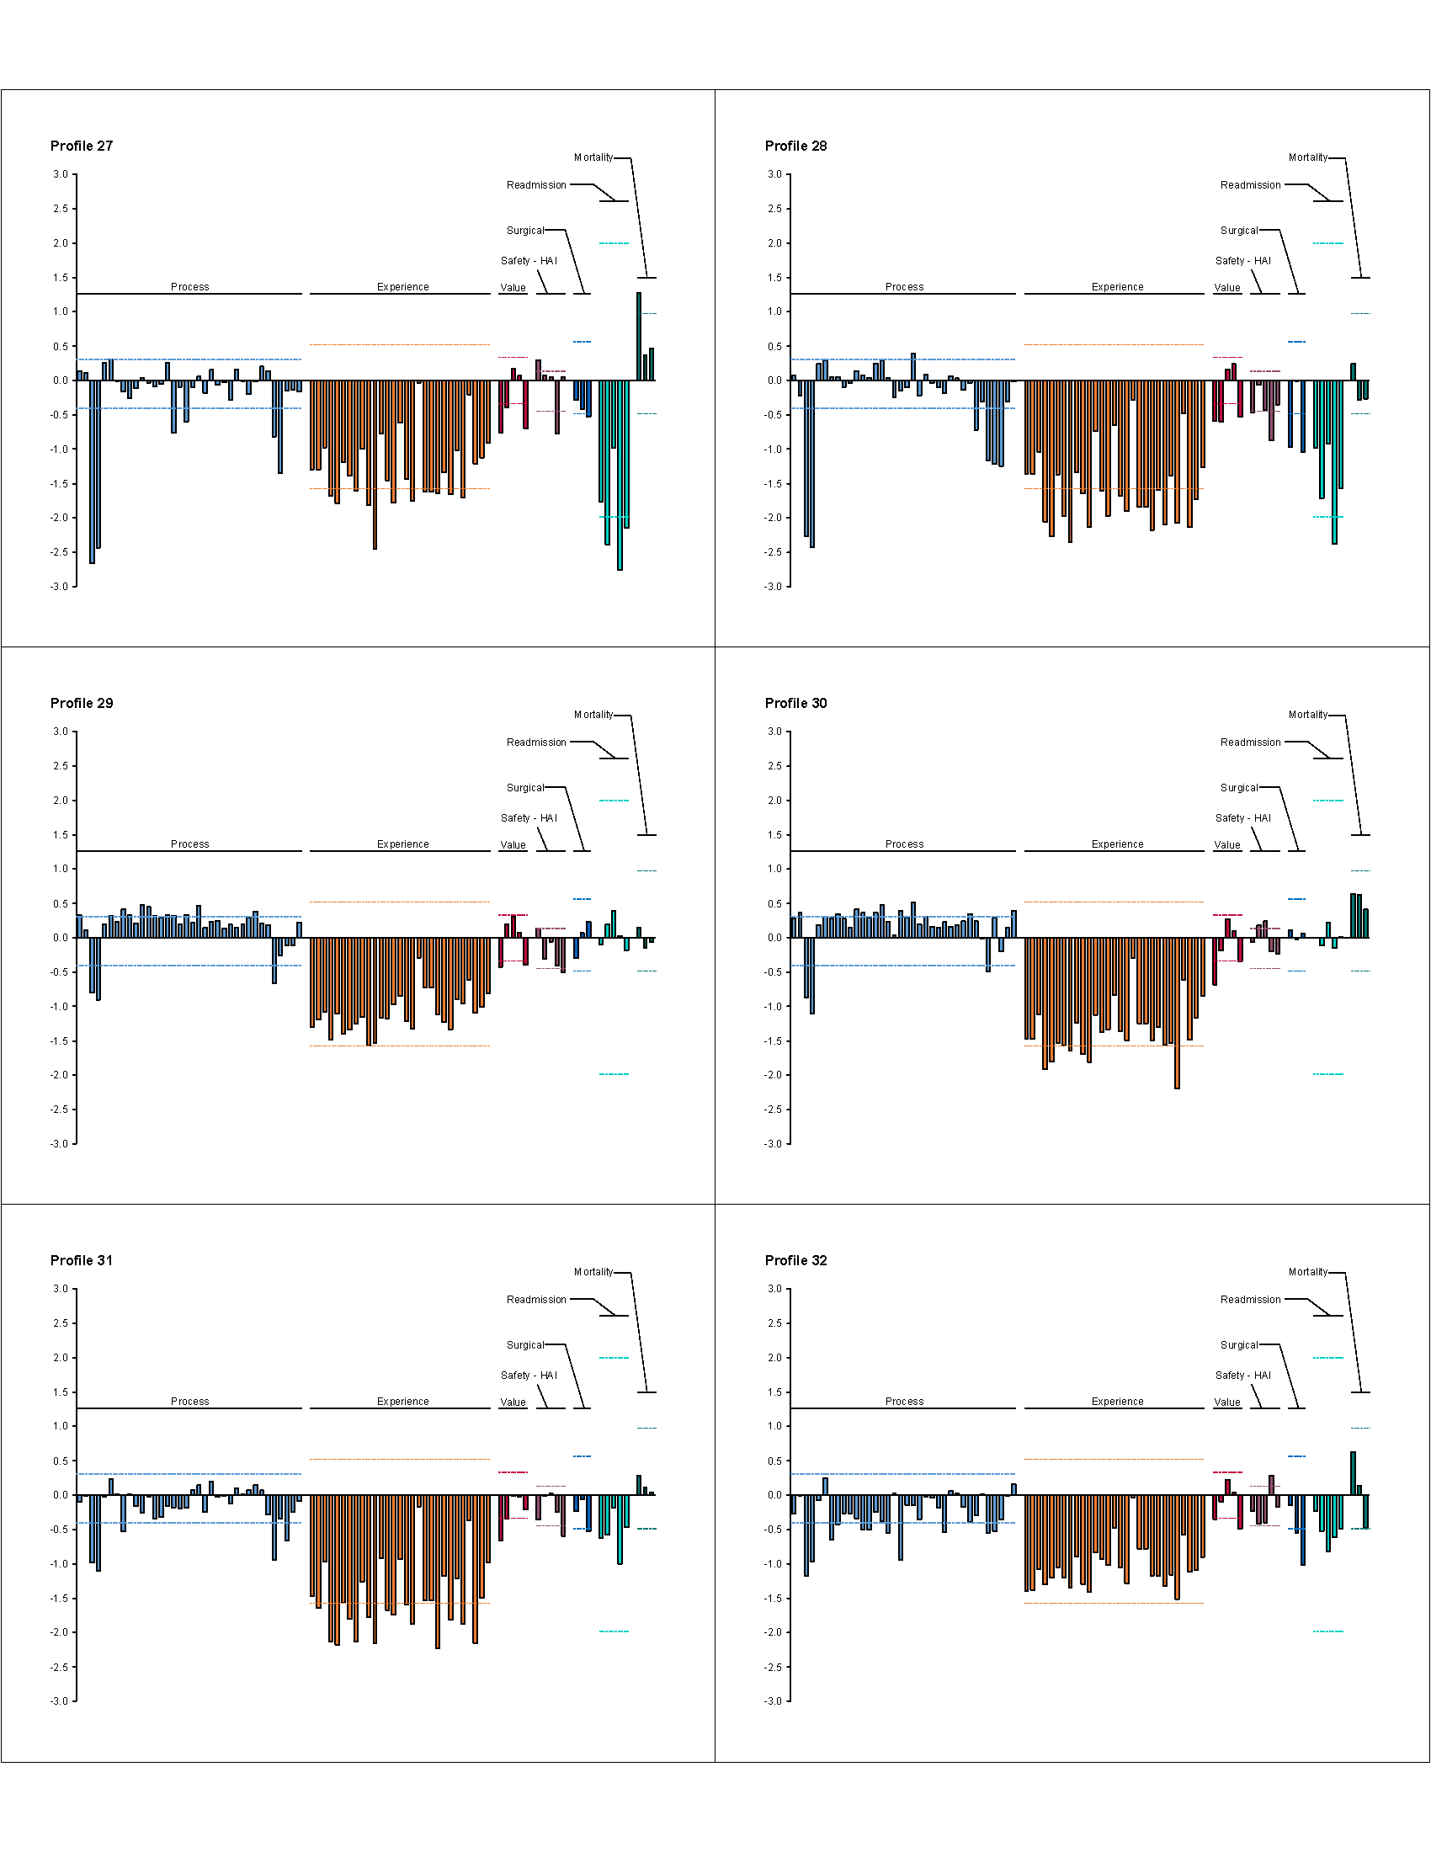

Table A. Excluded measures.
Structural measures
- OP_12: Ability of patients to check labs online
- OP_17: Ability of providers to track patients’ lab results, tests and referrals electronically between visits
- OP_25: Ability of providers to receive lab results electronically
- SM_PART_CARD: Presence of a cardiac surgery registry
- SM_PART_GEN_SURG: Presence of a general surgery registry
- SM_PART_STROKE: Presence of a stroke registry
- ACS_REGISTRY: Acute coronary syndrome registry
Volume of selected outpatient procedures (OP_26_xx measures)
- Gastrointestinal
- Eye
- Nervous system (i.e., CNS injections)
- Musculoskeletal
- Skin
- Genitourinary
- Cardiovascular
- Respiratory
Reported at fewer than 5% of all Medicare hospitals
- AMI_7a: Heart attack patients who got drugs to break up blood clots within 30 minutes of arrival
- OP_1: Median time to fibrinolysis
- OP_2: Outpatients with chest pain or possible heart attack who got fibrinolytic therapy within 30 minutes of arrival
- CAC_1: Children who received reliever medication while hospitalized for asthma
- CAC_2: Children who received systemic corticosteroid medication (oral and IV medication that reduces inflammation and controls symptoms) while hospitalized for asthma
- CAC_3: Children and their caregivers who received a home management plan of care document while hospitalized for asthma

Table B. Characteristics of hospitals, the demographics of their hospital services areas and high performers in existing rating systems.
 | U.S. Hospitals  (N=4665) | Sample  (N=1609)*
Hospital characteristics – no (%)
Region
Northeast | 577 (12.4%) | 313 (19.5%)
South | 1378 (29.5%) | 406 (25.2%)
Midwest | 1745 (37.4%) | 594 (36.9%)
West | 914 (19.6%) | 296 (18.4%)
Other† | 51 (1.1%) | 0 (0.0%)
Location
Urban | 3536 (75.8%) | 1600 (99.4%)
Rural | 1129 (24.2%) | 9 (0.6%)
Critical Access Hospital
Yes | 1251 (26.8%) | 0 (0.0%)
No | 3414 (73.2%) | 1609 (100.0%)
Size
<100 beds | 2351 (50.4 %) | 58 (3.6%)
100-200 beds | 974 (20.9 %) | 424 (26.4%)
200-300 beds | 552 (11.8%) | 421 (26.2%)
300-400 beds | 332 (7.1%) | 283 (17.6%)
≥400 beds | 456 (9.8%) | 423 (26.3%)
Teaching hospital
Yes | 1231 (26.4%) | 792 (49.2%)
No | 3434 (73.6%) | 817 (50.8%)

Hospital service areas characteristics
Proportion of population that is racial minority – median (IQR) | 15.8% (6.8%-30.2%) | 21.1% (11.5%-33.5%)
Average household income – median (IQR) | $48,954 ($41,724 -$57,926) | $54,219 ($46,012-$64,233)
High performers in existing hospital rating systems – no (%)
U.S. News and World Report Honor Roll | 17 (0.4%) | 16 (1.0%)
HealthGrades Top 100 | 100 (2.1%) | 93 (5.8%)
Consumer Reports | 116 (2.5%) | 36 (2.2%)
Leapfrog “A” Grade | 83 (1.8%) | 31 (1.9%)

*5 hospitals included in our sample were not listed in the 2013 American Hospital Association Annual Survey and could not be included in this table.
† Puerto Rico, Guam, Virgin Islands, and American Samoa

Table C. Definition of top ranked hospitals under four existing rating systems.
Rating system | Definition of “high performer”
Leapfrog | Recipient of Leapfrog Top Hospital award in 2014 (http://www.leapfroggroup.org/TopHospitals)
U.S. News and World Report | Listed on the U.S. News Honor Roll 2014-2015 (http://health.usnews.com/health-news/best-hospitals/articles/2014/07/15/best-hospitals-2014-15-overview-and-honor-roll)
Consumer Reports | Hospitals achieving a safety score of > 65, which corresponds to 2 standard deviations above the mean (http://www.consumerreports.org/health/doctors-hospitals/hospital-ratings.htm)
HealthGrades | America’s 100 Best Hospitals in 2014 (http://www.healthgrades.com/quality/2014-healthgrades-americas-best-hospitals-report)
Adapted from definition presented by Austin MJ et al. Health Affairs 2015;34(3):423-430.
Captions for 2 Movies:
Two movies of the diffusion map have been produced. In these, each point represents an individual hospital. The distance between points reflects the similarity of their underlying performance profiles.
Movie A. Overall diffusion map.
Movie B. Diffusion map in which each hospital is shaded according to its assigned neighborhood and the central hospital in each neighborhood is circled.

