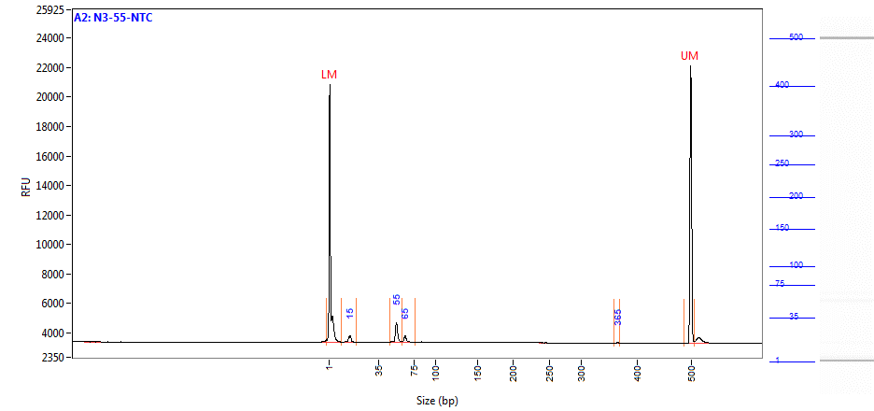
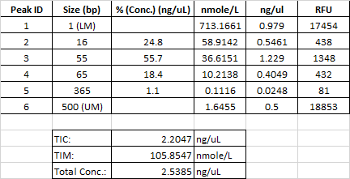

S6 Figure. Capillary electrophoresis analysis of EUA-kit N3 NTC RT-PCR products. Fragment Analyzer detection of a residual primers/probes at ~15 bp, as well as putative homo- and hetero-duplex molecules at 55 bp and 65 bp.

