Supplementary Figure S4: Expression of adipogenic markers in MSC derived from donor 3 during differentiation upon adipogenic conditions.

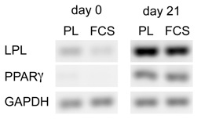

mRNA expression of GAPDH and the differentiation marker genes lipoproteinlipase (LPL) and peroxisome proliferator activated receptor γ (PPARγ) were studied in undifferentiated MSC at day 0 and after differentiation at day 21. MSC were isolated in complete medium CMSSP supplemented with 10% platelet lysate (PL) or with 10% fetal calf serum (FCS).

