Supporting information

Structure analysis and conformational transitions of the cell penetrating peptide transportan 10 in the membrane-bound state

Susanne Fanghänel,†,‡ Parvesh Wadhwani,§,‡ Erik Strandberg,§ Wouter P. R. Verdurmen,‖ Jochen Bürck,§ Sebastian Ehni,† Pavel K. Mykhailiuk,┴ Sergii Afonin,§ Dagmar Gerthsen,# Igor V. Komarov,¶ Roland Brock,‖ Anne S. Ulrich*,†,§
‡Susanne Fanghänel and Parvesh Wadhwani contributed equally to this work.
†Karlsruhe Institute of Technology (KIT), Institute of Organic Chemistry and DFG-Center for Functional Nanostructures (CFN), Karlsruhe, Germany
§KIT, Institute of Biological Interfaces (IBG2), Karlsruhe, Germany
‖Department of Biochemistry, Radboud Institute for Molecular Life Sciences, Radboud University Medical Centre, Nijmegen, The Netherlands
┴Taras Shevchenko National University of Kyiv, Chemistry Department, Kyiv, Ukraine and Enamine Ltd., Kyiv, Ukraine
#KIT, Laboratory for Electron Microscopy, Karlsruhe, Germany
¶Taras Shevchenko National University of Kyiv, Institute of High Technologies, Kyiv, Ukraine

TABLES AND FIGURES

Table S1: Sequences and LC-MS characterization of TP10-WT and the analogues labeled with L-CF₃-Bpg and with an additional carboxyfluorescein (CF). (Equivalent data were obtained for the D-epimers).
Peptide | Sequence | Mass  calculated | Mass  found
TP10-WT | AGYLLGKINLKALAALAKKIL-NH₂ | 2182 | 2183
Gly2 → L-CF₃-Bpg | A CF₃-Bpg YLLGKINLKALAALAKKIL-NH₂ | 2316 | 2316
Leu4 → L-CF₃-Bpg | AGY CF₃-Bpg LGKINLKALAALAKKIL-NH₂ | 2260 | 2260
Leu5 → L-CF₃-Bpg | AGYL CF₃-Bpg GKINLKALAALAKKIL-NH₂ | 2260 | 2260
Ile8 → L-CF₃-Bpg | AGYLLGK CF₃-Bpg NLKALAALAKKIL-NH₂ | 2260 | 2260
Leu10 → L-CF₃-Bpg | AGYLLGKIN CF₃-Bpg KALAALAKKIL-NH₂ | 2260 | 2260
Leu13 → L-CF₃-Bpg | AGYLLGKINLKA CF₃-Bpg AALAKKIL-NH₂ | 2260 | 2261
Leu16 → L-CF₃-Bpg | AGYLLGKINLKALAA CF₃-Bpg AKKIL-NH₂ | 2260 | 2260
Ile20 → L-CF₃-Bpg | AGYLLGKINLKALAALAKK CF₃-Bpg L-NH₂ | 2260 | 2260
Leu21 → L-CF₃-Bpg | AGYLLGKINLKALAALAKKI CF₃-Bpg -NH₂ | 2260 | 2260
CF-TP10-WT | CF-AGYLLGKINLKALAALAKKIL-NH₂ | 2540 | 2541
Gly2 → CF-L-CF₃-Bpg | CF-A CF₃-Bpg YLLGKINLKALAALAKKIL-NH₂ | 2674 | 2675
Leu4 → CF-L-CF₃-Bpg | CF-AGY CF₃-Bpg LGKINLKALAALAKKIL-NH₂ | 2618 | 2619
Leu5 → CF-L-CF₃-Bpg | CF-AGYL CF₃-Bpg GKINLKALAALAKKIL-NH₂ | 2618 | 2619
Ile8 → CF-L-CF₃-Bpg | CF-AGYLLGK CF₃-Bpg NLKALAALAKKIL-NH₂ | 2618 | 2619
Leu10 → CF-L-CF₃-Bpg | CF-AGYLLGKIN CF₃-Bpg KALAALAKKIL-NH₂ | 2618 | 2619
Leu13 → CF-L-CF₃-Bpg | CF-AGYLLGKINLKA CF₃-Bpg AALAKKIL-NH₂ | 2618 | 2619
Leu16 → CF-L-CF₃-Bpg | CF-AGYLLGKINLKALAA CF₃-Bpg AKKIL-NH₂ | 2618 | 2619
Ile20 → CF-L-CF₃-Bpg | CF-AGYLLGKINLKALAALAKK CF₃-Bpg L-NH₂ | 2618 | 2619
Leu21 → CF-L-CF₃-Bpg | CF-AGYLLGKINLKALAALAKKI CF₃-Bpg -NH₂ | 2618 | 2619

Table S2: Comparison of the ¹⁹F-NMR dipolar couplings of the L-CF₃-Bpg labeled TP10 analogs with and without the fluorescent carboxyfluorescein label in oriented DMPC/DMPG bilayers (P/L=1:200), measured at 0° and 90° sample tilt.
Peptide | Dipolar coupling [kHz]
 | Without CF-label |  | With CF-label
 | 0° | 90° | 0° | 90°
Gly2 → L-CF₃-Bpg* | -7.5 | -7.5 | na** | na**
Leu4 → L-CF₃-Bpg | 5.6 | -2.6 | 6.8 | -3.4
Leu5 → L-CF₃-Bpg | 4.9 | -2.4 | 1.1 | 0.7
Ile8 → L-CF₃-Bpg | 7.9 | -4.1 | 9.3 | -4.3
Leu10 → L-CF₃-Bpg | 0.9 | -0.4 | 0.9 | -0.4
Leu13 → L-CF₃-Bpg | 7.6 | -3.6 | 8.3 | -4.0
Leu16 → L-CF₃-Bpg | 3.3 | -1.6 | 3.3 | -1.6
Ile20 → L-CF₃-Bpg | 7.3 | -3.4 | 7.6 | -3.5
Leu21 → L-CF₃-Bpg | 2.0 | -1.1 | 2.7 | -0.9
* unlike all other analogs, the peptide labeled at Gly2 was not rotationally mobile
** not accessible

Table S3: Dipolar couplings of the L-CF₃-Bpg labeled TP10 analogs in oriented DMPC/DMPG bilayers, measured at 0° and 90° sample tilt, at P/L=1:50, 1:200, and 1:400.
Peptide | Dipolar coupling [kHz]
P/L ratio |  | 1:50 |  |  | 1:200 |  | 1:400
Sample tilt | 0° |  | 90° | 0° |  | 90° |  | 0° | 90°
Gly2 → L-CF₃-Bpg | -7.5 |  | -7.5 | -7.5 |  | -7.5 |  | 6.7 | -3.1
Leu4 → L-CF₃-Bpg | 5.5 |  | -2.7 | 5.6 |  | -2.6 |  | 5.5 | -2.8
Leu5 → L-CF₃-Bpg | 4.5 |  | -2.1 | 4.9 |  | -2.4 |  | 4.4 | -2.3
Ile8 → L-CF₃-Bpg | 7.8 |  | -3.7 | 7.9 |  | -4.1 |  | 7.8 | -4.0
Leu10 → L-CF₃-Bpg | 0.6 |  | -0.2 | 0.9 |  | -0.4 |  | 0.9 | -0.4
Leu13 → L-CF₃-Bpg | -7.5 |  | -7.5 | 7.6 |  | -3.6 |  | 7.6 | -3.3
Leu16 → L-CF₃-Bpg | -7.5 |  | -7.5 | 3.3 |  | -1.6 |  | 3.4 | -1.4
Ile20 → L-CF₃-Bpg | 6.7 |  | -2.9 | 7.3 |  | -3.4 |  | 7.2 | -3.2
Leu21 → L-CF₃-Bpg | 1.9 |  | -1.0 | 2.0 |  | -1.1 |  | 1.8 | -0.9

Table S4: Dipolar couplings of the D-CF₃-Bpg labeled TP10 analogs in oriented DMPC/DMPG bilayers, measured at 0° and 90° sample tilt, at P/L=1:50, 1:200, and 1:400.
Peptide | Dipolar coupling [kHz]
P/L ratio | 1:50 |  | 1:200 |  | 1:400
Sample tilt | 0° | 90° | 0° | 90° | 0° | 90°
Gly2 → D-CF₃-Bpg | 5.3 | -2.4 | 6.0 | -2.3 | 5.4 | -2.9
Leu4 → D-CF₃-Bpg | 9.2 | -4.1 | 9.3 | -4.0 | 9.4 | -4.1
Leu5 → D-CF₃-Bpg | 6.1 | -2.7 | 6.7 | -3.2 | 6.7 | -3.1
Ile8 → D-CF₃-Bpg | 6.4 | -3.0 | 6.4 | -3.1 | 6.5 | -3.7
Leu10 → D-CF₃-Bpg | 9.8 | -4.3 | 9.8 | -4.9 | 10.0 | -4.7
Leu13 → D-CF₃-Bpg | -7.5 | -7.5 | 6.0 | -3.0 | 6.1 | -2.8
Leu16 → D-CF₃-Bpg | -7.5 | -7.5 | -7.5 | -7.5 | -7.5 | -7.5
Ile20 → D-CF₃-Bpg | -7.5 | -7.5 | 8.3 | -3.9 | 8.3 | -3.7
Leu21 → D-CF₃-Bpg | -7.5 | -7.5 | 5.1 | -2.7 | 5.6 | -2.5

Scheme S1: Chemical structure of L-CF₃-Bpg (left) and D-CF₃-Bpg (right).
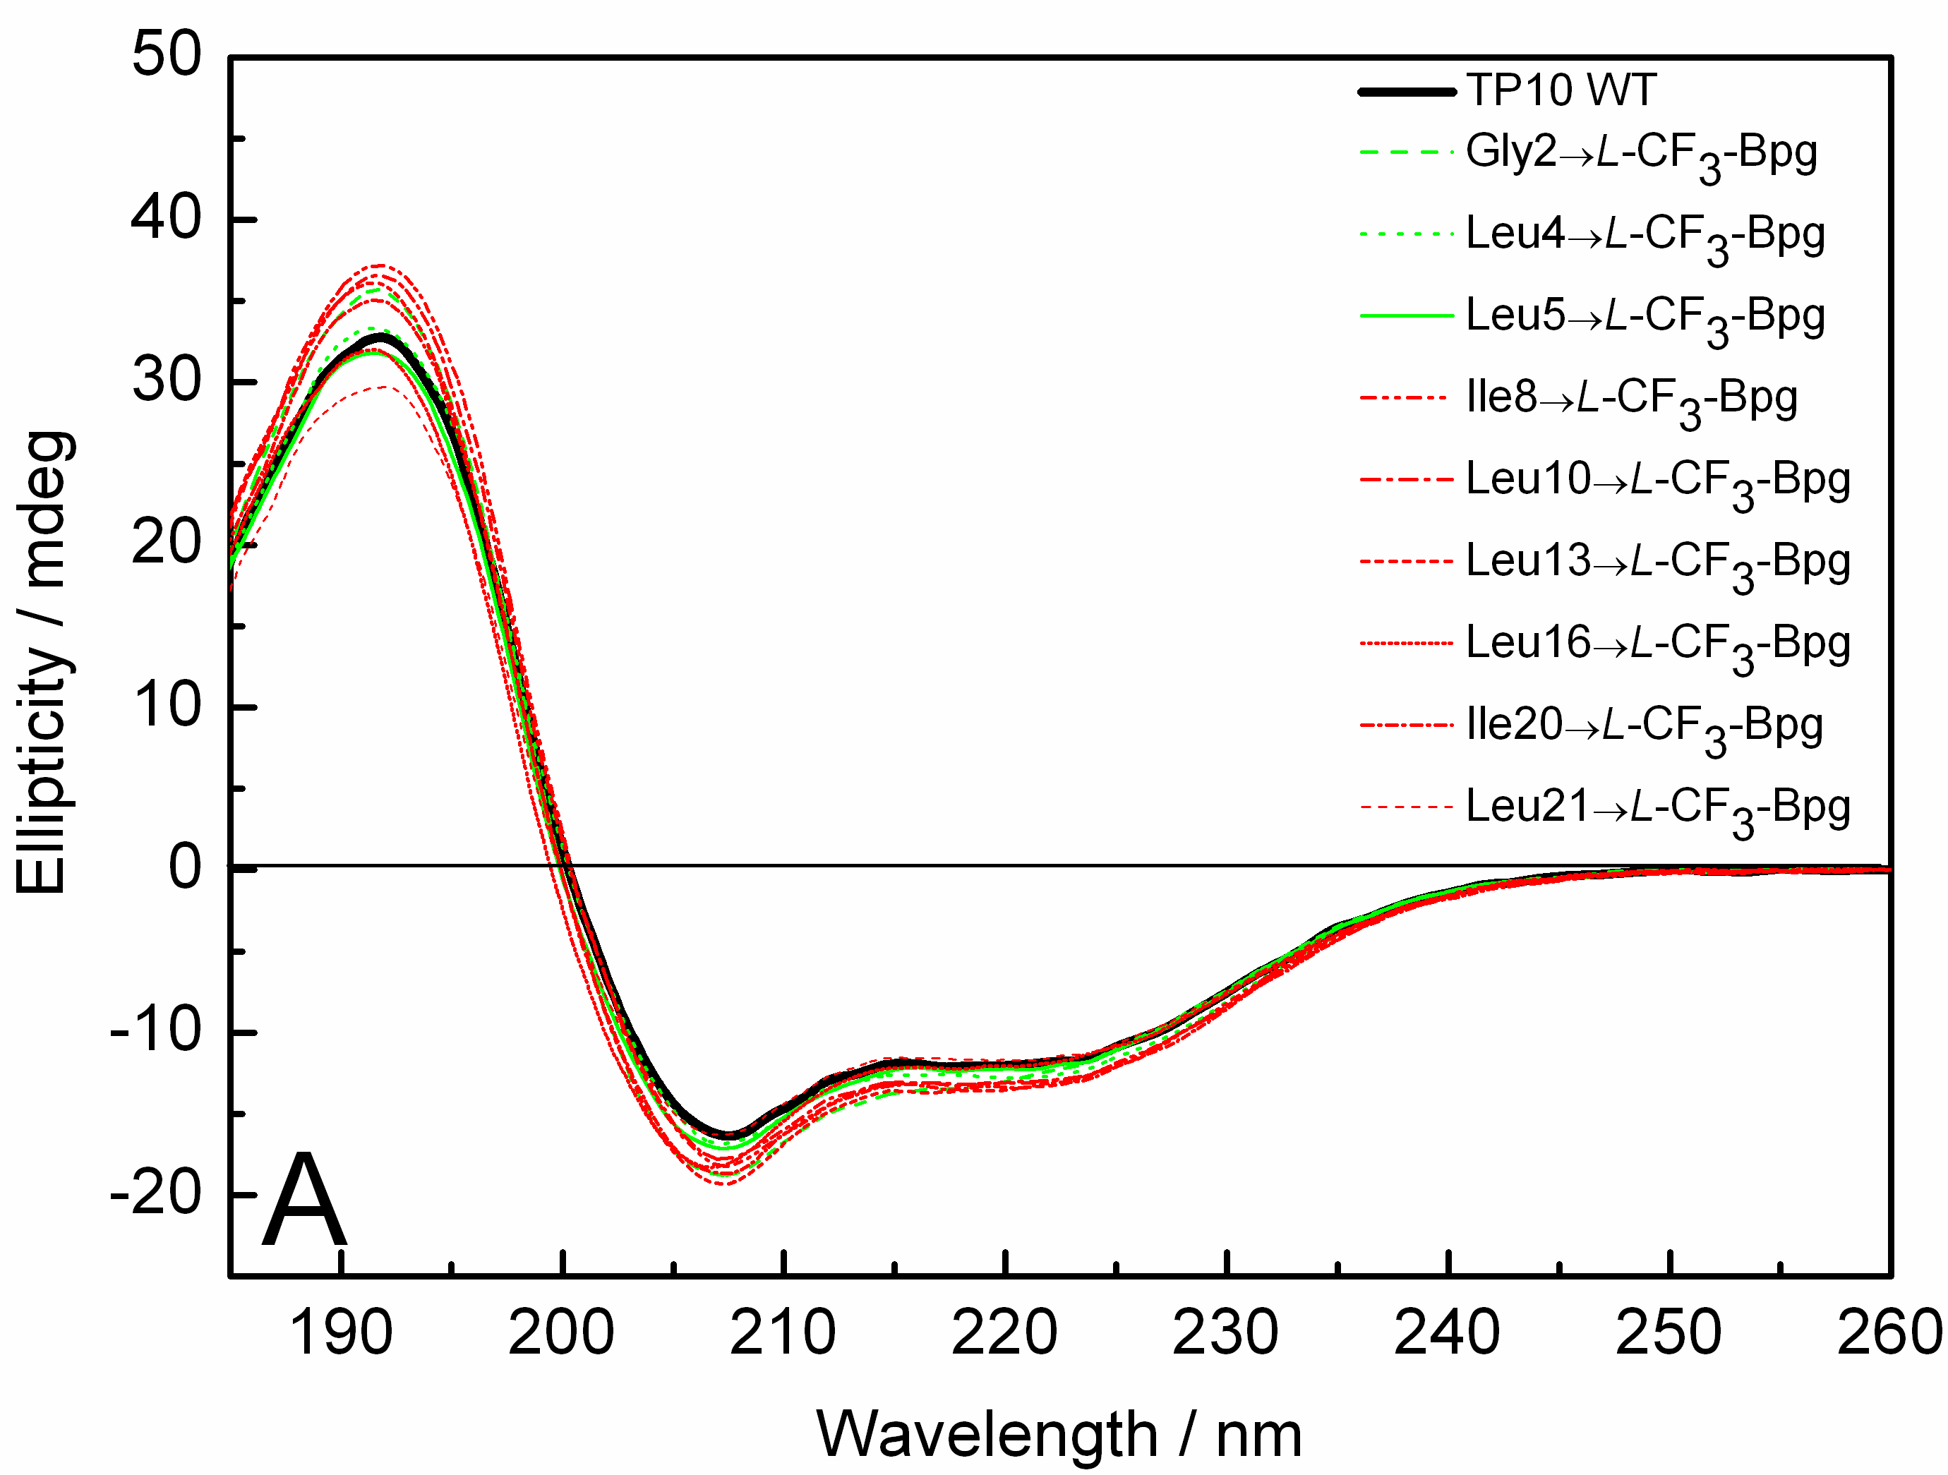
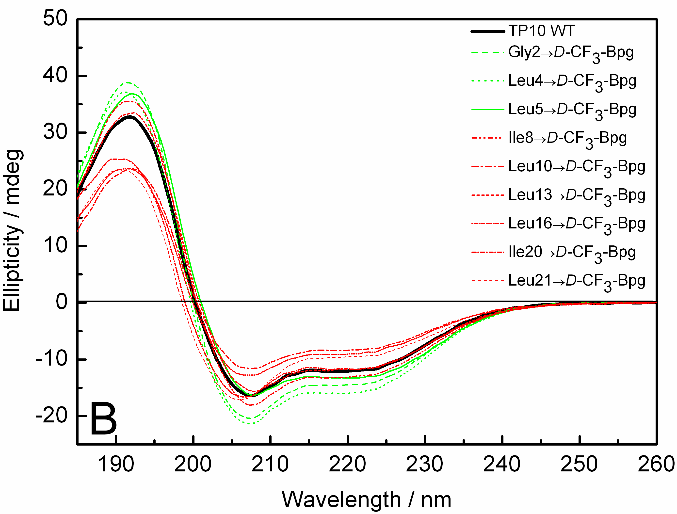
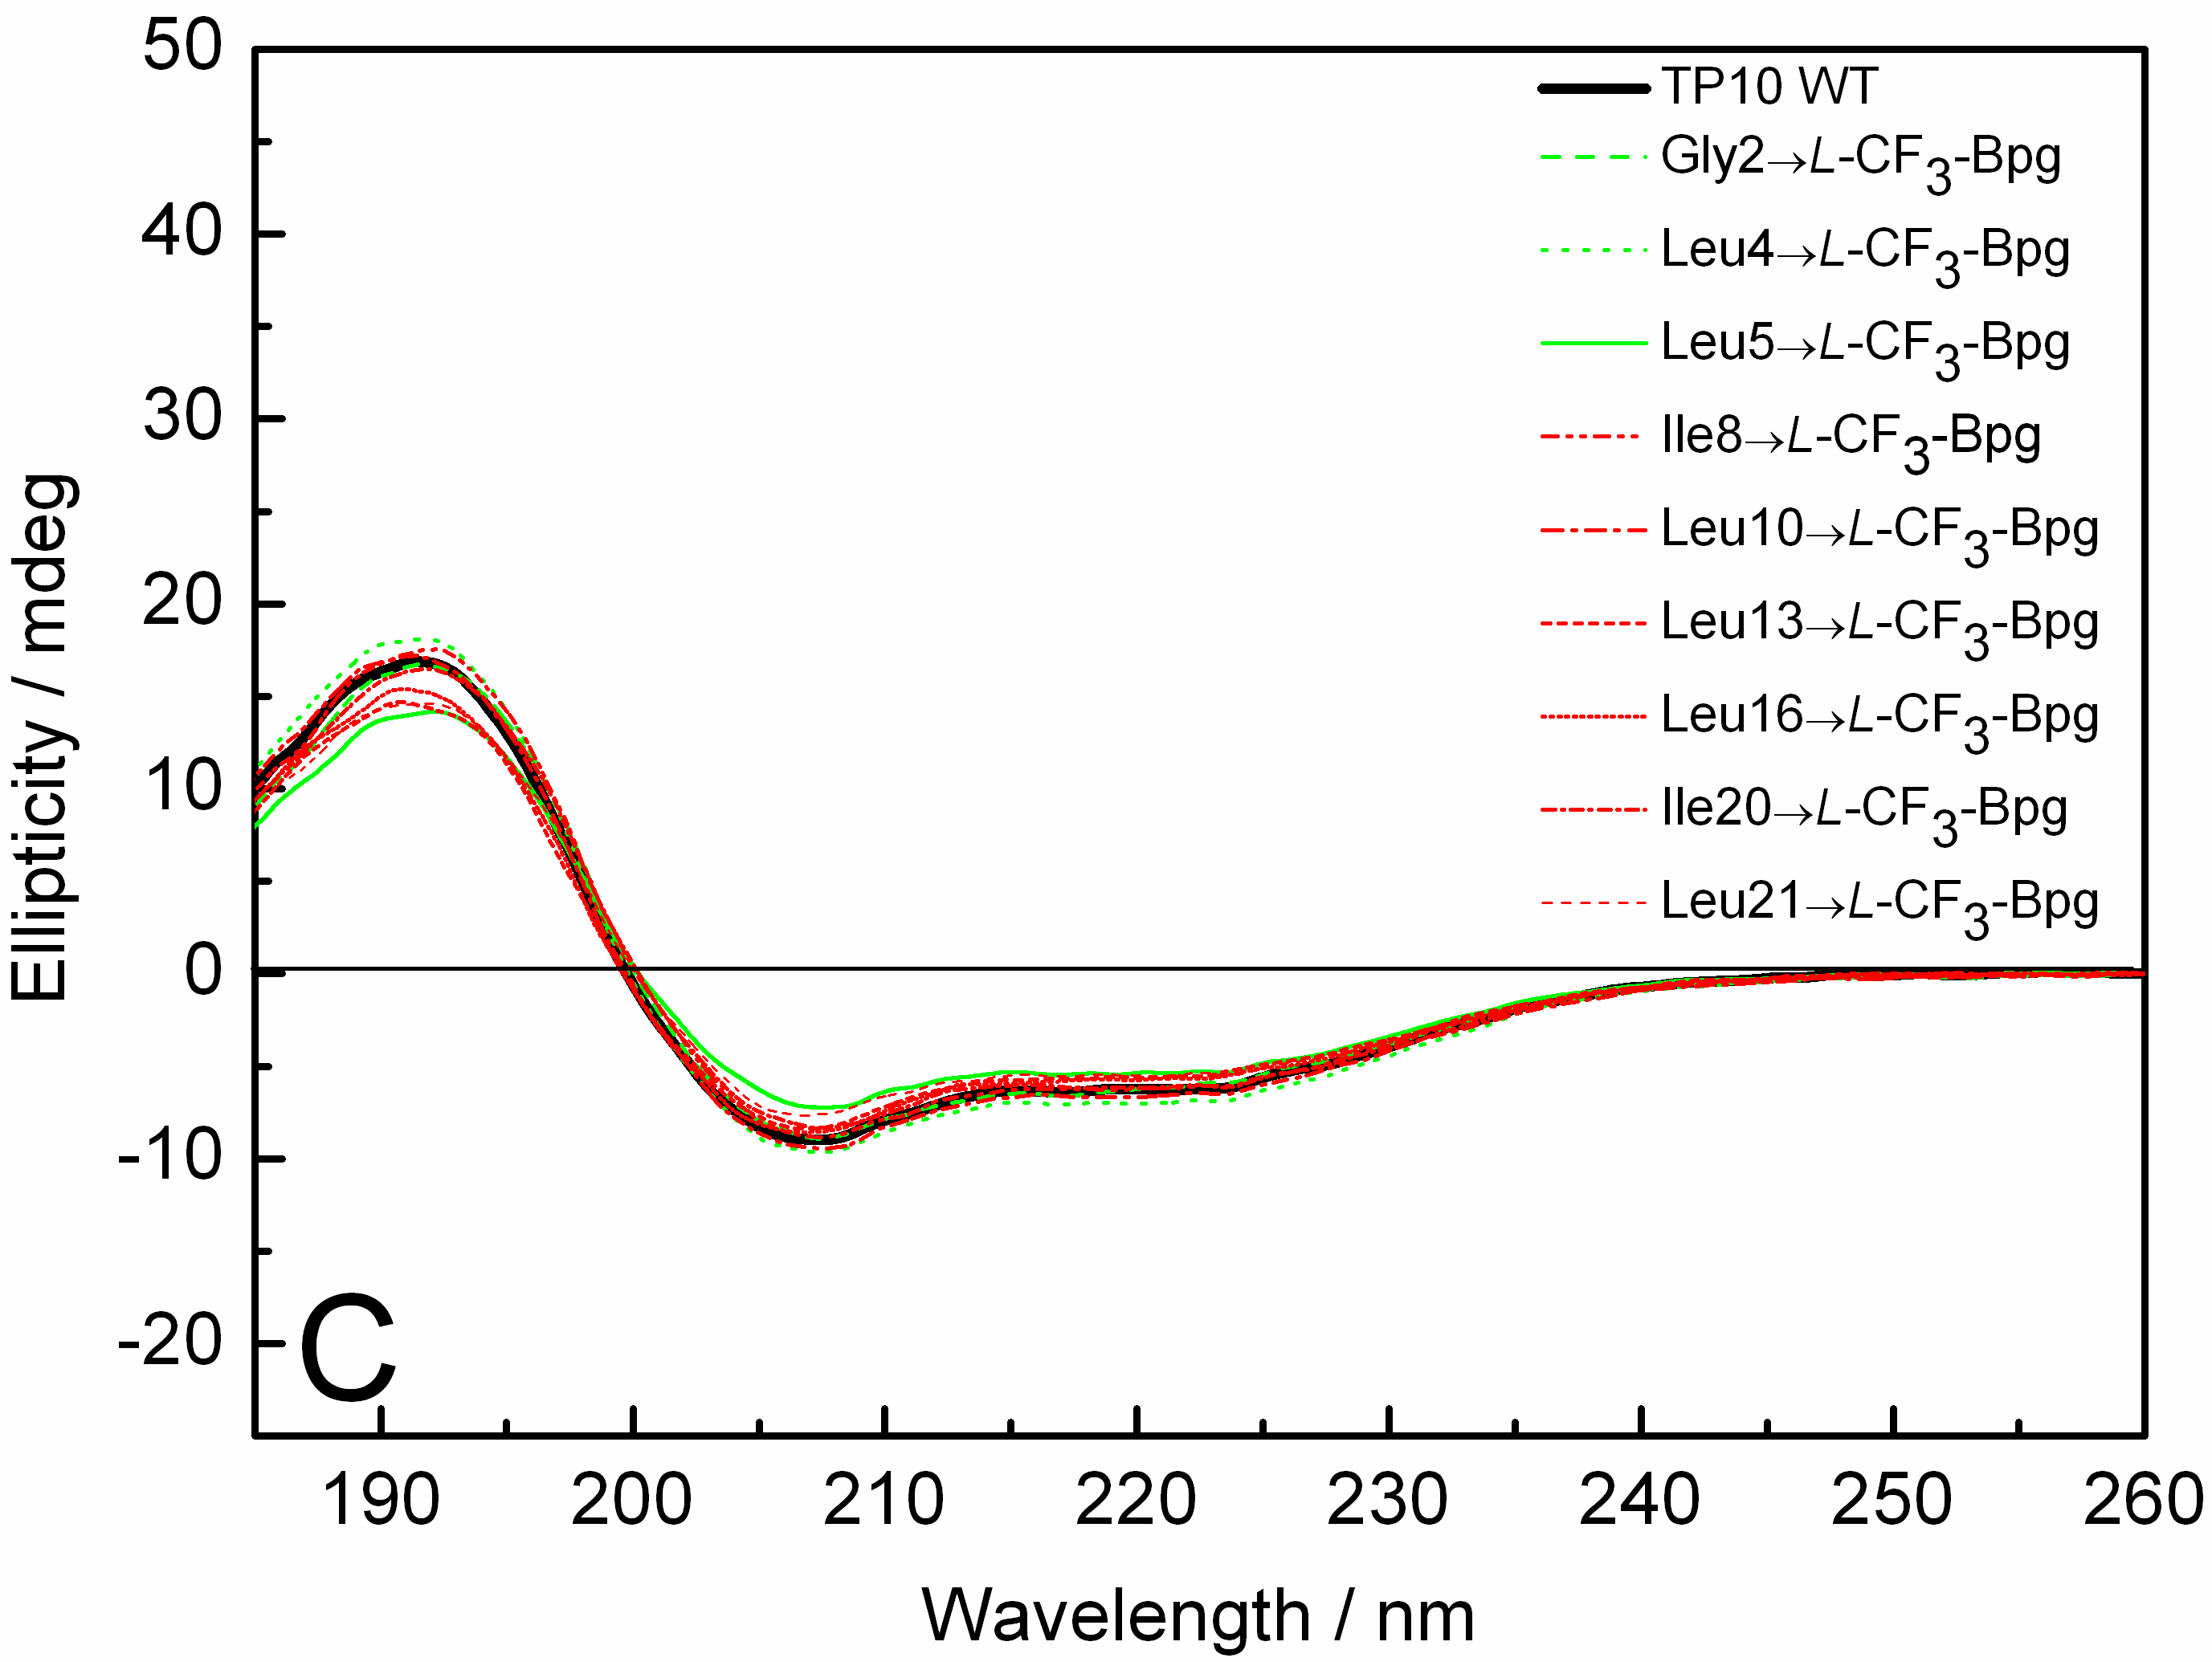
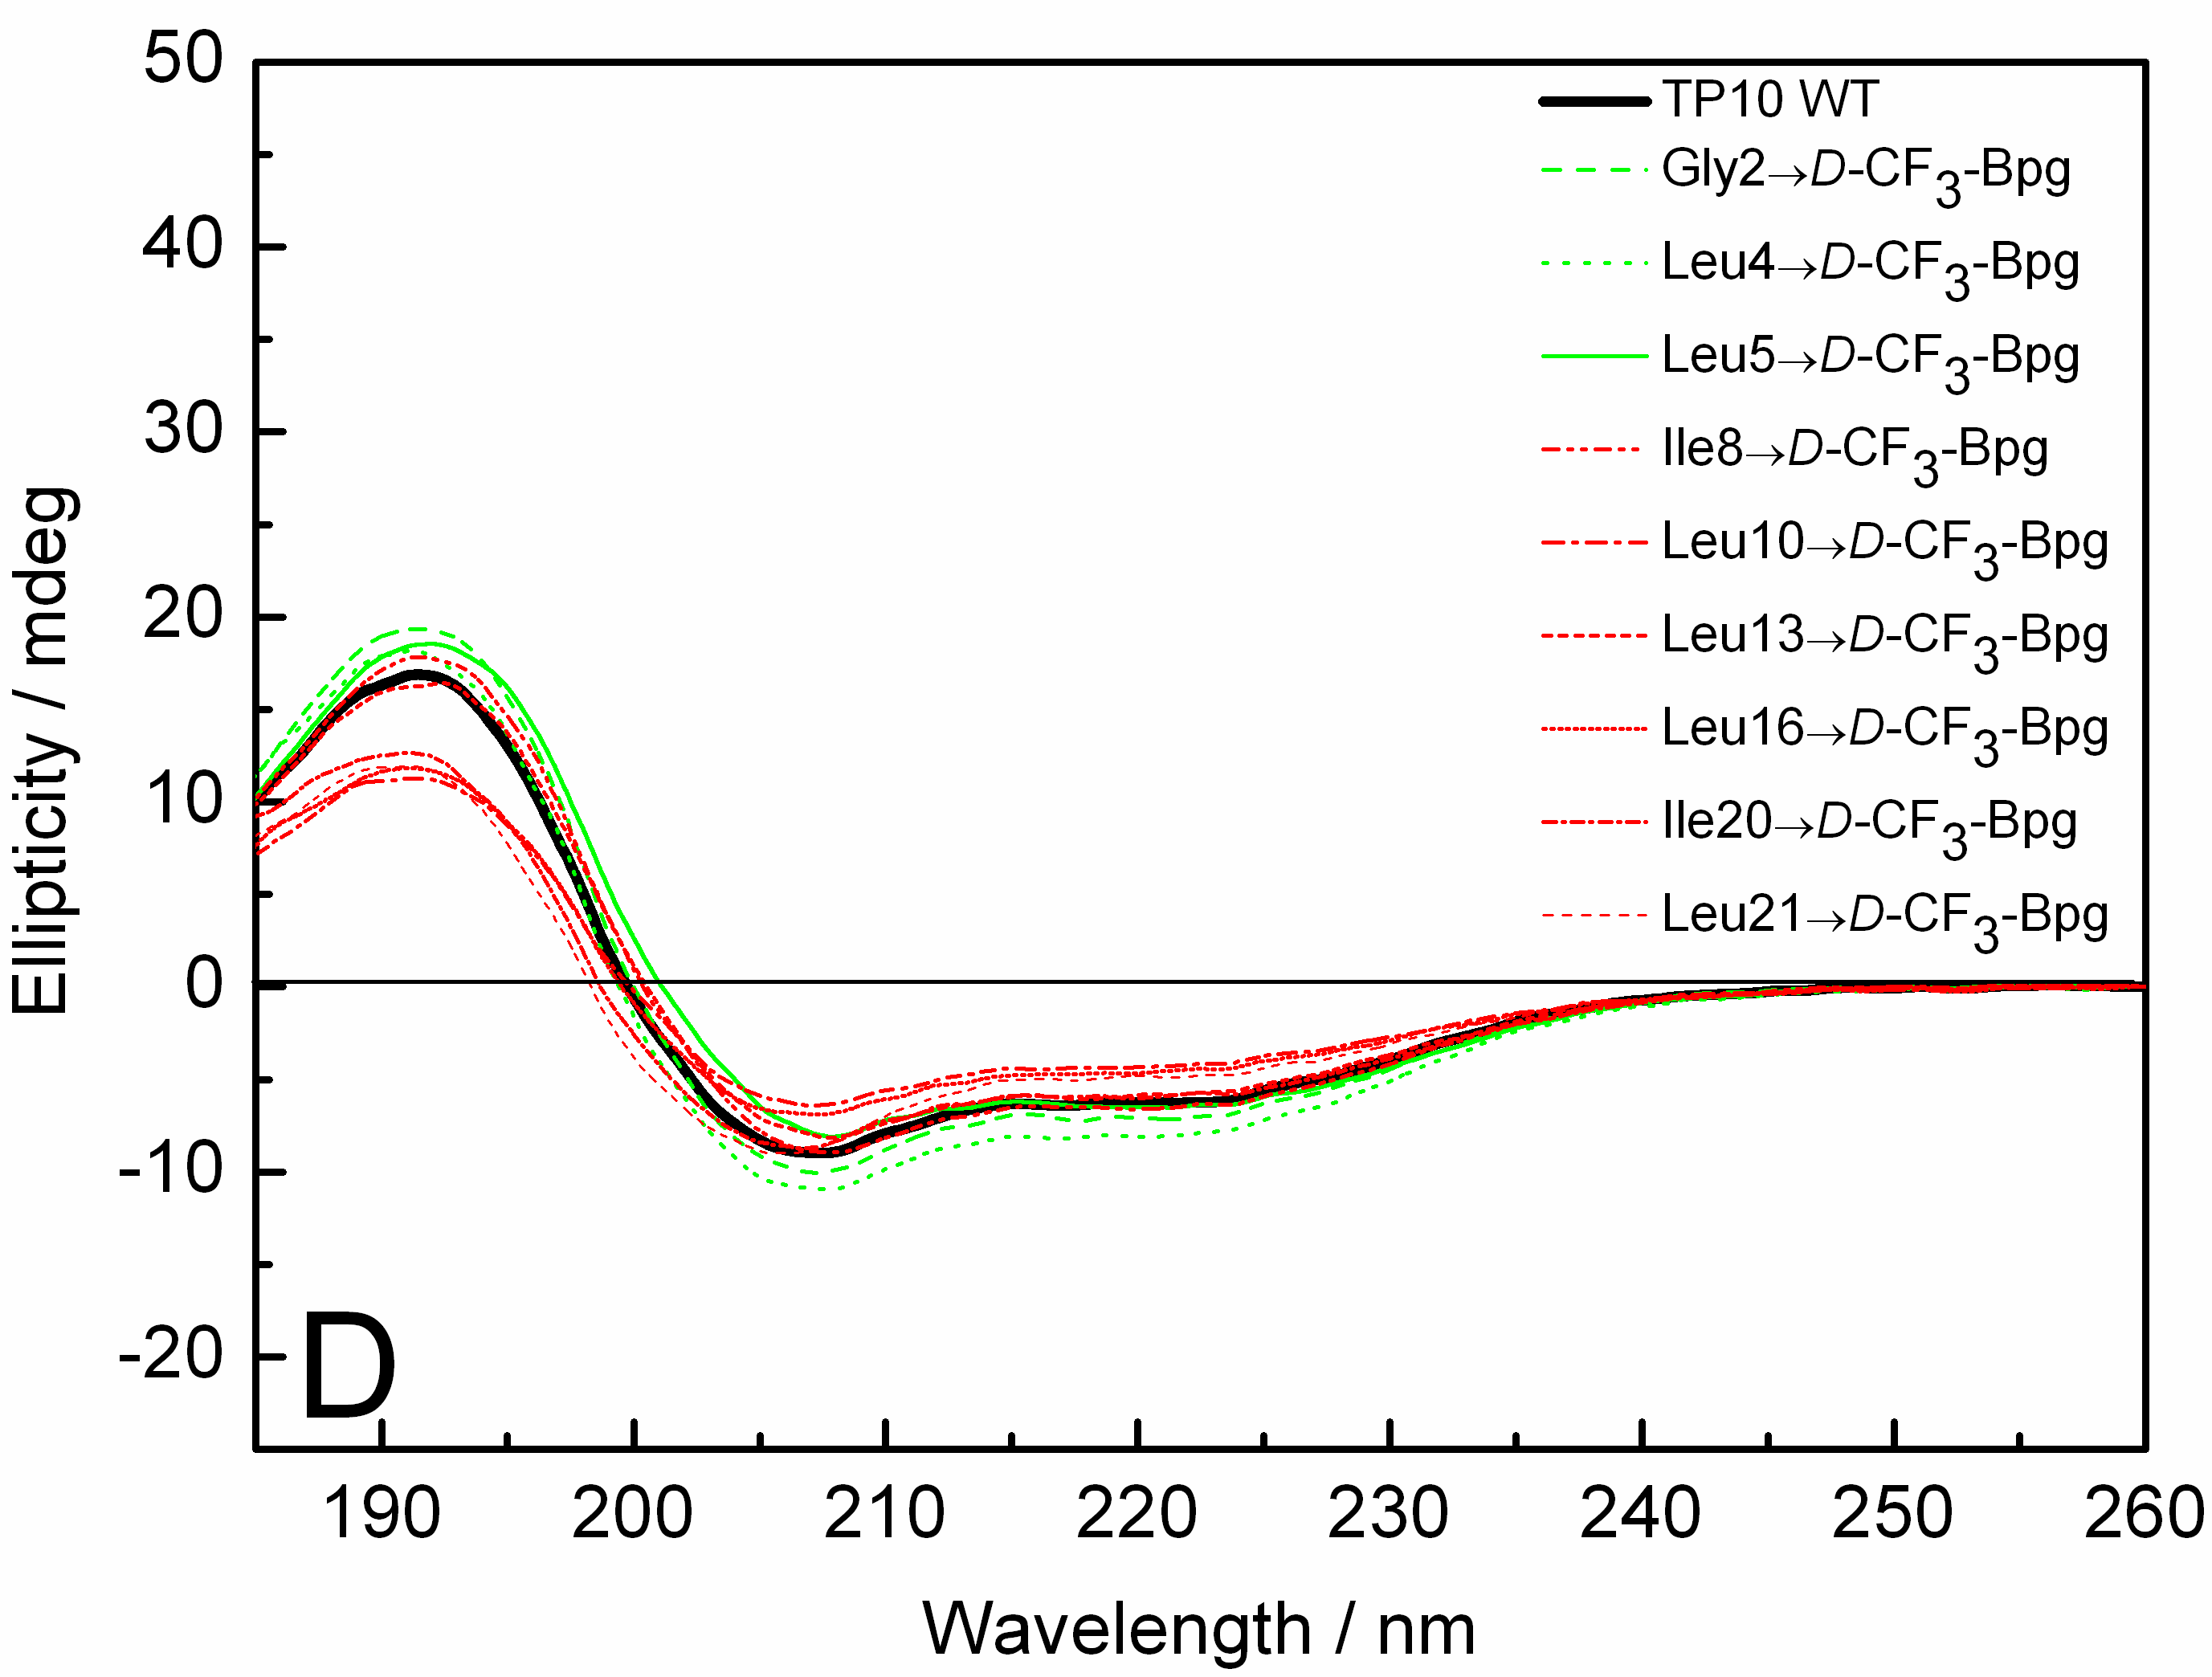

Figure S1: CD spectra of the CF₃-Bpg labeled TP10 analogs bound to DMPC/DMPG vesicles. (A) L- and (B) D-epimers at P/L=1:50. (C) L- and (D) D-epimers at P/L=1:100. The wild type TP10 is shown as a black line; green lines show analogs with CF₃-Bpg labels in the galanin part, and red lines in the mastoparan part.

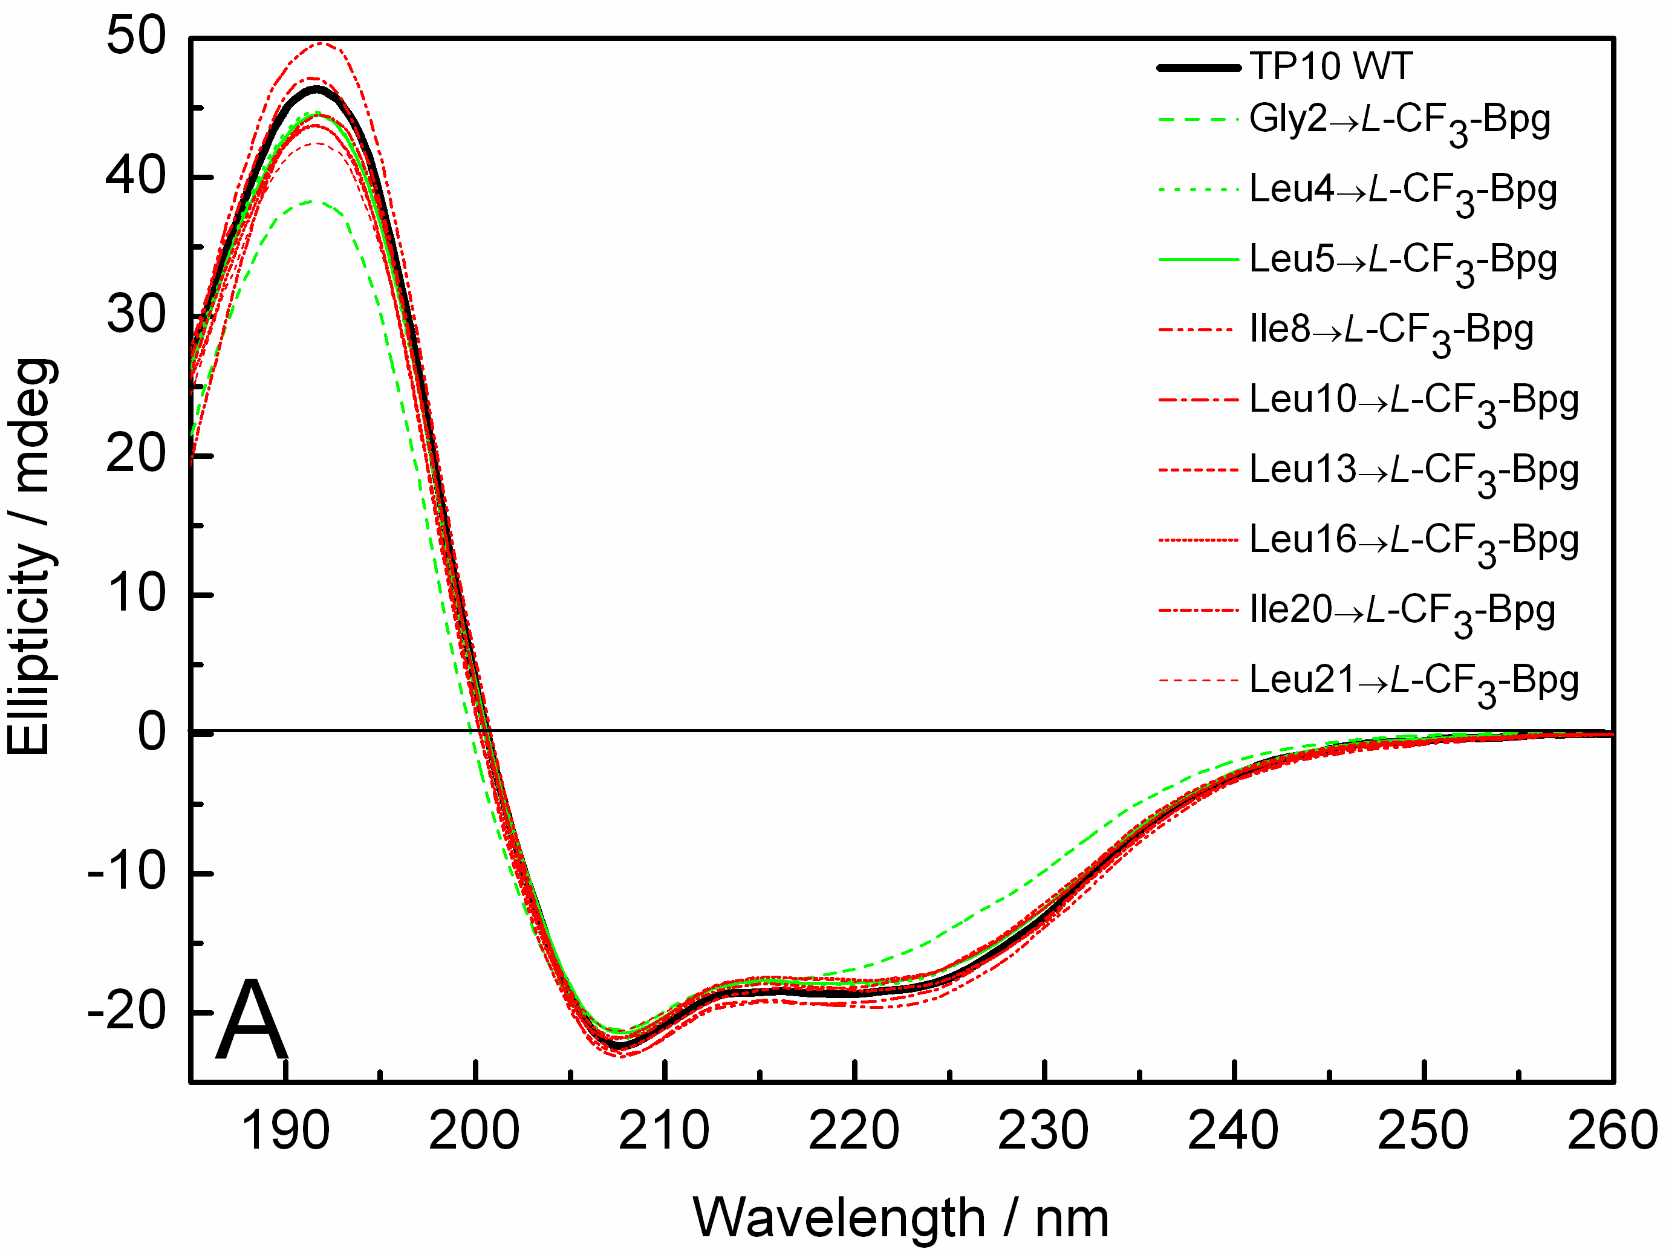
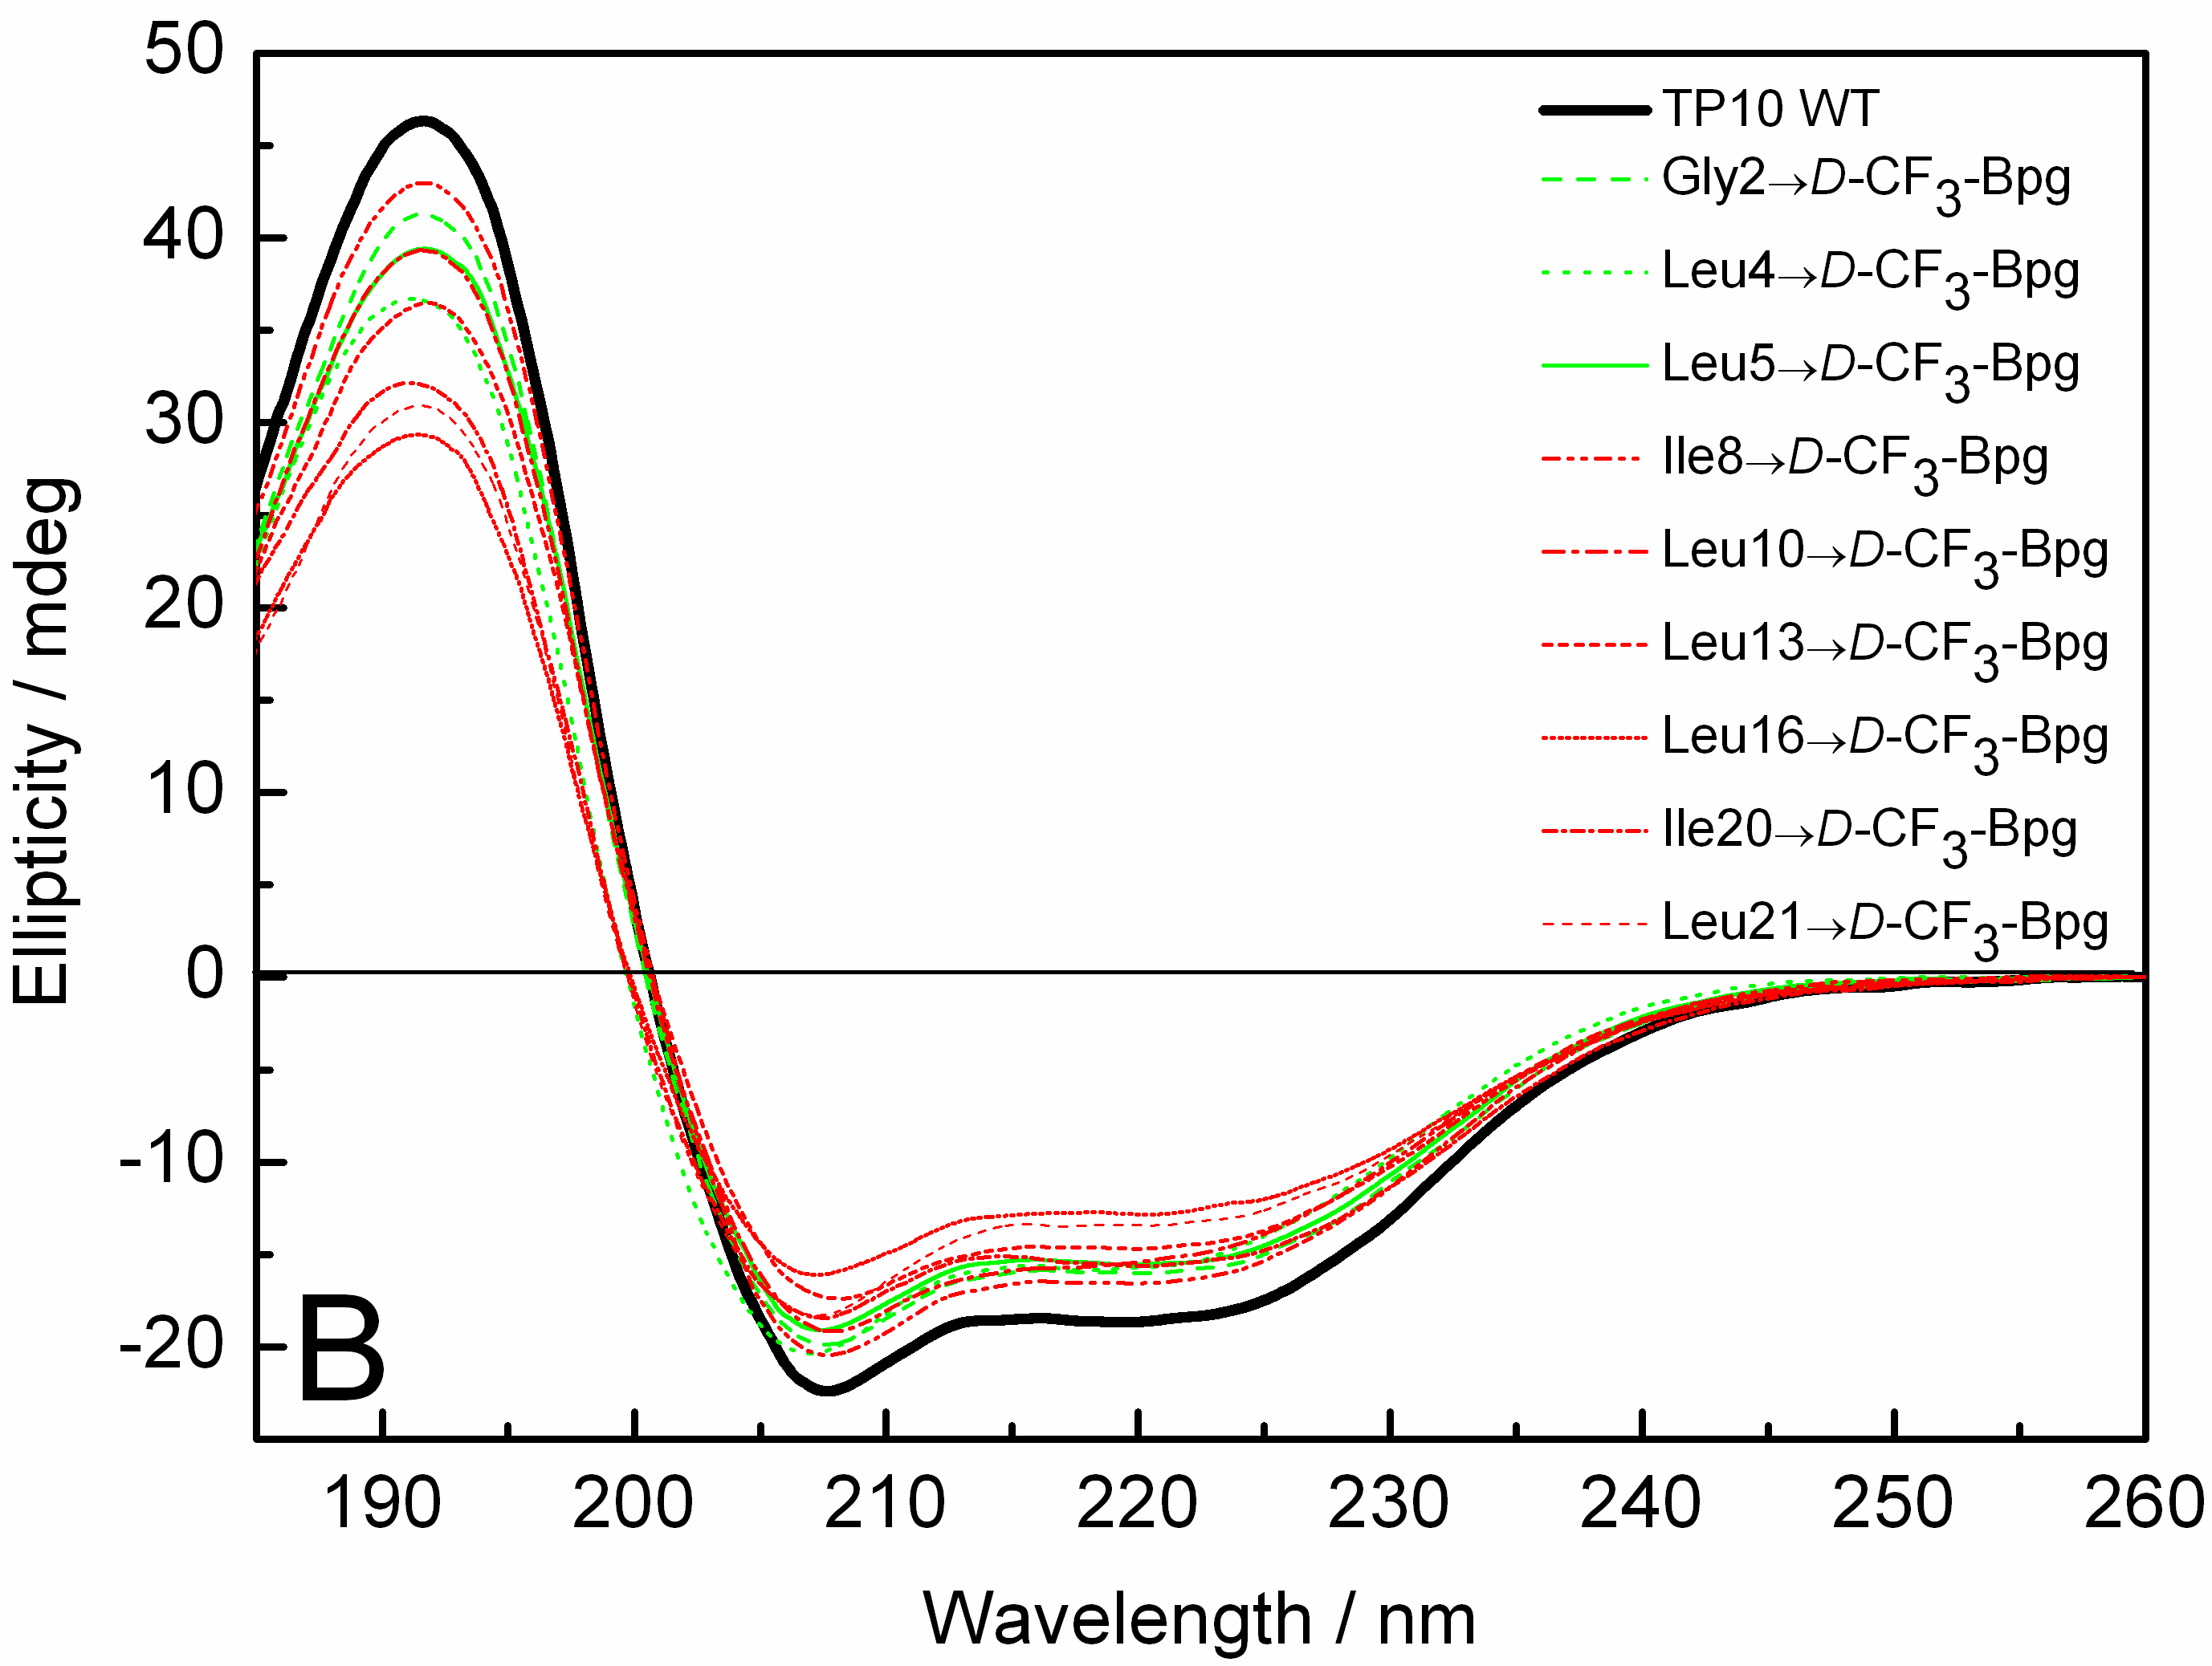
Figure S2: CD spectra of the carboxyfluorescein- and CF₃-Bpg labeled TP10 analogs in DMPC/DMPG vesicles at P/L=1:50. (A) L- and (B) D-epimers. The wild type TP10 is shown as a black line; green lines show analogs with CF₃-Bpg labels in the galanin part, and red lines in the mastoparan part.

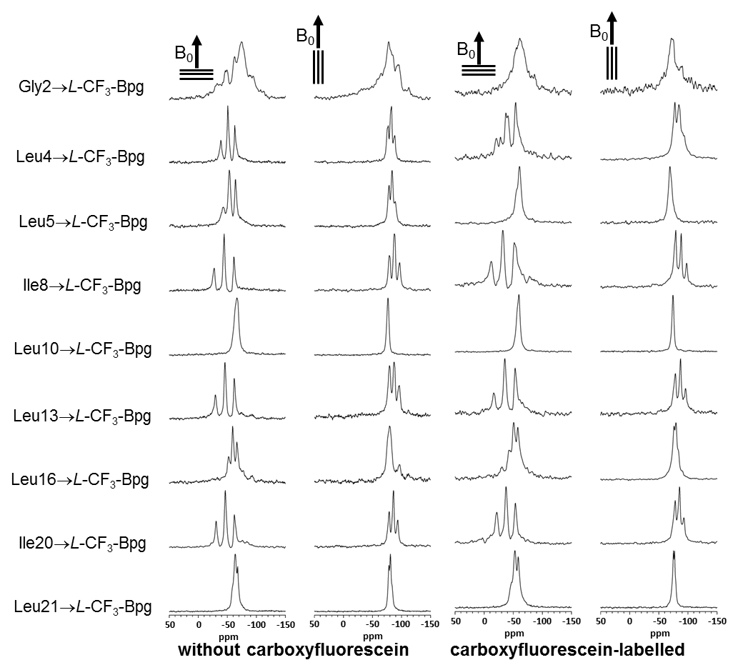

Figure S3: Comparison of the solid-state ¹⁹F-NMR spectra of L-CF₃-Bpg labeled TP10. Analogs with and without the carboxyfluorescein-label were measured in oriented DMPC/DMPG bilayers at P/L=:200, at 40°C, with the sample normal aligned parallel (0°) and perpendicular (90°) to the static magnetic field.

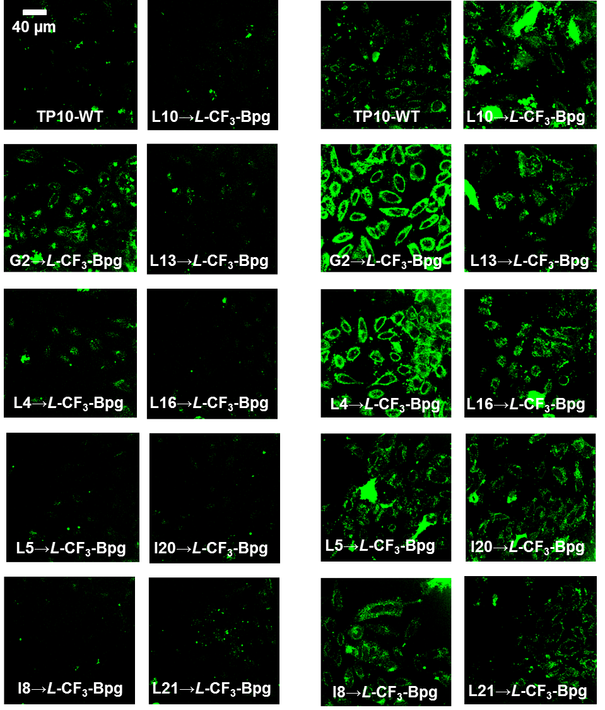
Figure S4: Internalization of the carboxyfluorescein-labeled TP10-WT and the L- and D-CF₃-Bpg analogs by HeLa-cells. The cells were incubated with 2 µM (left column) and 10 µM (right column) peptide at 37°C for 30 min.

Figure S5: Solid-state ¹⁹F-NMR spectra of the L-CF₃-Bpg labeled TP10. Analogs were measured in oriented DMPC/DMPG bilayers at P/L=1:50 and 1:200, at 40°C, with the sample normal aligned parallel (0°) and perpendicular (90°) to the static magnetic field B₀. Several spectra showed an immobilized powder component, as indicated by the boxes.

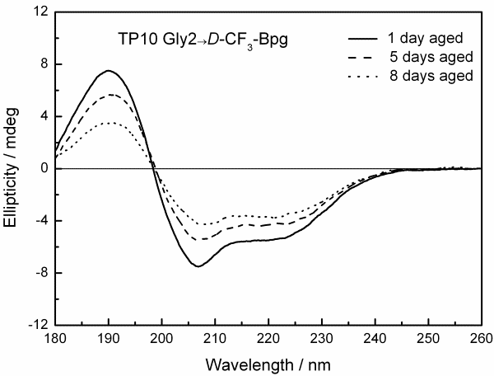
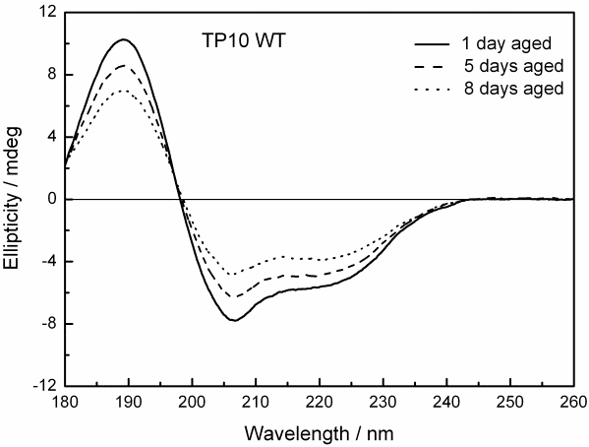
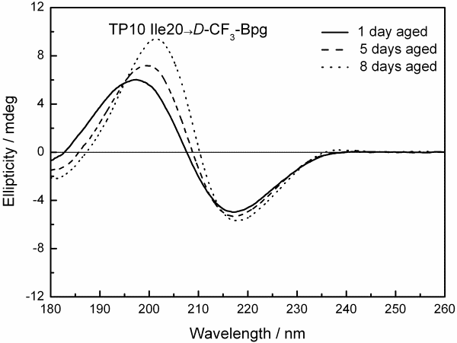
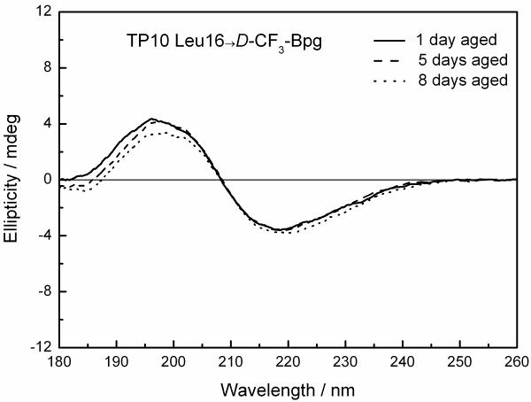
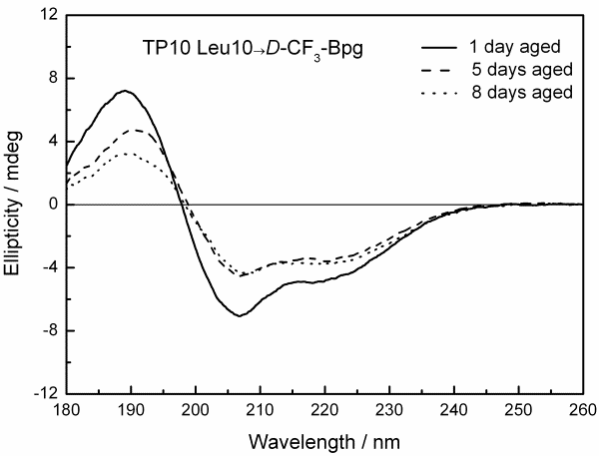
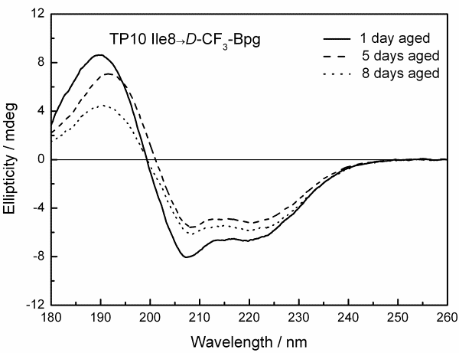
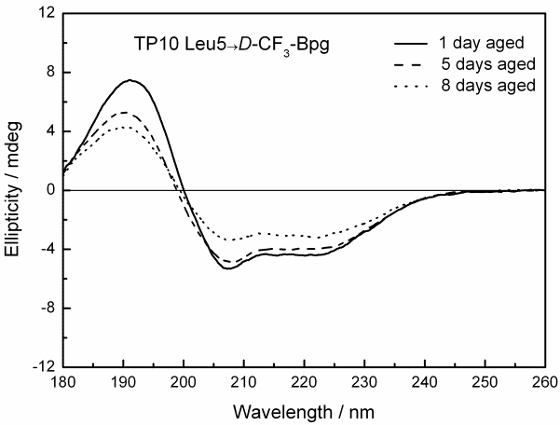
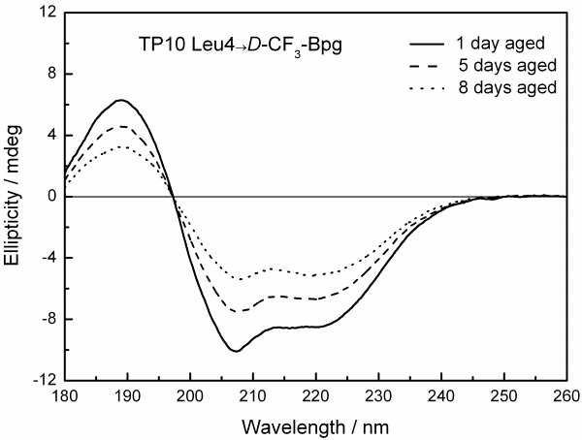

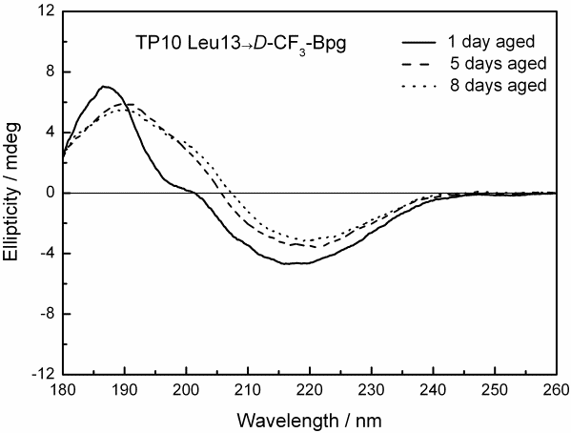

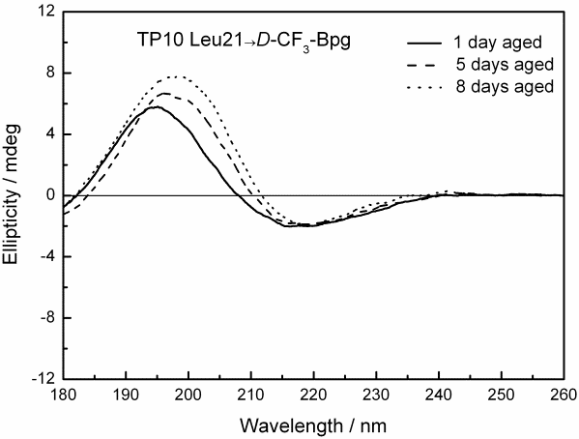

Figure S6: OCD spectra of the D-CF₃-Bpg labeled TP10. Analogs were measured in oriented DMPC/DMPG bilayers at P/L=1:50. Spectra were recorded after 1 (straight lines), 5 (dashed lines) and 8 days (dotted lines) hydration of the OCD sample.

Figure S7: OCD spectra of the Leu16→L-CF₃-Bpg labeled TP10. Peptide measured in oriented DMPC/DMPG bilayers at P/L=1:50. Spectra were recorded after 1 (straight lines), 5 (dashed lines) and 8 days (dotted lines) hydration of the OCD sample.

