Appendix

Table A. Country List to Calculate Weights in Constructing SynthChina
1 | Argentina | 17 | Egypt | 33 | Kenya | 49 | Portugal
2 | Australia | 18 | El Salvador | 34 | Korea, Rep. | 50 | South Africa
3 | Austria | 19 | Finland | 35 | Luxembourg | 51 | Spain
4 | Belgium | 20 | France | 36 | Malawi | 52 | Sri Lanka
5 | Bolivia | 21 | Germany | 37 | Malta | 53 | Sweden
6 | Brazil | 22 | Greece | 38 | Mauritius | 54 | Switzerland
7 | Canada | 23 | Guatemala | 39 | Mexico | 55 | Taiwan
8 | Chile | 24 | Honduras | 40 | Netherlands | 56 | Thailand
9 | China | 25 | Iceland | 41 | New Zealand | 57 | Trinidad and Tobago
10 | Colombia | 26 | India | 42 | Nicaragua | 58 | Turkey
11 | Congo, Dem. Rep. | 27 | Ireland | 43 | Norway | 59 | Uganda
12 | Costa Rica | 28 | Israel | 44 | Pakistan | 60 | United Kingdom
13 | Cyprus | 29 | Italy | 45 | Panama | 61 | United States
14 | Denmark | 30 | Jamaica | 46 | Paraguay | 62 | Uruguay
15 | Dominican Rep. | 31 | Japan | 47 | Peru | 63 | Venezuela, RB
16 | Ecuador | 32 | Jordan | 48 | Philippines | 64 | Zimbabwe

Table B. Robustness Check for the 1991 Shock
A: Pre-Intervention Characteristics for TFR, 1980-1991
 | China  (Actual) | SynthChina  (Simulated for Pre-Intervention Periods) | Our Comparator  (All countries in the sample)
Pre-1991 but Post- 1979
TFR | 2.56 | 2.57 | 3.30
Male to Female (0-4) | 1.07 | 1.07 | 1.05
Childbearing Age | 26.27 | 26.76 | 28.14
Ln GDP per Capita | 7.76 | 8.85 | 9.03
Life Expectancy at Birth | 68.70 | 70.13 | 69.31
Years of Schooling | 5.93 | 6.69 | 7.17

B: Countries Resembling China with Significant Weights for TFR, Pre-1991 but Post- 1979
Greece | 68.3%
India | 31.2%

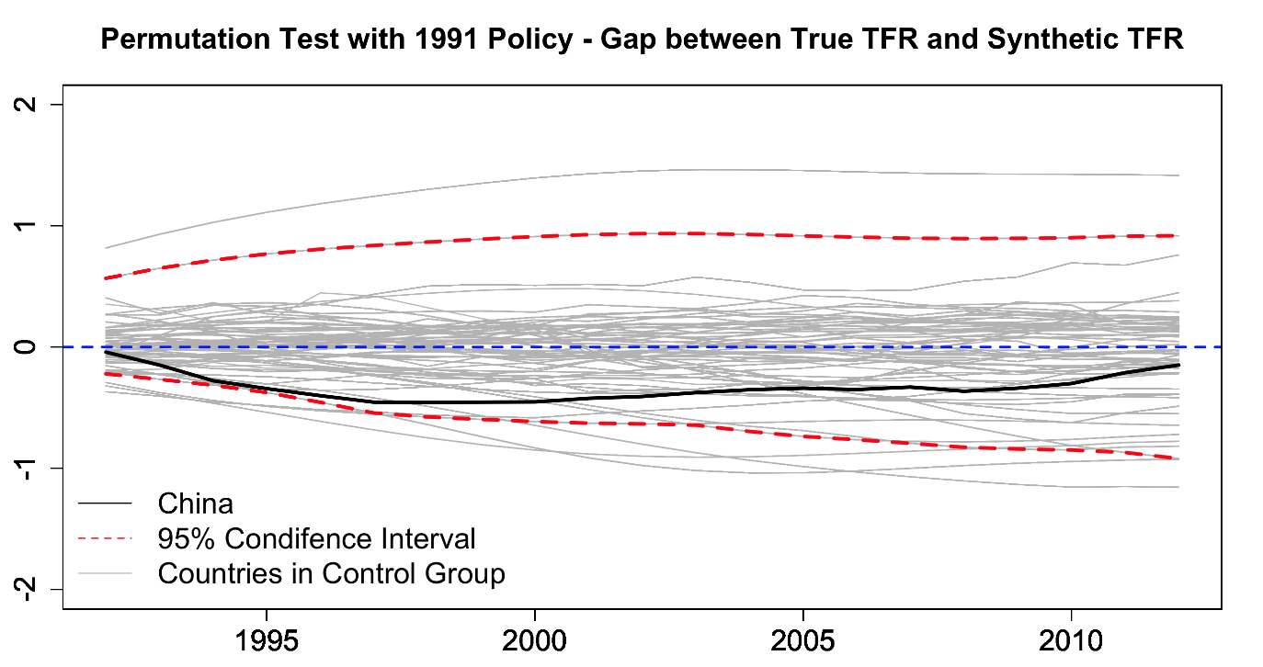

Fig A. Robustness permutation test on the significance of the 1991 policy impact

Table C. Country List for Robustness Check using the Extended Dataset for the 1973 shock
1 | Algeria | 37 | Guatemala | 73 | Pakistan
2 | Argentina | 38 | Haiti | 74 | Panama
3 | Australia | 39 | Honduras | 75 | Paraguay
4 | Austria | 40 | HK SAR, China | 76 | Peru
5 | Bangladesh | 41 | Iceland | 77 | Philippines
6 | Barbados | 42 | India | 78 | Portugal
7 | Belgium | 43 | Indonesia | 79 | Romania
8 | Benin | 44 | Iran, Islamic Rep. | 80 | Rwanda
9 | Bolivia | 45 | Ireland | 81 | Senegal
10 | Botswana | 46 | Israel | 82 | Sierra Leone
11 | Brazil | 47 | Italy | 83 | Singapore
12 | Burundi | 48 | Jamaica | 84 | South Africa
13 | Cameroon | 49 | Japan | 85 | Spain
14 | Canada | 50 | Jordan | 86 | Sri Lanka
15 | Central Africa Rep. | 51 | Kenya | 87 | Sweden
16 | Chile | 52 | Korea, Rep. | 88 | Switzerland
17 | China | 53 | Lesotho | 89 | Syrian Arab Rep.
18 | Colombia | 54 | Liberia | 90 | Taiwan
19 | Congo, Dem. Rep. | 55 | Luxembourg | 91 | Tanzania
20 | Congo, Rep. | 56 | Malawi | 92 | Thailand
21 | Costa Rica | 57 | Malaysia | 93 | Togo
22 | Cote d'Ivoire | 58 | Mali | 94 | Trinidad & Tobago
23 | Cyprus | 59 | Malta | 95 | Tunisia
24 | Denmark | 60 | Mauritania | 96 | Turkey
25 | Dominican Rep. | 61 | Mauritius | 97 | Uganda
26 | Ecuador | 62 | Mexico | 98 | United Kingdom
27 | Egypt, Arab Rep. | 63 | Morocco | 99 | United States
28 | El Salvador | 64 | Mozambique | 100 | Uruguay
29 | Fiji | 65 | Myanmar | 101 | Venezuela, RB
30 | Finland | 66 | Namibia | 102 | Zambia
31 | France | 67 | Nepal | 103 | Zimbabwe
32 | Gabon | 68 | Netherlands
33 | Gambia, The | 69 | New Zealand
34 | Germany | 70 | Nicaragua
35 | Ghana | 71 | Niger
36 | Greece | 72 | Norway

Table D. Country List for Robustness Check using the Extended Dataset for the 1979 shock
1 | Albania | 32 | Ecuador | 63 | Lesotho | 94 | Romania
2 | Algeria | 33 | Egypt | 64 | Liberia | 95 | Rwanda
3 | Argentina | 34 | El Salvador | 65 | Luxembourg | 96 | Saudi Arabia
4 | Australia | 35 | Fiji | 66 | Macao SAR, China | 97 | Senegal
5 | Austria | 36 | Finland | 67 | Malawi | 98 | Sierra Leone
6 | Bahrain | 37 | France | 68 | Malaysia | 99 | Singapore
7 | Bangladesh | 38 | Gabon | 69 | Maldives | 100 | South Africa
8 | Barbados | 39 | Gambia, The | 70 | Mali | 101 | Spain
9 | Belgium | 40 | Germany | 71 | Malta | 102 | Sri Lanka
10 | Belize | 41 | Ghana | 72 | Mauritania | 103 | Sudan
11 | Benin | 42 | Greece | 73 | Mauritius | 104 | Swaziland
12 | Bolivia | 43 | Guatemala | 74 | Mexico | 105 | Sweden
13 | Botswana | 44 | Haiti | 75 | Mongolia | 106 | Switzerland
14 | Brazil | 45 | Honduras | 76 | Morocco | 107 | Syrian Arab Rep.
15 | Brunei Darussalam | 46 | HK SAR, China | 77 | Mozambique | 108 | Taiwan
16 | Bulgaria | 47 | Hungary | 78 | Myanmar | 109 | Tanzania
17 | Burundi | 48 | Iceland | 79 | Namibia | 110 | Thailand
18 | Cambodia | 49 | India | 80 | Nepal | 111 | Togo
19 | Cameroon | 50 | Indonesia | 81 | Netherlands | 112 | Trinidad & Tobago
20 | Canada | 51 | Iran | 82 | New Zealand | 113 | Tunisia
21 | Central African Rep. | 52 | Iraq | 83 | Nicaragua | 114 | Turkey
22 | Chile | 53 | Ireland | 84 | Niger | 115 | Uganda
23 | China | 54 | Israel | 85 | Norway | 116 | United Arab Emirates
24 | Colombia | 55 | Italy | 86 | Pakistan | 117 | United Kingdom
25 | Congo, Dem. Rep. | 56 | Jamaica | 87 | Panama | 118 | United States
26 | Congo, Rep. | 57 | Japan | 88 | Paraguay | 119 | Uruguay
27 | Costa Rica | 58 | Jordan | 89 | Peru | 120 | Venezuela
28 | Cote d'Ivoire | 59 | Kenya | 90 | Philippines | 121 | Vietnam
29 | Cyprus | 60 | Korea, Rep. | 91 | Poland | 122 | Zambia
30 | Denmark | 61 | Kuwait | 92 | Portugal | 123 | Zimbabwe
31 | Dominican Rep. | 62 | Lao PDR | 93 | Qatar

Table E. Estimation Results of Synthetic Control Method Using Unbalanced Dataset
A: Pre-intervention characteristics
 | China  (Actual) | SynthChina  (Simulated for Pre-Intervention Periods) | Our Comparator  (All countries in the sample)
Pre- 1973: (103 countries)
TFR | 5.85 | 5.85 | 5.30
Male to Female (0-4) | 1.05 | 1.05 | 1.03
Childbearing Age | 29.76 | 29.73 | 28.93
Ln GDP per Capita | 7.12 | 7.90 | 8.22
Life Expectancy at Birth | 56.44 | 56.55 | 57.68
Years of Schooling | 3.67 | 3.70 | 4.02
Pre-1979 but Post- 1973 (123 countries)
TFR | 3.59 | 3.63 | 4.82
Male to Female (0-4) | 1.06 | 1.06 | 1.03
Childbearing Age | 29.17 | 29.25 | 28.76
Ln GDP per Capita | 7.26 | 8.19 | 8.51
Life Expectancy at Birth | 64.15 | 61.43 | 60.67
Years of Schooling | 4.66 | 4.69 | 4.72

B: Countries Resembling China with Significant Weights
Pre-1973 Period |  | Pre-1979 but Post- 1973 Period
India | 29.9% | India | 27.9%
Ireland | 13.6% | Korea | 31.7%
Jordan | 22.8% | Macao SAR, China | 22.8%
Korea | 8.8% | Nepal | 1.0%
Pakistan | 1.0%

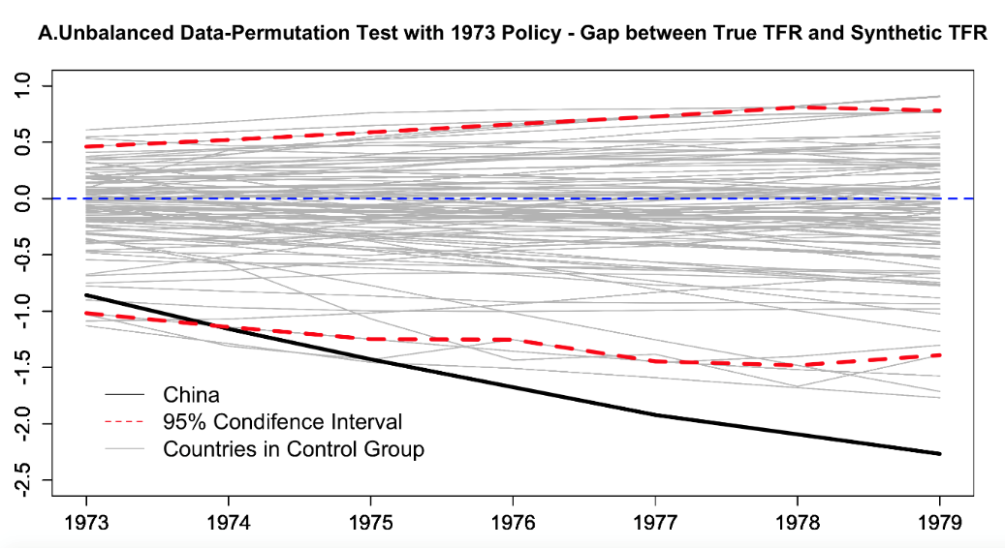
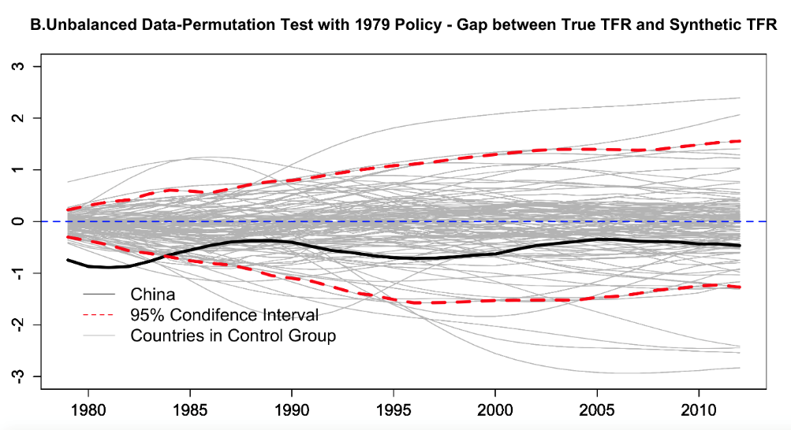

Fig B. Robustness permutation test on the significance of the policy impact using unbalanced Data

Table F. Country List for Robustness Check Using the Selected Dataset
Selected 25 Countries as the Dataset
1 | Albania | 8 | Panama | 15 | India | 22 | Indonesia
2 | Brazil | 9 | Paraguay | 16 | Japan | 23 | Vietnam
3 | Colombia | 10 | South Africa | 17 | Korea, Rep. | 24 | Malaysia
4 | Costa Rica | 11 | Turkmenistan | 18 | Pakistan | 25 | Mongolia
5 | Jamaica | 12 | Uzbekistan | 19 | Philippines
6 | Korea, Dem. Peop. Rep. | 13 | Venezuela | 20 | Taiwan
7 | Lebanon | 14 | China | 21 | Thailand
For the 1973 Shock
1 | China | 6 | Jamaica | 11 | Panama | 16 | Thailand
2 | Colombia | 7 | Japan | 12 | Paraguay | 17 | Venezuela
3 | Costa Rica | 8 | Korea, Rep. | 13 | Philippines
4 | India | 9 | Malaysia | 14 | South Africa
5 | Indonesia | 10 | Pakistan | 15 | Taiwan
For the 1979 Shock
1 | Albania | 6 | Indonesia | 11 | Mongolia | 16 | South Africa
2 | China | 7 | Jamaica | 12 | Pakistan | 17 | Taiwan
3 | Colombia | 8 | Japan | 13 | Panama | 18 | Thailand
4 | Costa Rica | 9 | Korea, Rep. | 14 | Paraguay | 19 | Venezuela
5 | India | 10 | Malaysia | 15 | Philippines | 20 | Vietnam

Table G. Estimation Results of Synthetic Control Method Using Selected Countries
A: Pre-intervention characteristics
 | China  (Actual) | SynthChina  (Simulated for Pre-Intervention Periods) | Our Comparator  (All countries in the sample)
Pre- 1973: (17 countries)
TFR | 5.85 |  | 5.80 | 5.63
Male to Female (0-4) | 1.05 |  | 1.04 | 1.04
Childbearing Age | 29.76 |  | 29.73 | 29.24
Ln GDP per Capita | 7.12 |  | 7.30 | 8.11
Life Expectancy at Birth | 56.44 |  | 56.40 | 61.06
Years of Schooling | 3.67 |  | 2.48 | 4.08
Pre-1979 but Post- 1973 (20 countries)
TFR |  | 3.59 | 3.62 | 4.62
Male to Female (0-4) |  | 1.06 | 1.06 | 1.04
Childbearing Age |  | 29.17 | 29.35 | 29.19
Ln GDP per Capita |  | 7.26 | 8.22 | 8.25
Life Expectancy at Birth |  | 64.15 | 63.65 | 63.89
Years of Schooling |  | 4.66 | 5.83 | 4.97

B: Countries Resembling China with Significant Weights
Pre-1973 Period |  | Pre-1979 but Post- 1973 Period
India | 8.5% | Korea | 64.10%
Indonesia | 30.3% | Thailand | 35.70%
Thailand | 59.8%

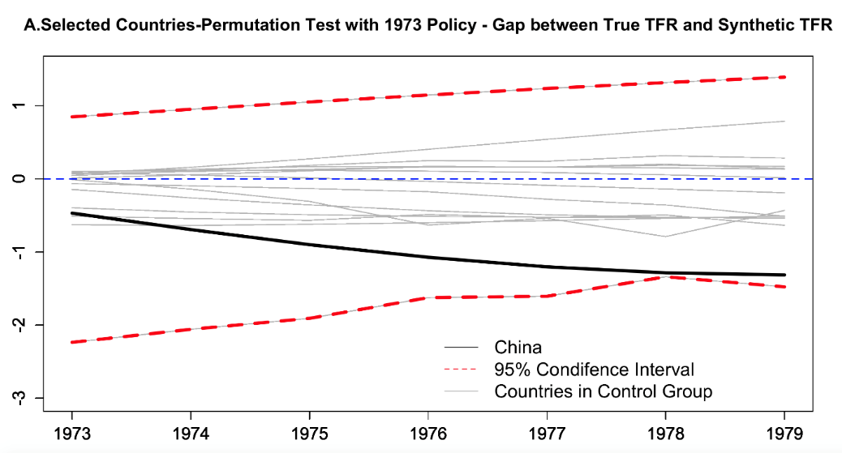
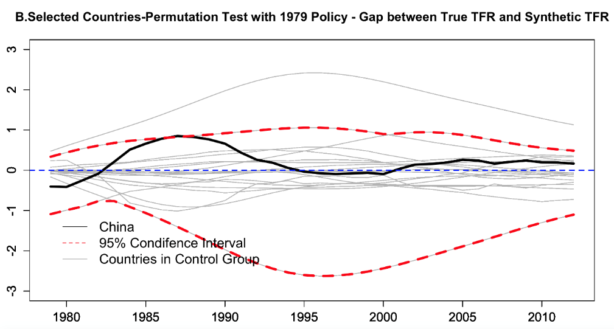

Fig C. Robustness permutation test on the significance of the policy impact for selected countries

Table H. Comparison of TFRs used in our analysis and UN Interpolated TFRs
 | TFR | TFR (UN)
Minimum | 0.83 | 0.83
1 Quartile | 2.33 | 2.33
Median | 4.21 | 4.21
Mean | 4.29 | 4.30
3rd Quartile | 6.21 | 6.25
Maximum | 8.45 | 8.46

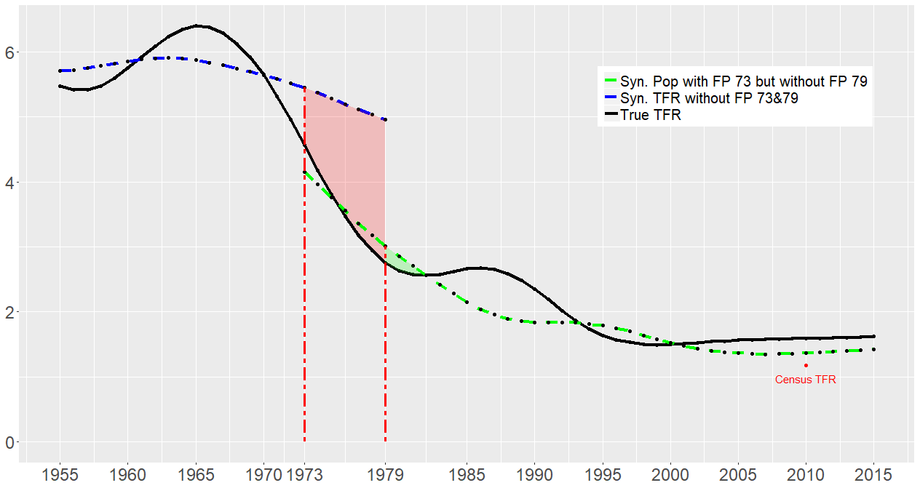

Fig D. Time trend of ‘actual’ and ‘synthetic’ Total Fertility Rate for China using UN interpolated data, 1955-2015

The pre-intervention period for TFR is 1980-1991 while for the others are 1985-1991.
Altogether, 57 countries were used to construct the SynthChina. Here we only present the countries with weights higher than 1%.
Altogether, 21 countries were used to construct the SynthChina. Here we only present the countries with weights higher than 1%.
Altogether, 57 countries were used to construct the SynthChina. Here we only present the countries with weights higher than 1%.
Altogether, 21 countries were used to construct the SynthChina. Here we only present the countries with weights higher than 1%.

