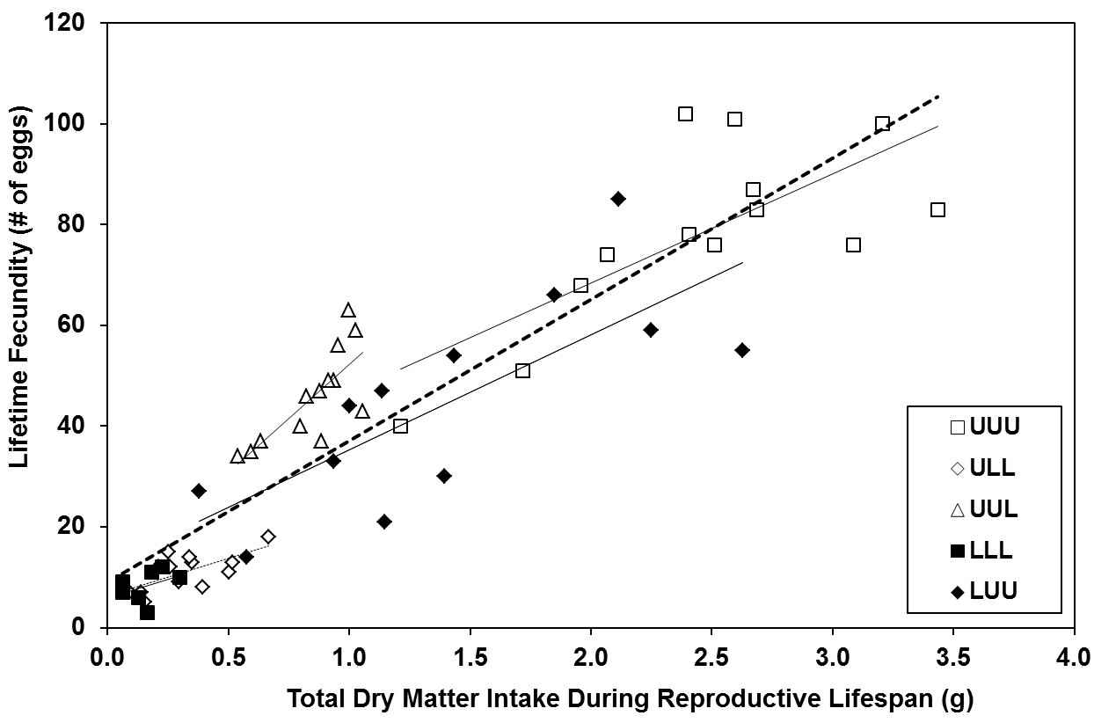
y = 28.053x + 9.038
F_{1,56} = 276.00, p < 0.0001,
R² = 0.828

Figure S9. Relationship between fecundity and total dry matter (g) consumed during the reproductive lifespan for all insects that oviposited (n = 58) as determined by least squares linear regression. Trendlines depict the relationships within individual groups (thin lines) and among all insects that oviposited (thick hashed line). The equation, F-value, p-value, and R² value included on the figure are the results of the regression analysis of data for all groups combined. U = unlimited access to food, L = limited access to food.

