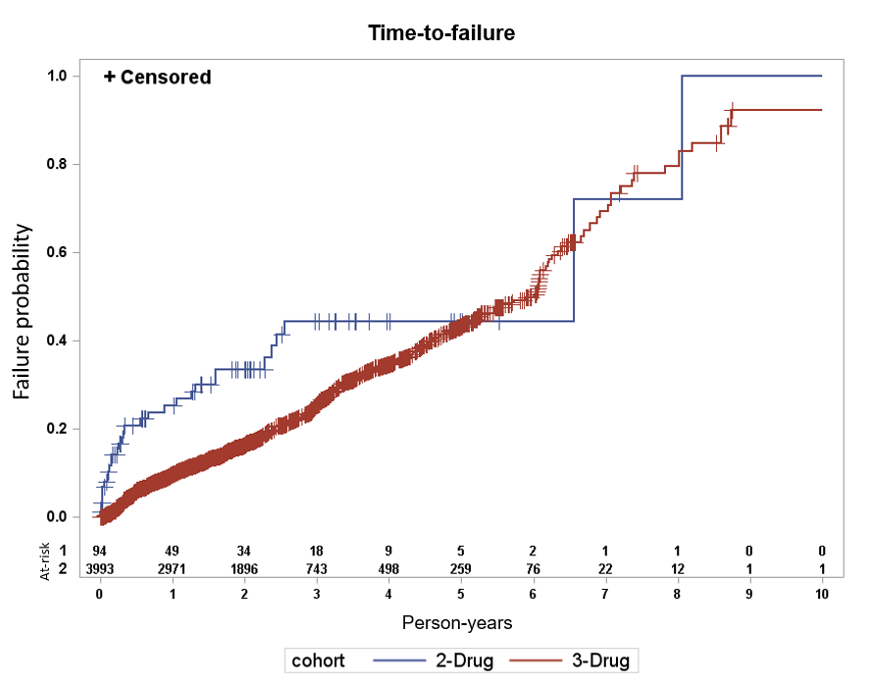
S3 Fig. Kaplan Meier curve for time-to-switch for the 2- and 3-drug regimen cohorts

