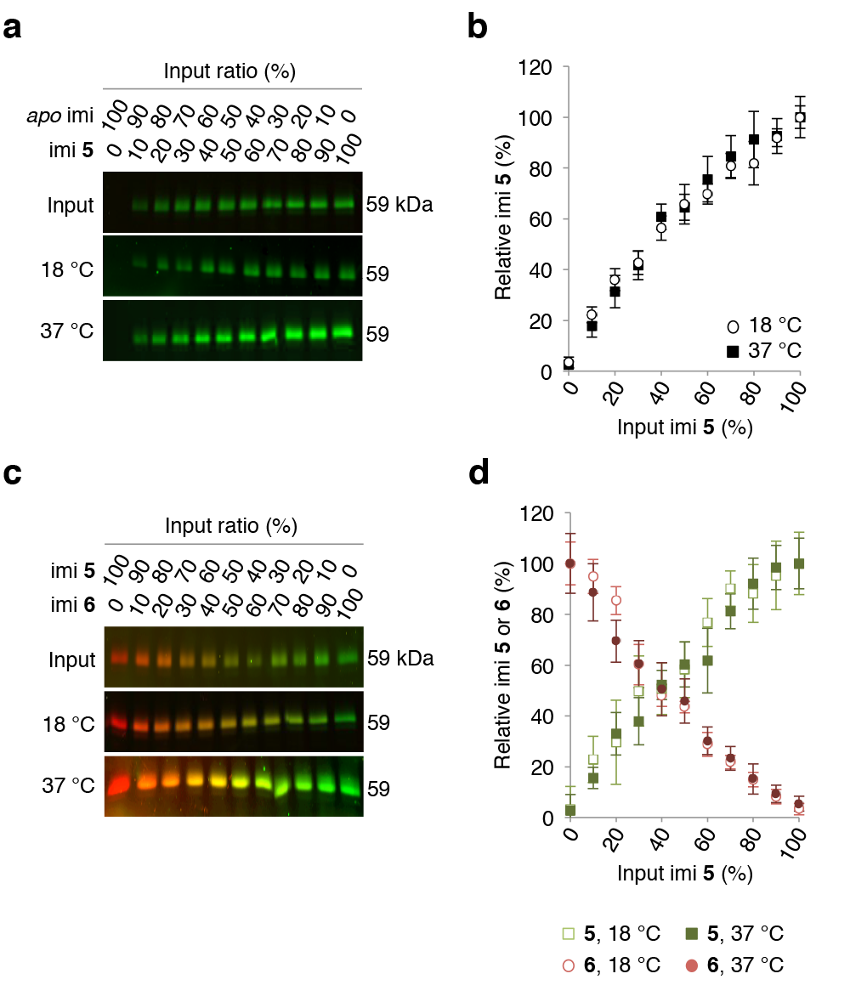
S1 Figure 2 | Dose-dependence and proportional binding and uptake of ABP-labeled imiglucerase. (a) Human monocyte-derived macrophages were incubated with increasing ABP 5-labeled imi (top) at 18 °C (binding) or 37 °C (binding + uptake). (b) Quantification of a: cell-bound imiglucerase at 18 °C related to input (open circle) and cell-bound imiglucerase at 37 °C related to input (closed square). Data are average of duplicate experiments, ± SD. (c) Similar to a: except exposure of cells to mixture of green ABP 5− and red ABP 6-labeled imiglucerase. (d) Idem b for mixture of green ABP 5− and red ABP 6-labeled imiglucerase: cell-bound green ABP 5-imiglucerase at 18 °C related to input (green closed square); cell-bound red ABP 6-imiglucerase at 18 °C related to input (red closed circle); cell-bound green ABP 5-imiglucerase at 37 °C related to input (green open square); cell-bound red ABP 6-imiglucerase at 37 °C related to input (red open circle). Data are average of duplicate experiments, ± SD.

