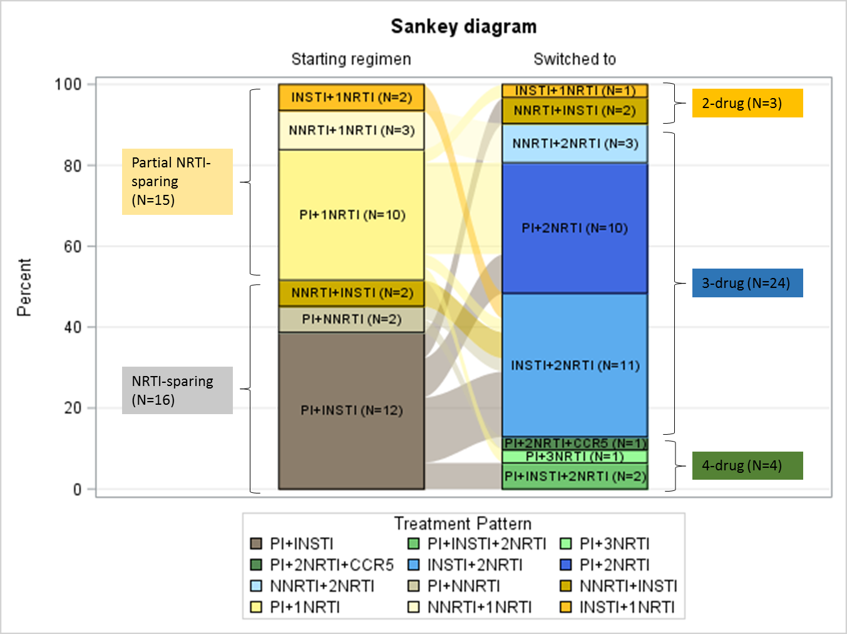
S4 Fig. Switch patterns for 2-drug regimen cohort

