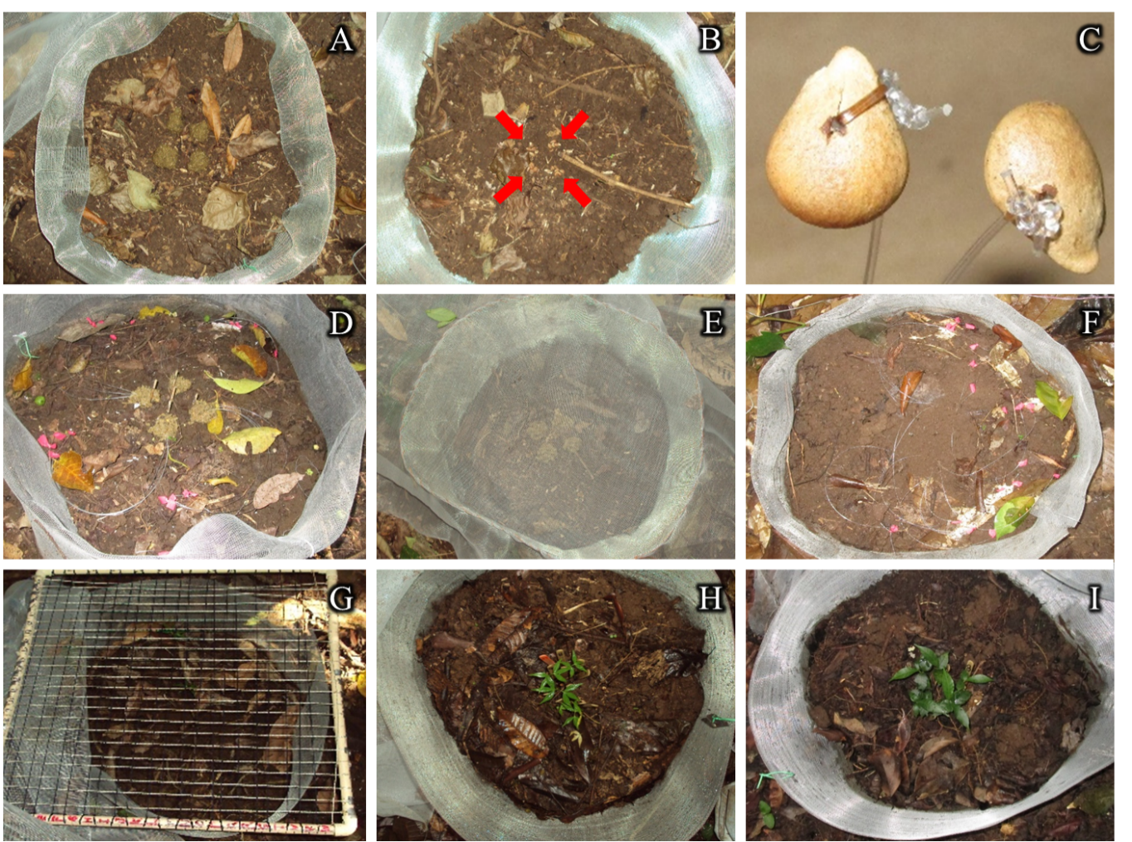

S1 Fig. Methodological details of the two experiments carried out to assess the effects of dung beetle activity on the spatial distribution of seeds (Experiment 1) and seedlings (Experiment 2), and on the probability of seedling establishment (Experiment 2).

