S2 File. Quality control analysis after the removal of the sequencing adapter. Quality scores across all bases (Figure A). Quality score distribution over all sequences (Figure B). Percentage of adapter sequence (Figure C).

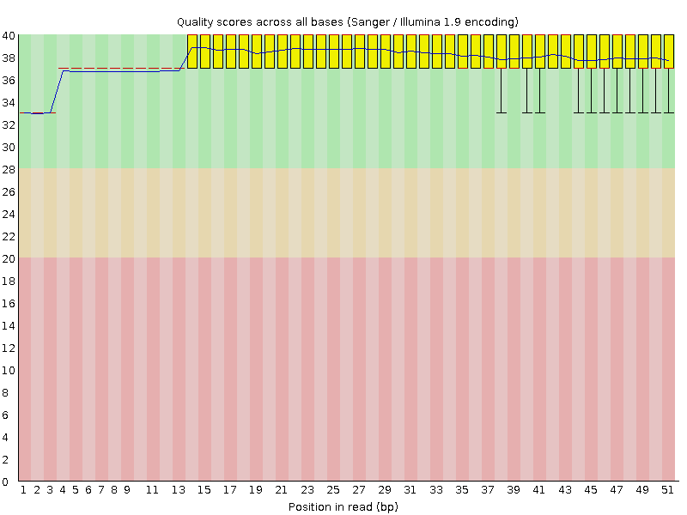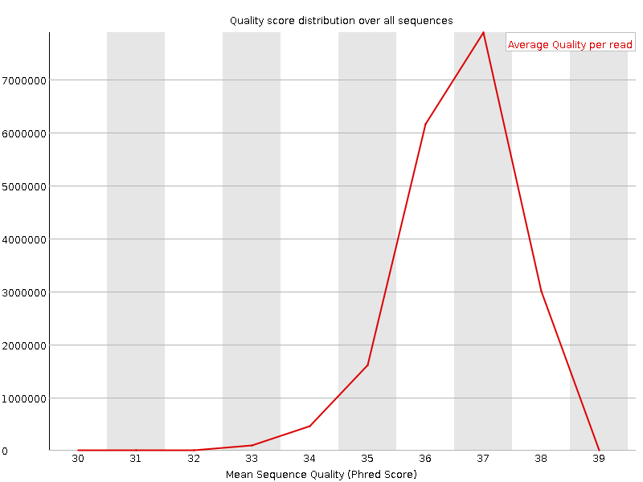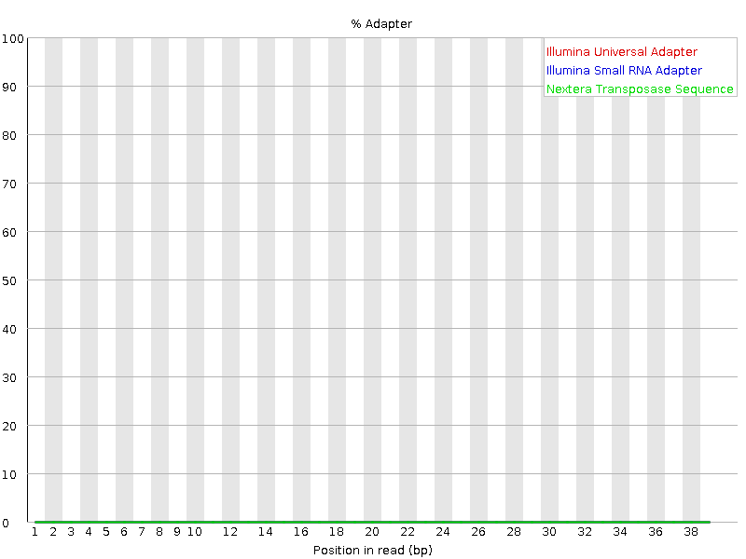
A
B
C

