Supporting Information
For the main article, “Predicting sediment and nutrient concentrations from high-frequency water-quality data” by Catherine Leigh, Sevvandi Kandanaarachchi, James M. McGree, Rob J. Hyndman, Omar Alsibai1, Kerrie Mengersen and Erin E. Peterson, published by Plos One.

This document contains S5 Fig.

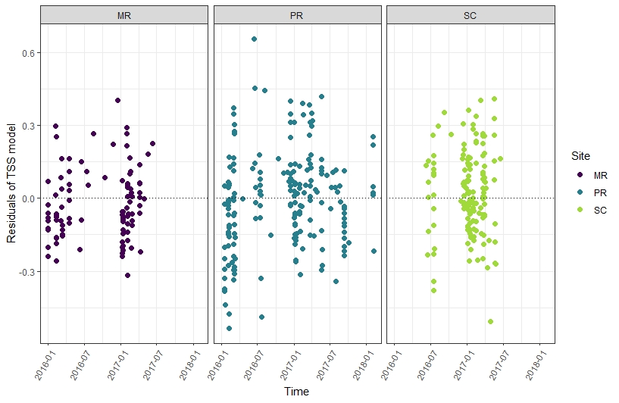 S5 Fig. TSS-model residuals. Residuals from the final total suspended solids (TSS, mg/L, log₁₀-transformed) model plotted in chronological order of the observations at Mulgrave River (MR; left plot), Pioneer River (PR, middle plot) and Sandy Creek (SC, right plot).

