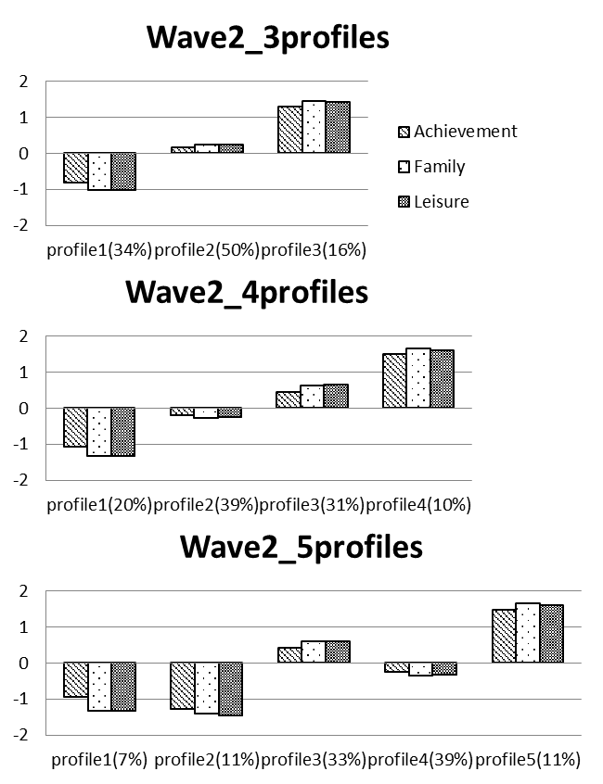
S8 Fig. latent profile analysis solution for Cohort 1995 at wave 2.

