S2 Supporting Information for
“Solar cell cracks within a photovoltaic module: Characterization by AC impedance spectroscopy”

Tadanori Tanahashi, Shu-Tsung Hsu

To electrically separate the individual PV cells within the PV module, the backsheet and encapsulant layers of the PV modules were peeled off (Fig S2a) using a micro-grinder with a small wire brush (Urawa Corp., HD20A-SET), and the electrical leads (1.5 mm in width) were soldered to the interconnector ribbons between the PV cells (Fig S2b). The leads were bound together with another set of copper-solder ribbons (6 mm in width) at each side of the respective PV cells (Fig 1c).
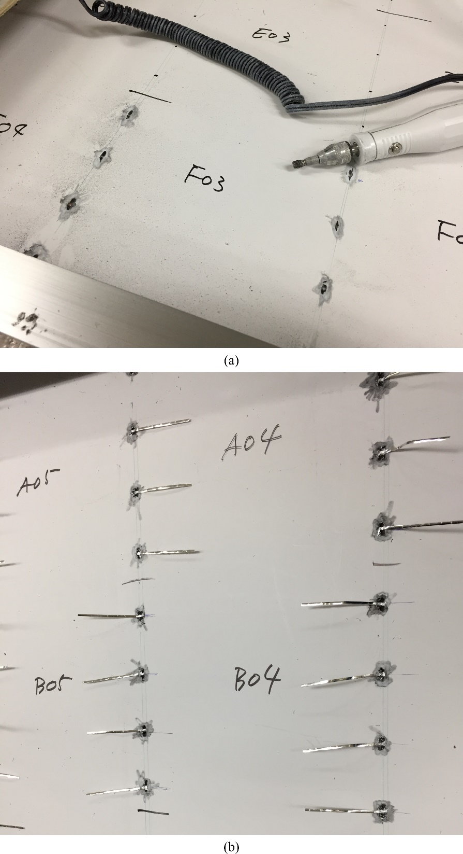
Fig S2. Interconnector ribbons exposed using a micro-grinder (a) and the attached electrical leads (b).

