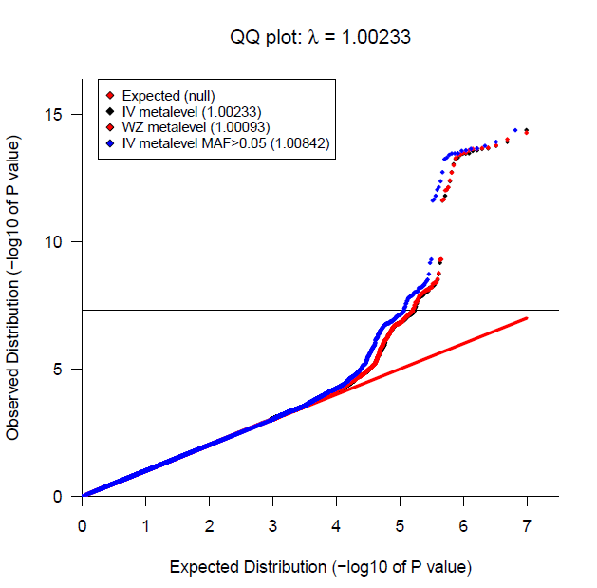
S7 Figure. Manhattan plot and QQ plot for the meta-analysis
results for the ratio hepcidin/ferritin in all individuals.

