S1 File. Details on the C1-oxidative background activity in wildtype P. pastoris and its effect on the indicator diagram.
Fig A. Traces of C1-oxidation activity in ultrafiltrated broth of P. pastoris CBS7435 and NcLPMO9C expressing transformant. HPAEC-PAD analysis of enzyme tests performed with 100µL ultrafiltrated culture broth. Two time points (after 0.5h and 2h) are shown.
NcLPMO9C is a strict C4-oxidizing LPMO
The minor C1-oxidative activity observed for NcLPMO9C was compared to the background activity in the ultrafiltrated broth of wildtype P. pastoris CBS7435 (see Fig A). For this, enzyme tests were performed using 100µL ultrafiltrated broth as this corresponds to the maximal dose in the activity tests used throughout our regioselectivity study. The slope of the A2-signal formation was used as an indicator of C1-oxidation and was shown not to be significantly different for NcLPMO9C when comparing to the wildtype sample (Fig B). This is in accordance with NcLPMO9C being generally accepted to be a strict C4-oxidizing LPMO [1]. The results for the P. pastoris control strain (harboring the empty expression vector) were the same as for the wildtype P. pastoris CBS7435 strain.
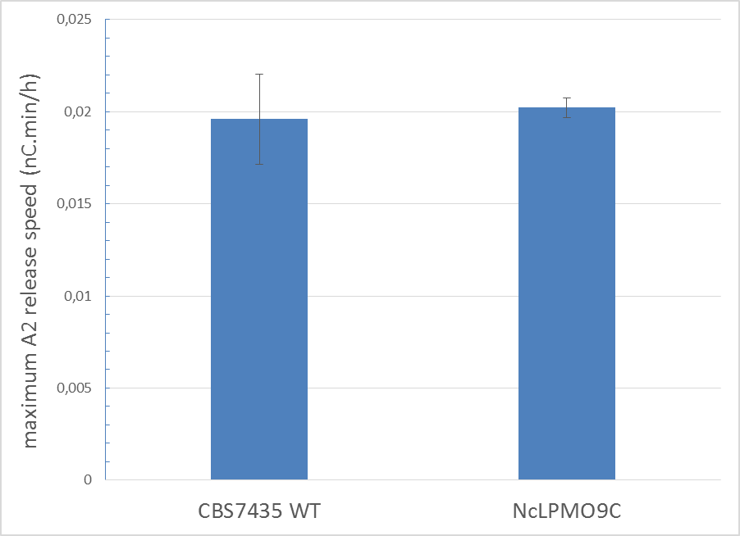
Fig B. C1-oxidative activity in NcLPMO9C broth not significantly different from that of wildtype P. pastoris CBS7435. Comparison was done based on the rate of the A2 formation.

Effect of C1-oxidation background activity on screening system
As variants will always be compared relatively to their wildtype enzyme, the influence of the background activity is believed to be limited. This is demonstrated by the similar indicator diagram obtained for purified enzymes (see S5 Fig). Only at the lowest A2 release rates (below 0.022 nC.min/h), some prudence is called for, as it will be difficult to discriminate between background and C1-oxidative LPMO activity.
Reference
1. Isaksen T, Westereng B, Aachmann FL, Agger JW, Kracher D, Kittl R, et al. A C4-oxidizing lytic polysaccharide monooxygenase cleaving both cellulose and cello-oligosaccharides. J Biol Chem. 2014;289(5):2632–42.

