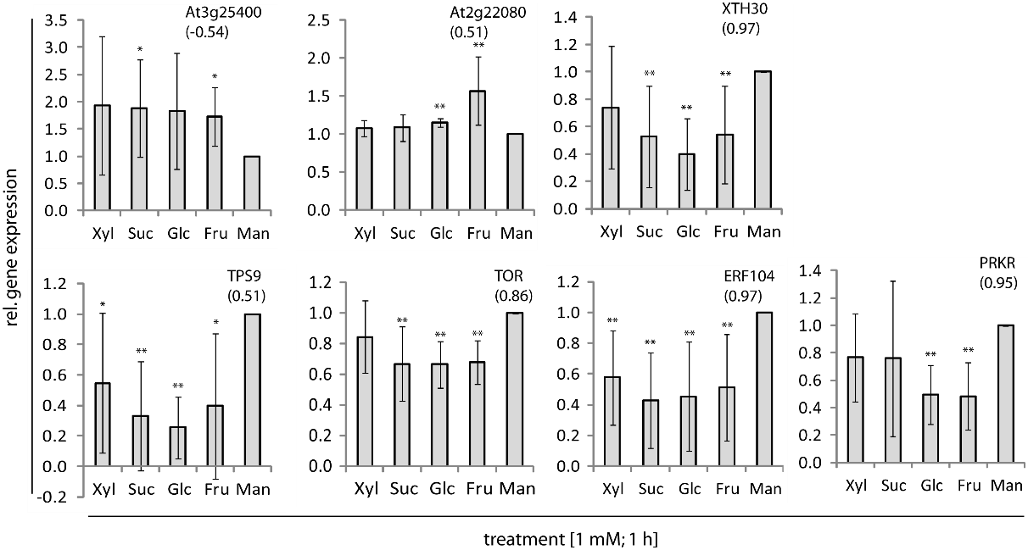
Fig. S7. Defined sets of sugars trigger significant changes in gene expression of selected sugar-responsive genes in 7-d-old A.thaliana cell culture. qPCR analysis of the expression of selected genes in response to Suc, Glc, Fru, Xyl and mannitol (Man) showed a sugar species-dependent regulation in response to Suc/Glc/Fru (ERF104, XTH30, TPS9, TOR), Glc/Fru (At2g22080, PRKR) and Suc/Fru (At3g25400). The numbers in parentheses indicate the correlation between the gene expression profile measured by the microarray and qPCR analysis. Significance: t-test; * α=0.05, ** α=0.01, n=8. See also Fig.2B and Fig.3C for examples of other genes.

