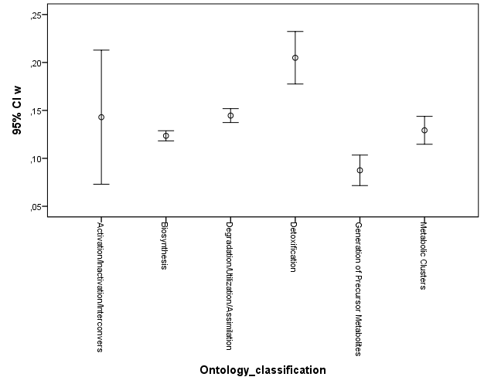 | 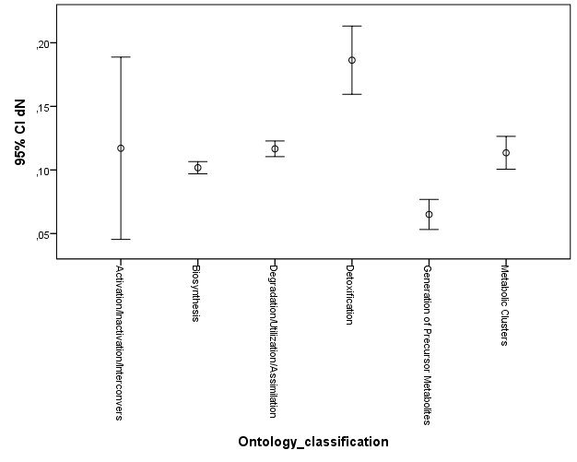 | 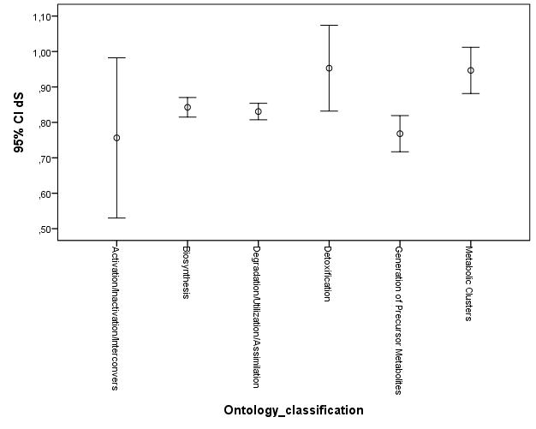

S1 Fig. Graph representing dN/dS, dN and dS among genes belonging to different functional classes according to ontology-based classification.

