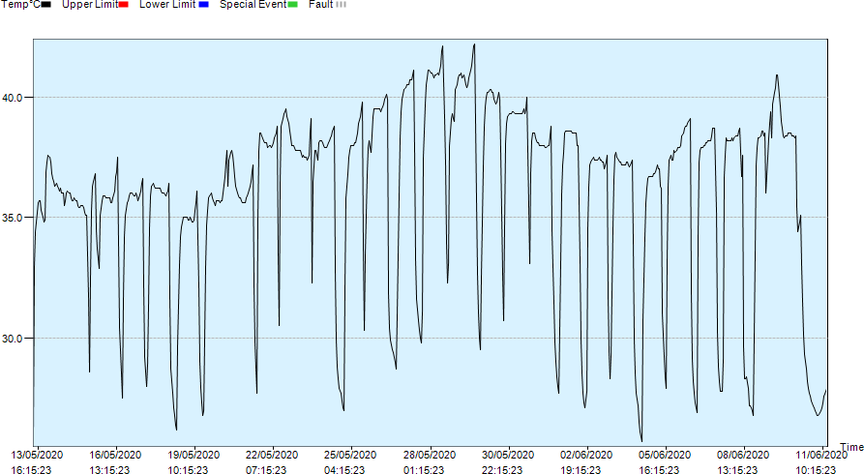
S2 Fig. Cultivation temperature variations in step 2 of the study.

