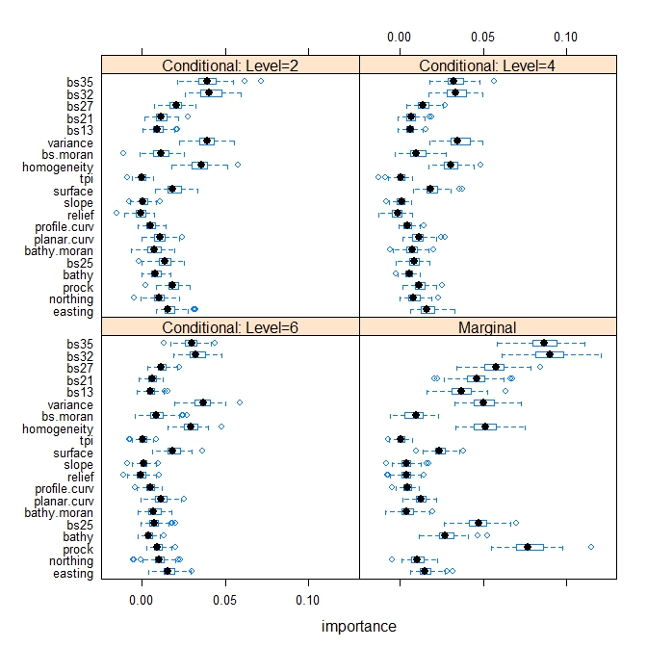
Fig A
Fig B
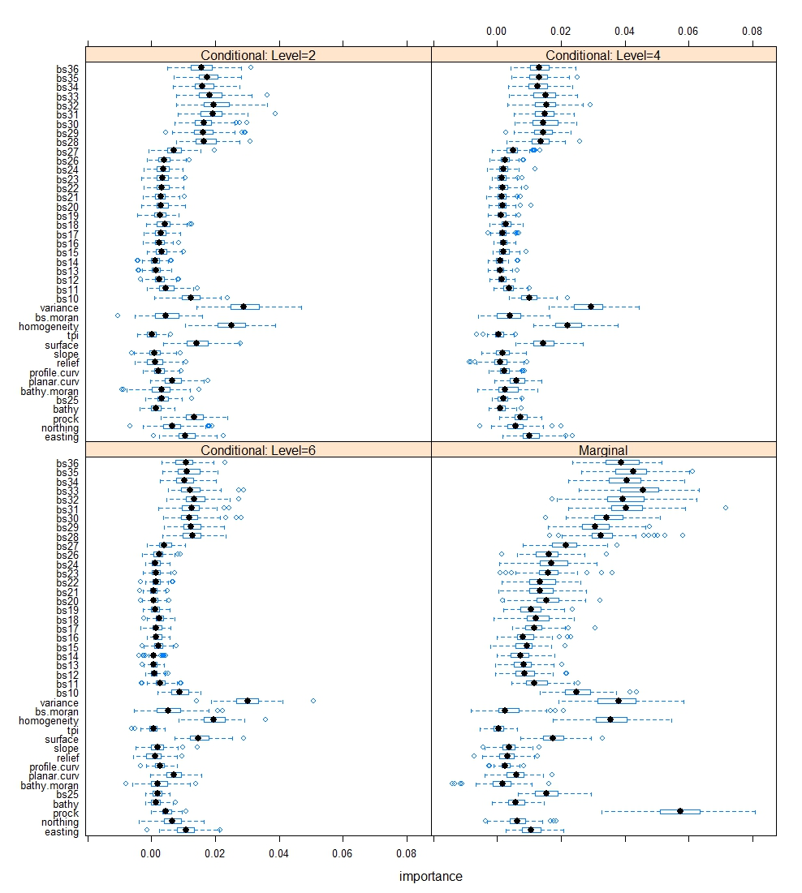
Fig C
S3 File. Variable importance (VI) for hard90. Fig A: measured by RF using randomForest package for 20 predictive variables [1]; Fig B: averaged VI from 100 iterations of RF using extendedForest package for 20 variables [2]; and Fig C: averaged VI from 100 iterations of RF using extendedForest package for 41 variables [2].

1. Liaw A, Wiener M. Classification and regression by randomForest. R News. 2002;2(3):18-22.
2. Smith SJ, Ellis N, Pitcher CR. Conditional variable importance in R package extendedForest. R vignette 〈http://gradientforestr-forger-projectorg/Conditional-importancepdf〉. 2011.

