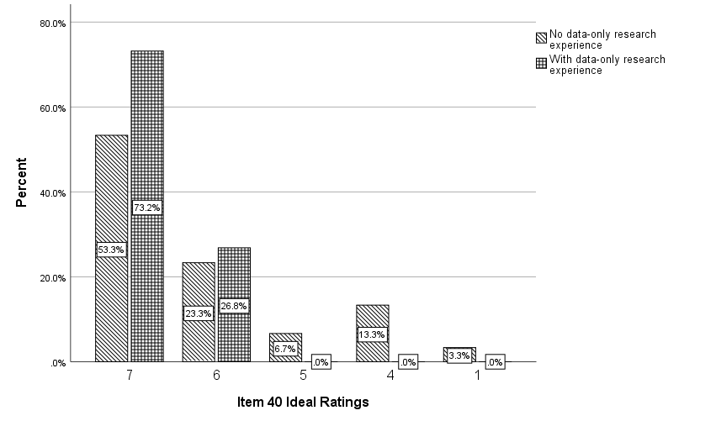
S1 Figure. Clustered bar chart showing the distribution of ideal ratings for item 40 for respondents with and without experience in data-only research.

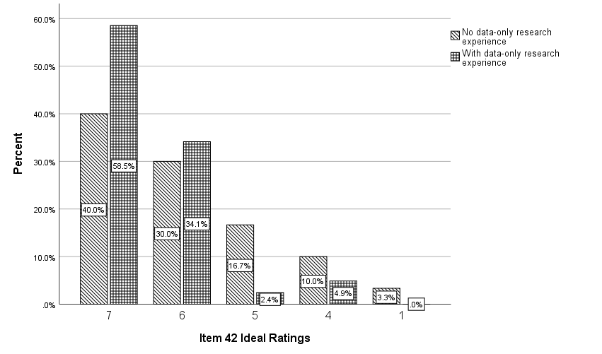
S2 Figure. Clustered bar chart showing the distribution of ideal ratings for item 42 for respondents with and without experience in data-only research.

