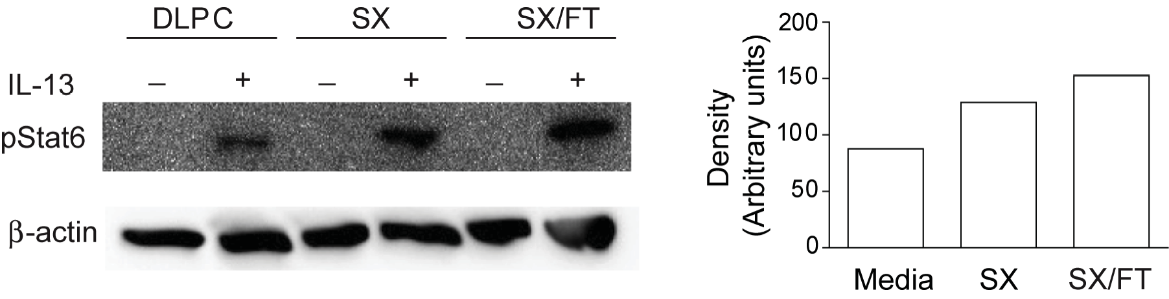
Figure S5. Salmeterol-dependent STAT6 activation occurs independently of fluticasone. Phosphorylated STAT6 was assessed in A549 cells cultured for 4 days in the presence of liposome vehicle (DLPC), salmeterol (SX), or salmeterol and fluticasone (SX/FT) then stimulated with IL-13 for 30 min. Data are from one 1 experiment.

