Supplemental Table 5. Median coefficients of variation (CV) by serum cytokine¹ based on replicate samples from different batches.

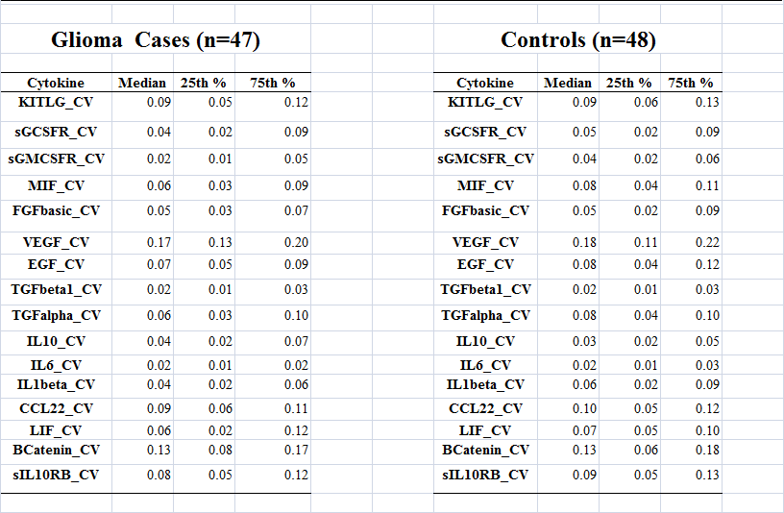
- For abbreviations see Table 2 and Figs 2A and 2B.

