S4 Appendix.

Median-joining haplotype networks for each of the markers used in this study.
(a) Control Region and (b) Cytb. For the Aldabra rail, the Picard pre-extinction individuals, those from Île aux Cèdres and those caught from unknown locations are shown separately, whereas the individuals from Malabar and Malabar* are pooled.
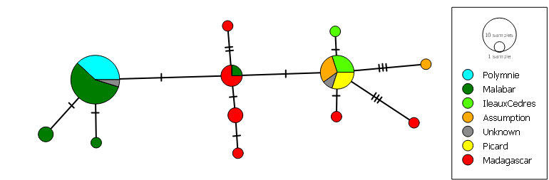
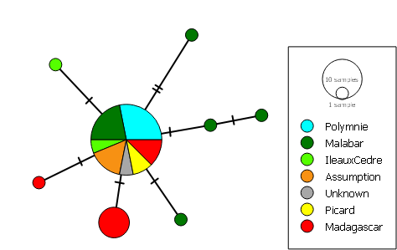
(a)
(b)

