BELIZE

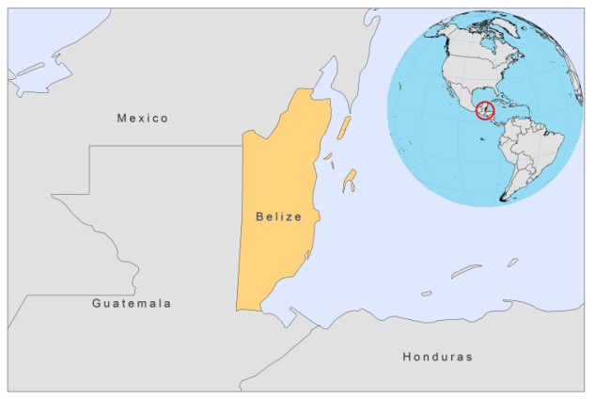
BASIC COUNTRY DATA

Total Population: 344,700
Population 0-14 years: 35%
Rural population: 47%
Population living under USD 1.25 a day: 13.4%
Population living under the national poverty line: no data
Income status: Lower middle income economy
Ranking: High human development (ranking 93)
Per capita total expenditure on health at average exchange rate (US dollar): 223
Life expectancy at birth (years): 76
Healthy life expectancy at birth (years): 60

BACKGROUND INFORMATION

VL has never been reported, but CL by L.mexicana is a well known disease in the northern area of the country [1]. In 1984, L. braziliensis was reported for the first time among British military personnel, infected in the southern part of Belize [2]. The infection frequency among soldiers is rising and suggests that the vector is a highly anthropophilic species, such as Lu. ovallesi or Lu. Cruciata [1].

Cutaneous leishmaniasis is an emerging health problem among travelers to Belize [3]. The nearby area in Mexico, Quintana Roo, is one of Mexico's most important endemic areas.

PARASITOLOGICAL INFORMATION

Leishmania species | Clinical form | Vector species | Reservoirs
L. braziliensis | ZCL | Lu. ovallesi | Unknown
L. mexicana | ZCL | Lu. olmeca olmeca | Heteromys sp., Nyctomys sp., Ototylomys sp., Sigmodon sp., Oryzomys sp.

DIAGNOSIS, TREATMENT, MAPS AND TRENDS

Data not available

ACCESS TO DRUGS

The antimonials Pentostam, GSK (SSG) and Glucantime, Sanofi (meglumine antimoniate) are not registered.

SOURCES OF INFORMATION

1. Desjeux P (1991). Information on the epidemiology and control of the leishmaniases by country or territory. WHO/LEISH/91.30.

2. Evans DA, Lanham SM, Baldwin CI, Peters W (1984). The isolation and isoenzyme characterization of Leishmania braziliensis subsp. from patients with cutaneous leishmaniasis acquired in Belize. Trans R Soc Trop Med Hyg.78(1):35-4.

3. Herwaldt BL, Stokes SL, Juranek DD (1993). American Cutaneous Leishmaniasis in U.S. Travelers. Annals of Internal Medicine 118 (10): 779-84.

