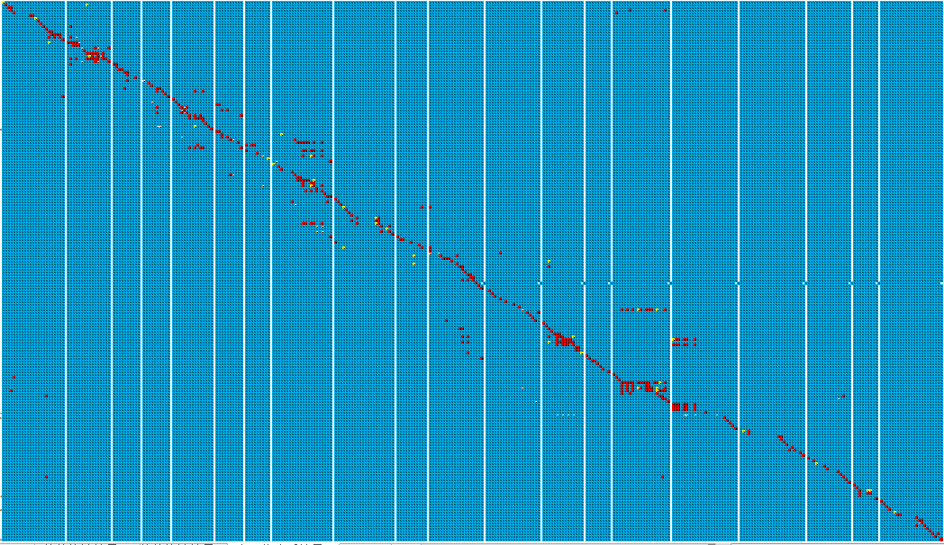
注： ZYD00006/Donor Suinong 14/Recurrent Heterozygous Unknow

Figure S2 Genotypes of Genome-wide introgression line in 20

