Figure S11

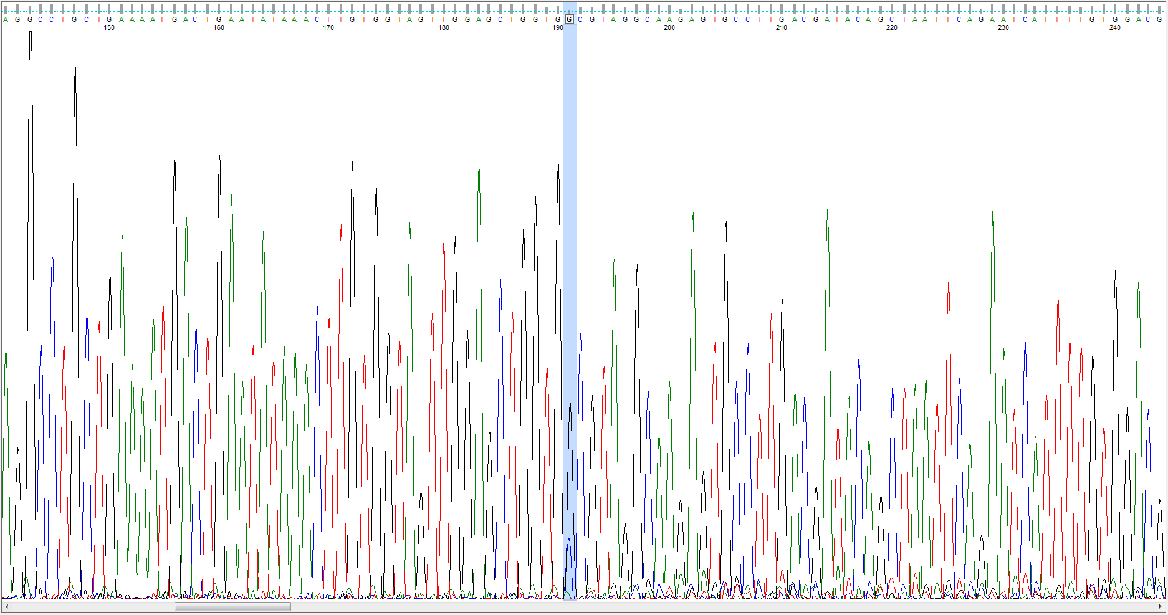
S11 Fig. The Sanger sequencing results of the genomic DNA from SW48 HT-Cas9 cells.

