The ARRIVE Guidelines Checklist
Animal Research: Reporting In Vivo Experiments
Guangwei Sun^{1,2#}, Guozhong SiMa ^{2#}, Chunhui Wu ², Yongzhong Fan ², Yong Tan ², Zhong Wang ^{1*}, Gang Cheng ¹, Jie Li ²
- Department of Neurosurgery & Brain and Nerve Research Laboratory, The First Affiliated Hospital of Soochow University
- Department of Neurosurgery, Danyang People’s Hospital
- # These authors contributed equally to this study and share first authroship.
- *Corresponding author
 |  | ITEM | RECOMMENDATION | Section/  Paragraph
 |  |  |  | Title
 |  |  |  | Abstract
 | INTRODUCTION
 | 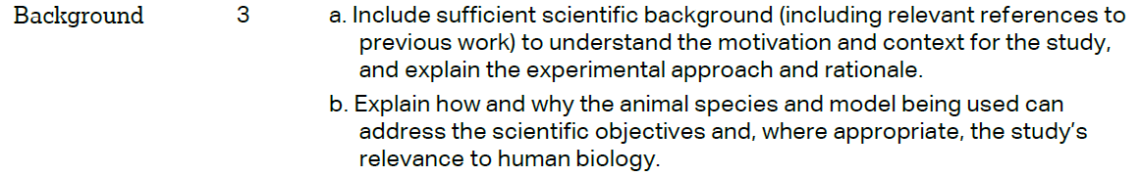 |  |  | Paragraphs 1-3  Paragraphs 2-3
 |  |  |  | Paragraph 3
 | METHODS
 |  |  |  | Paragraph 1
 | 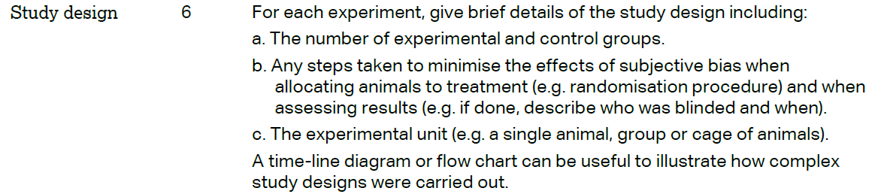 |  |  | Paragraph 1  Paragraphs 8-9  Paragraphs 6  Figure1
 | 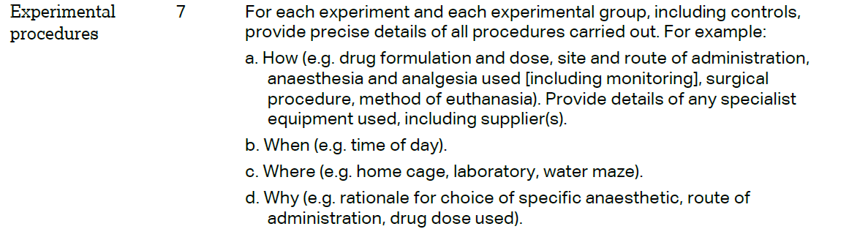 |  |  | Paragraphs 2-7,10-12
 | 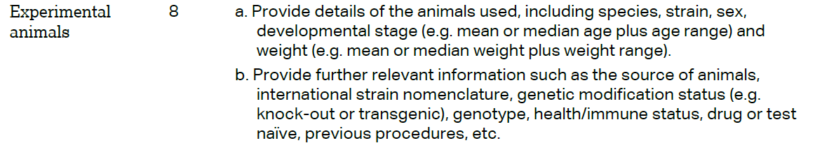 |  |  | Paragraph 1

 | 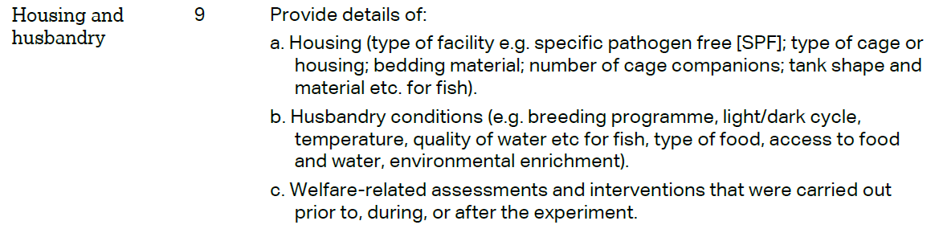 | Paragraph 1
 | 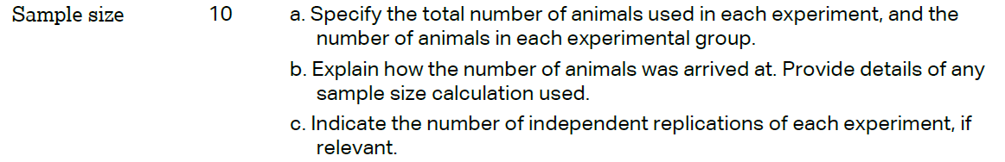 | Paragraph 1
 | 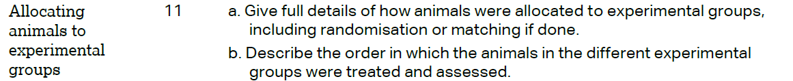 | Paragraph 9
 |  | Paragraph 13
 | 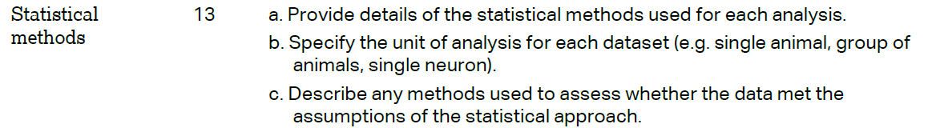 | Paragraphs 13&14andDiscussion  Paragraph  7
 | RESULTS
Methods
Paragraph 1
Methods
Paragraph 1
 |  | Paragraphs 2 7 4 andFigures3&4
 |  | Paragraph 1
 | DISCUSSION
 | 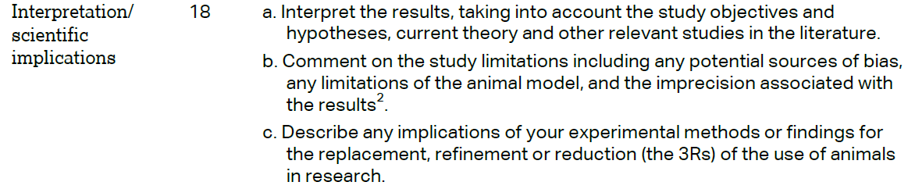 | Throughout  Paragraph 8  Paragraphs 8&9
 |  | Paragraphs 4&11
 |  | Paragraph 14

