Supporting Materials: Supplementary Appendix 1

Table of Contents:

Figures A, B, C Page 1
Percentage of patient population achieving performance measure by zip code
Figure D Page 5
Correlation of HbA1c control with socioeconomic status variables

Figure A: Percentage of Patient Population Achieving BP Target by Zip Code Areas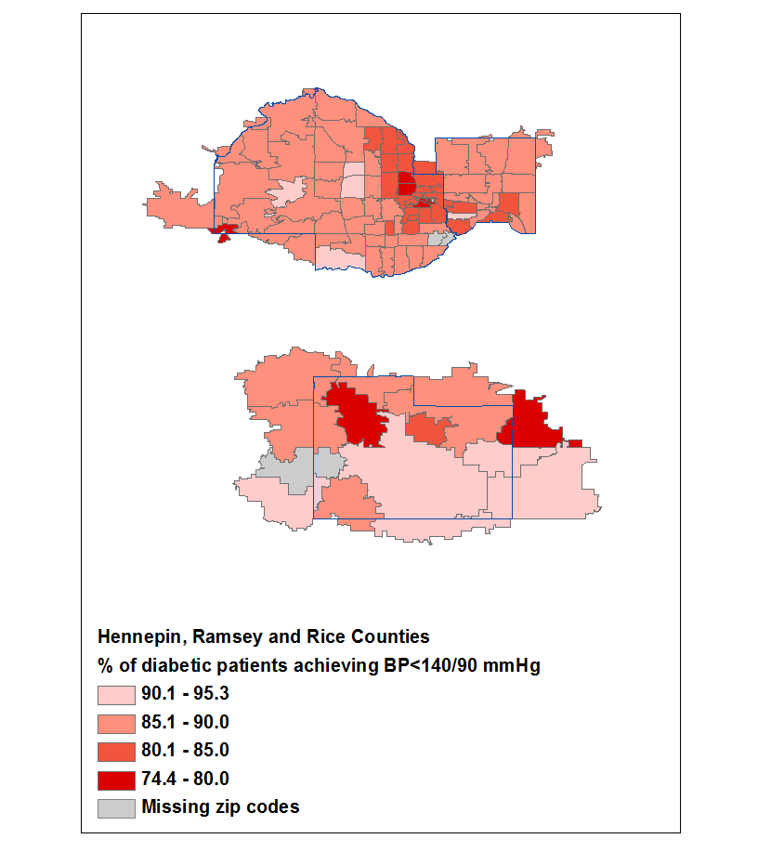
Figure B: Percentage of Patient Population Achieving LDL-C Target by Zip Code Areas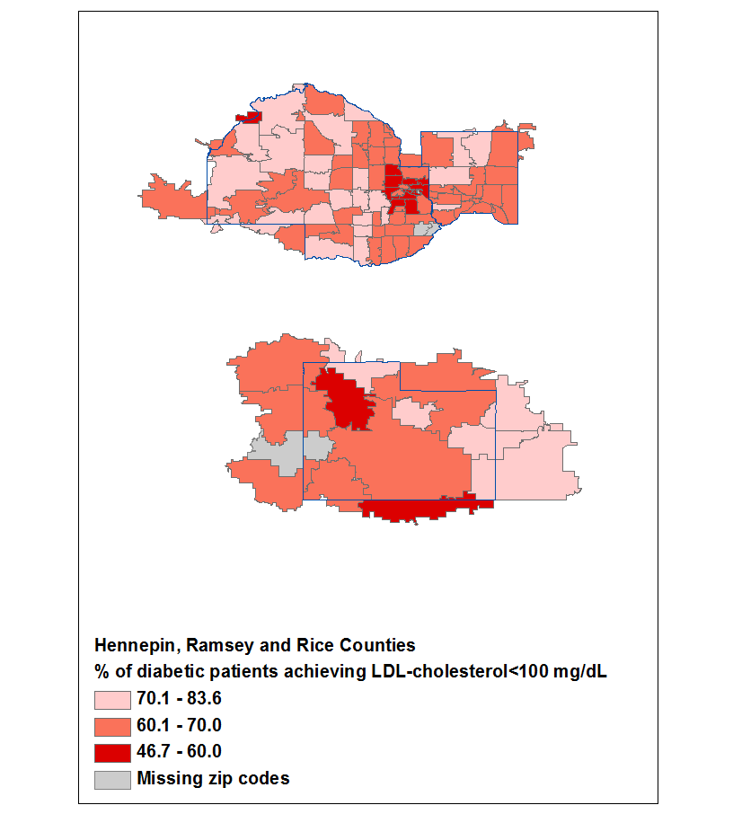
Figure C: Percentage of Patient Population Achieving Smoking Target by Zip Code Areas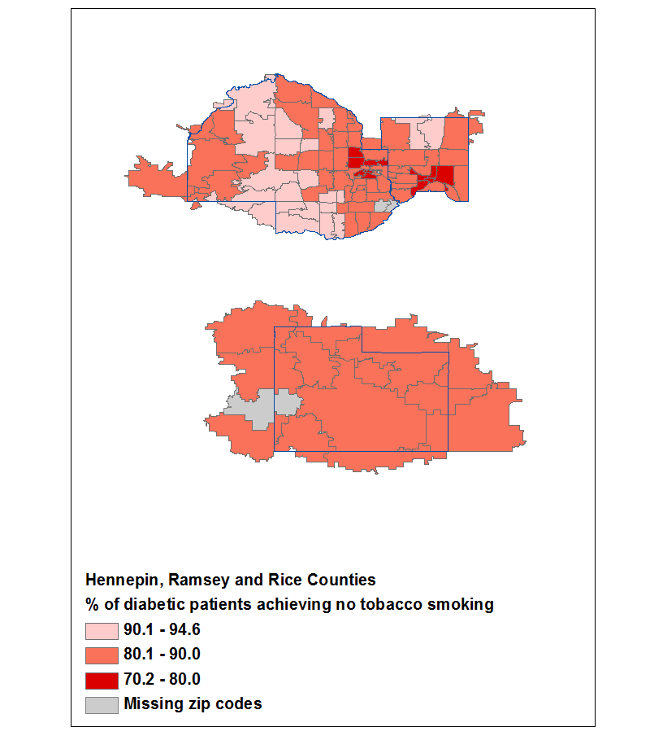

Figure D. Association of HbA1c control and socioeconomic variables within zip code areas

