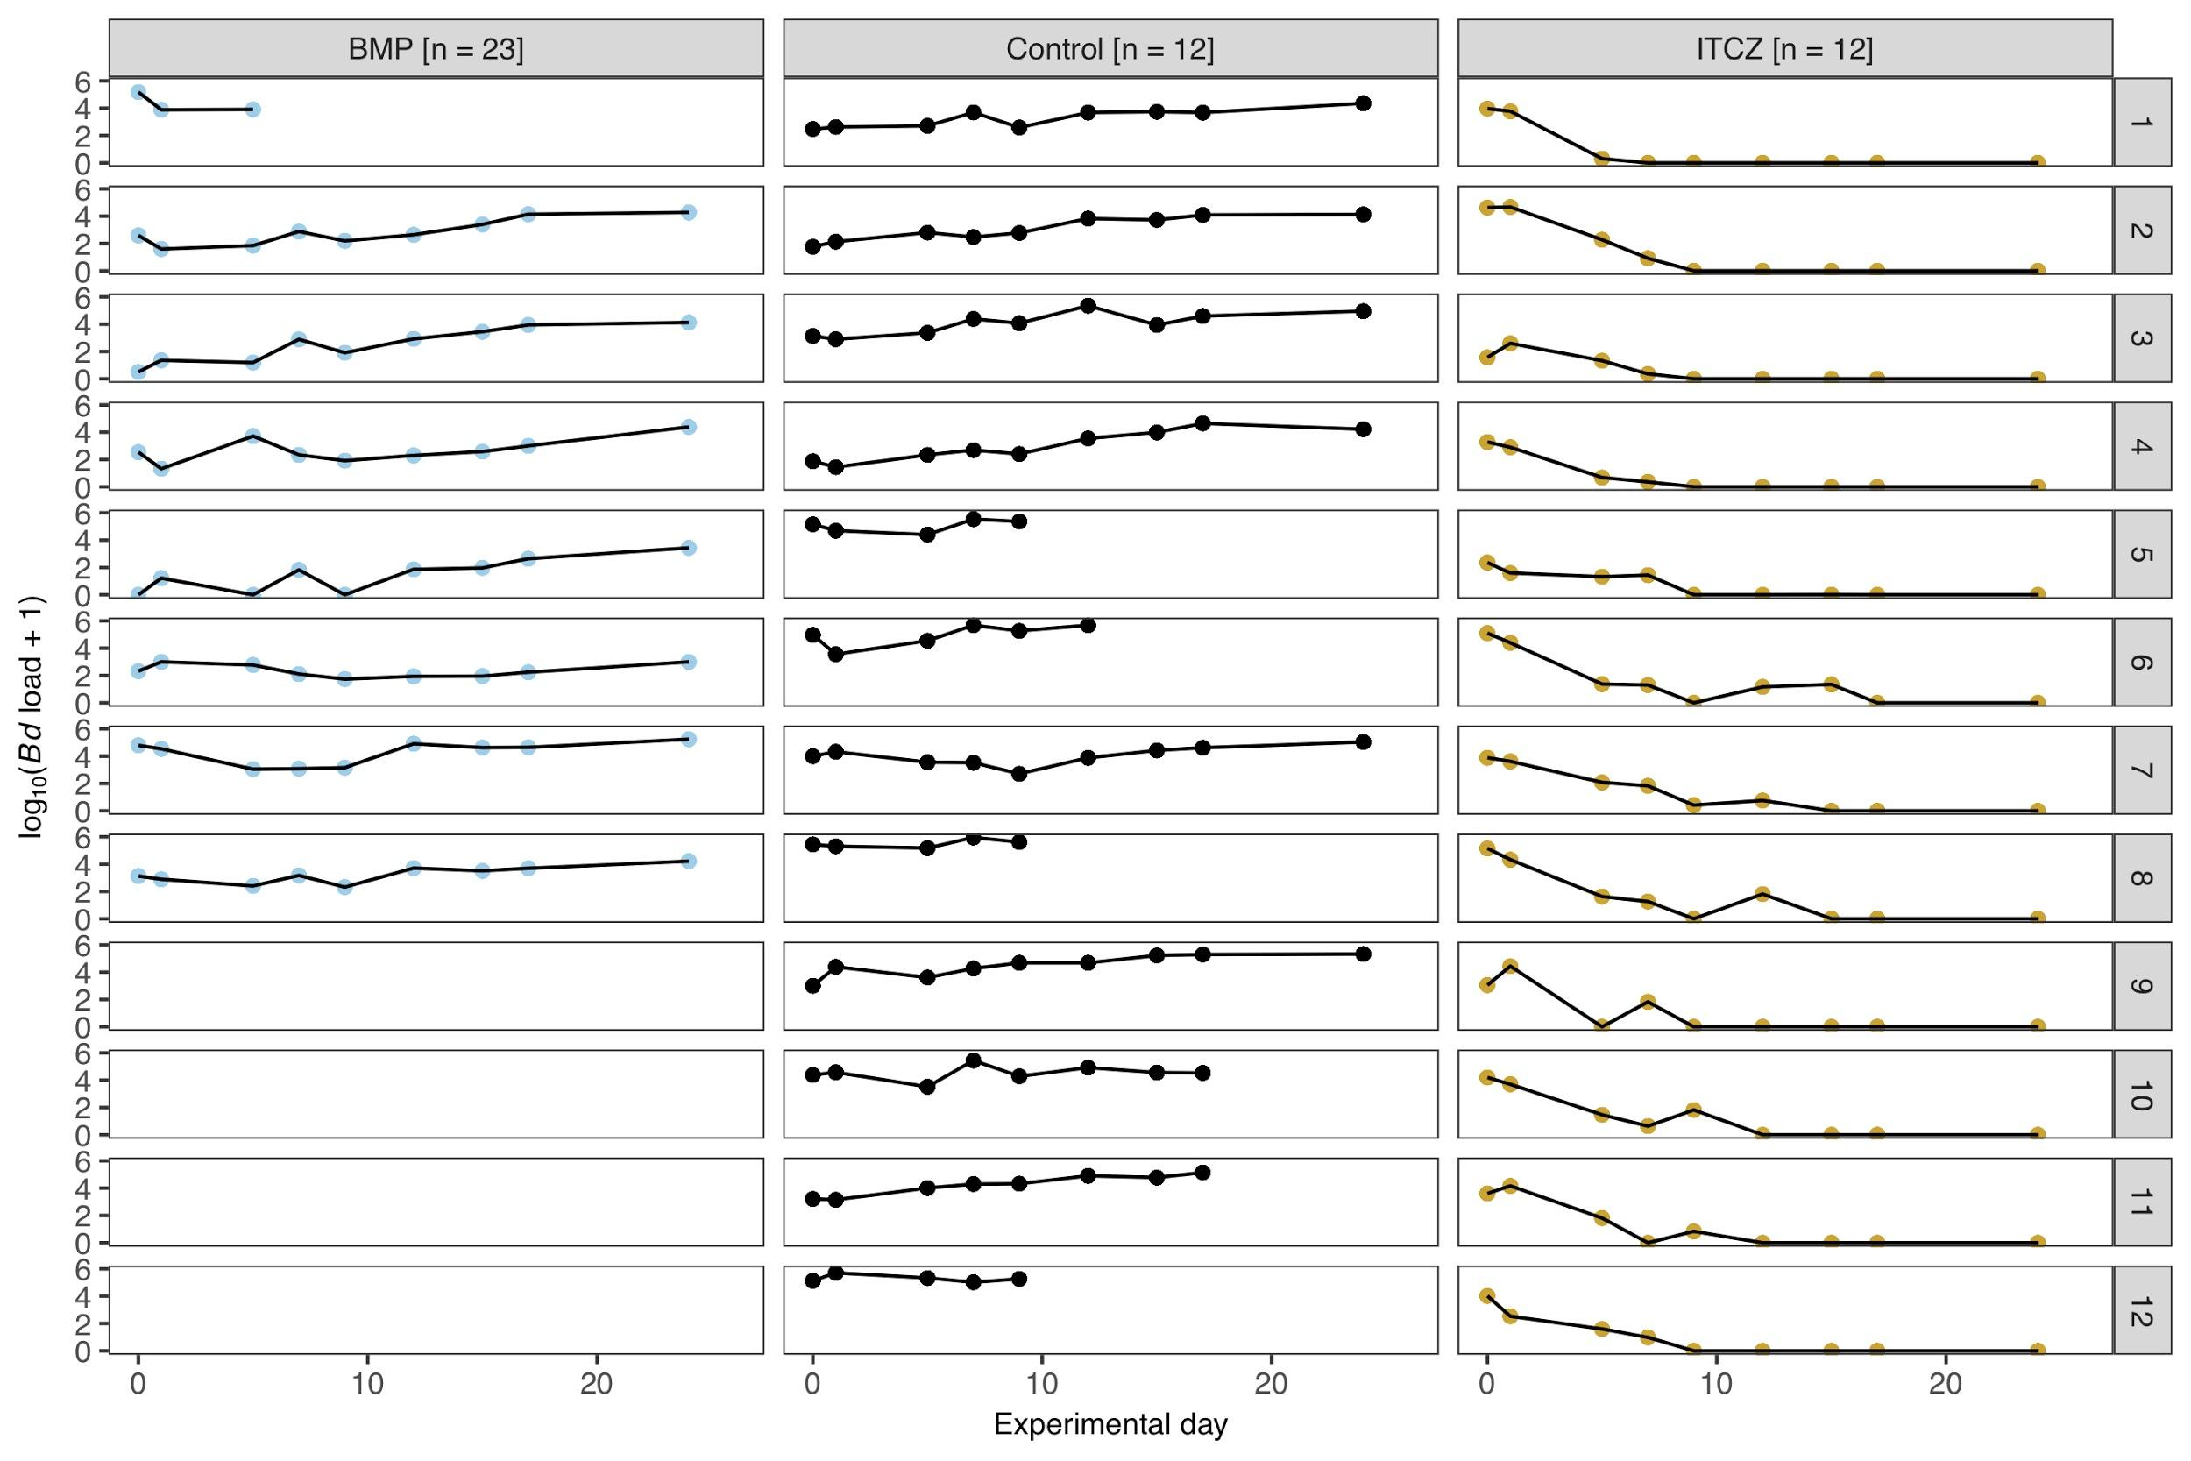
Figure S2. Individual Bd infection intensity trajectory for the three treatment groups (Bd + BMP-NTf2 [BMP], Bd only [Control], and Bd + itraconazole [ITCZ]) of Dendrobates tinctorius. Note that the sample size for Bd + BMP-NTf2 is 23 animals, but 15 of 23 animals died immediately upon BMP-NTf2 application.

