Figure A (ParBc1)
Probe¹ sequence² BS ParB+ Sign³ BS ParB-

S1wt TGTTTCACGTGAAACA 55 ± 10 *** 10 ± 2
S9half ATCTGATTGTGAAACA 27 ± 2 * 3 ± 4
S21rdm ATCTGATCCAGAATTG 9 ± 3 8 ± 2
S2 GGTTTCACGTGAAACA 47 ± 4 *** 7 ± 3
S5 AGTTTCACGTGAAACA 40 ± 8 ** 12 ± 4
S6 TGCTTCACGTGAAACA 43 ± 1 *** 9 ± 3
S8 TGATTCACGTGAAACA 42 ± 2 *** 16 ± 5
S14 TGTATCACGTGAAACA 46 ± 3 ** 3 ± 3
S16 TGTTACACGTGAAACA 43 ± 4 *** 8 ± 3
S77 AGtttcacgtgaaaCg 36 ± 5 *** 3 ± 4
S3 GGTTTCACGTGAAACC 39 ± 3 *** 6 ± 1
S4 CGTTTCACGTGAAACC 41 ± 2 ** 4 ± 2
S151 CGTTTCACGTGAAACG 43 ± 2 *** 10 ± 3
S10 AGTTTCACGTGAAACT 33 ± 4 * 9 ± 4
S11 TCTTTCACGTGAAAGA 9 ± 2 2 ± 2
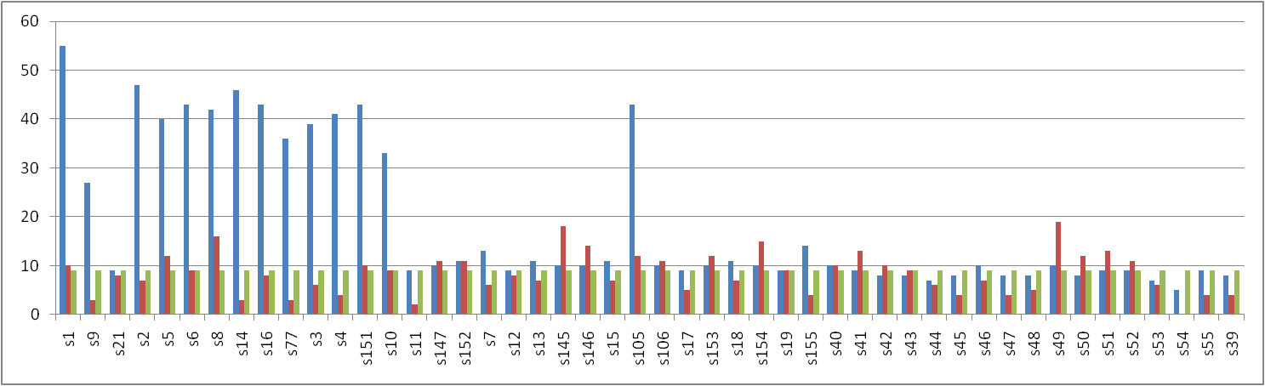
S147 TTTTTCACGTGAAAAA 10 ± 1 11 ± 7
S152 TATTTCACGTGAAATA 11 ± 1 11 ± 5
S7 TGCTTCACGTGAAGCA 13 ± 2 6 ± 5
S12 TGATTCACGTGAATCA 9 ± 2 8 ± 3
S13 TGTATCACGTGATACA 11 ± 1 7 ± 3
S145 TGTGTCACGTGACACA 10 ± 1 18 ± 8
S146 TGTCTCACGTGAGACA 10 ± 1 14 ± 5
S15 TGTTACACGTGTAACA 11 ± 1 7 ± 6
S105 TGTTCCACGTGGAACA 43 ± 5 *** 12 ± 7
S106 TGTTGCACGTGCAACA 10 ± 1 11 ± 6
S17 TGTTTGACGTCAAACA 9 ± 2 5 ± 5
S153 TGTTTTACGTAAAACA 10 ± 1 12 ± 2
S18 TGTTTCTCGAGAAACA 11 ± 1 7 ± 2
S154 TGTTTCGCGCGAAACA 10 ± 2 15 ± 1
S19 TGTTTCAGCTGAAACA 9 ± 1 9 ± 4
S155 TGTTTCATATGAAACA 14 ± 1 4 ± 1
S40 CttggctcgagccaaC 10 ± 2 10 ± 4
S41 GttggctcgagccaaC 9 ± 2 13 ± 5
S42 CAtggctcgagccaTG 8 ± 2 10 ± 7
S43 CtAggctcgagccTaG 8 ± 1 9 ± 6
S44 CttCgctcgagcGaaG 7 ± 1 6 ± 2
S45 CttgCctcgagGcaaG 8 ± 1 4 ± 1
S46 CttggGtcgaCccaaG 10 ± 2 7 ± 6
S47 CttggCtcgCGccaaG 8 ± 4 4 ± 4
S48 CttggCGcgCGccaaG 8 ± 2 5 ± 3
S49 CttggAtcgagccaaG 10 ± 1 19 ± 5
S50 CttggAtcgATccaaG 8 ± 1 12 ± 2
S51 CttggcAcgTgccaaG 9 ± 2 13 ± 5
S52 CttggctGCagccaaG 9 ± 2 11 ± 3
S53 CttggTtcgagccaaG 7 ± 1 6 ± 3
S54 CttggTtcgaAccaaG 5 ± 1 0 ± 3
S55 TGACGTGACGTGACGC 9 ± 3 4 ± 5
S39 TGACGTGTgagccaaG 8 ± 1 4 ± 2

Figure B (ParBc3)
Probe¹ sequence² BS ParB+ Sign³ BS ParB-

S56wt GttgtcacgtgacaaC 22 ± 7 ** 0 ± 3
S57half TGACTGATgtgacaaC 17 ± 2 * 0 ± 0
S70rdm TGACTGACTGACTGAC 6 ± 4 3 ± 3
S58 TttgtcacgtgacaaC 26 ± 3 ** 0 ± 1
S61 CttgtcacgtgacaaC 28 ± 11 ** 2 ± 1
S74 GttgtTacgtGacaaC 28 ± 1 ** 3 ± 2
S107 ATTGTCACGTGACAAT 21 ± 7 ** 3 ± 4
S59 TttgtcacgtgacaaA 24 ± 2 * 3 ± 2
S60 AttgtcacgtgacaaA 20 ± 8 ** 2 ± 1
S62 CttgtcacgtgacaaG 10 ± 3 6 ± 4
S63 GAtgtcacgtgacaTC 16 ± 2 ** 2 ± 2
S108 GCTGTCACGTGACAGC 12 ± 3 4 ± 3
S109 GTCGTCACGTGACGAC 5 ± 2 2 ± 3
S110 GTGGTCACGTGACCAC 10 ± 2 2 ± 1
S64 GtAgtcacgtgacTaC 16 ± 5 2 ± 4
S65 GttCtcacgtgaGaaC 11 ± 6 2 ± 2
S71 GttTtcacgtgaAaaC 10 ± 2 3 ± 1
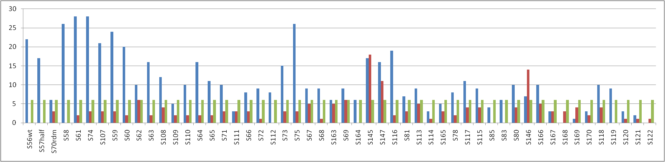
S111 GTTATCACGTGATAAC 3 ± 5 3 ± 2
S66 GttgAcacgtgTcaaC 8 ± 4 3 ± 2
S72 GttgCcacgtgGcaaC 9 ± 2 1 ± 1
S112 GTTGGCACGTGCCAAC 8 ± 4 na
S73 GttgtAacgtTacaaC 15 ± 3 3 ± 3
S75 GttgtTacgtAacaaC 26 ± 5 ** 3 ± 1
S67 GttgtGacgtCacaaC 9 ± 4 5 ± 1
S68 GttgtcTcgAgacaaC 9 ± 8 1 ± 0
S163 GttgtcGcgCgacaaC 6 ± 8 5 ± 2
S69 GttgtcaGCtgacaaC 9 ± 6 6 ± 6
S164 GttgtcaTAtgacaaC 6 ± 3 0 ± 2
S145 TGTGTCACGTGACACA 17 ± 2 18 ± 8
S147 TTTTTCACGTGAAAAA 16 ± 3 11 ± 7
S116 GTTTTAACGTTAAAAC 19 ± 2 2 ± 2
S81 GTTgCaacgttgCaac 7 ± 2 3 ± 1
S113 GTTTCCACGTGGAAAC 9 ± 6 5 ± 1
S114 GTTGCTACGTAGCAAC 3 ± 2 1 ± 1
S165 GttTtTacgtAaAaaC 5 ± 6 3 ± 6
S78 GTTTCaacgttgaaac 8 ± 5 2 ± 2
S117 GTTTAAACGTTTAAAC 11 ± 2 4 ± 2
S115 GTTTGAACGTTCAAAC 9 ± 2 4 ± 2
S85 gtttctacgtagaaac 4 ± 6 0 ± 3
S83 GTTCCaacgttgGaac 6 ± 4 0 ± 3
S80 GTTTCGacgtCgaaac 10 ± 5 4 ± 1
S146 TGTCTCACGTGAGACA 7 ± 3 14 ± 5
S166 ATTTCaacgttgaaaT 10 ± 5 5 ± 2
S167 GCTTCaacgttgaaGc 3 ± 3 3 ± 3
S168 GTCTCaacgttgaGac 0 ± 5 3 ± 3
S169 GTTTCaGcgCtgaaac 1 ± 3 4 ± 3
S170 GTTTCaaTAttgaaac 3 ± 3 2 ± 1
S118 CTTTCaacgttgaaaG 10 ± 4 4 ± 2
S119 GATTCaacgttgaaTc 9 ± 4 0 ± 3
S120 GTATCaacgttgaTac 3 ± 5 1 ± 3
S121 GTTTCaTcgAtgaaac 2 ± 7 1 ± 4
S122 GTTTCaaGCttgaaac 0 ± 1 1 ± 1
Figure C (ParBpBC)
Probe¹ sequence² BS ParB+ Sign³ BS ParB-
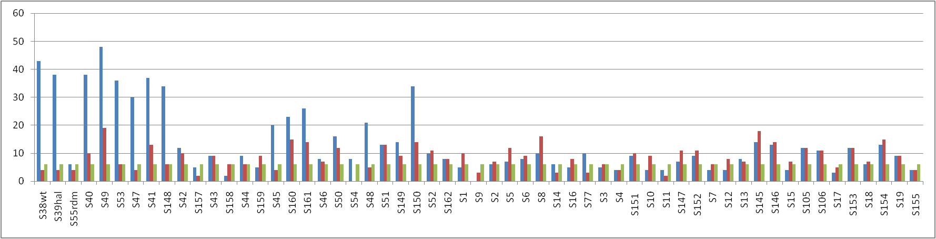
S38wt CttggctcgagccaaG 43 ± 4 *** 4 ± 0
S39half TGACGTGTgagccaaG 38 ± 7 ** 4 ± 2
S55rdm TGACGTGACGTGACGC 6 ± 1 4 ± 5
S40 GttggctcgagccaaG 38 ± 3 *** 10 ± 4
S49 CttggAtcgagccaaG 48 ± 5 ** 19 ± 5
S53 CttggTtcgagccaaG 36 ± 4 ** 6 ± 3
S47 CttggCGcgAGccaaG 30 ± 1 *** 4 ± 4
S41 GttggctcgagccaaC 37 ± 5 *** 13 ± 5
S148 ATTGGCTCGAGCCAAT 34 ± 1 *** 6 ± 4
S42 CAtggctcgagccaTG 12 ± 3 10 ± 7
S157 CCtggctcgagccaGG 5 ± 3 2 ± 4
S43 CtAggctcgagccTaG 9 ± 5 9 ± 6
S158 CtCggctcgagccGaG 2 ± 2 6 ± 1
S44 CttCgctcgagcGaaG 9 ± 2 6 ± 2
S159 CttAgctcgagcTaaG 5 ± 1 9 ± 4
S45 CttgCctcgagGcaaG 20 ± 5 4 ± 1
S160 CttgActcgagTcaaG 23 ± 2 15 ± 4
S161 CttgTctcgagAcaaG 26 ± 1 14 ± 5
S46 CttggGtcgaCccaaG 8 ± 6 7 ± 6
S50 CttggAtcgATccaaG 16 ± 1 12 ± 2
S54 CttggTtcgaAccaaG 8 ± 3 0 ± 3
S48 CttggCGcgCGccaaG 21 ± 6 * 5 ± 3
S51 CttggcAcgTgccaaG 13 ± 1 13 ± 5
S149 CTTGGCGCGTGCCAAG 14 ± 1 9 ± 3
S150 CTTGGCCCGGGCCAAG 34 ± 7 ** 14 ± 9
S52 CttggctGCagccaaG 10 ± 2 11 ± 3
S162 CttggctTAagccaaG 8 ± 1 8 ± 4
S1 TGTTTCACGTGAAACA 5 ± 3 10 ± 2
S9 ATCTGATTGTGAAACA 0 ± 2 3 ± 4
S2 TGTTTCACGTGAAACC 6 ± 2 7 ± 3
S5 TGTTTCACGTGAAACT 7 ± 1 12 ± 5
S6 TGCTTCACGTGAAACA 8 ± 3 9 ± 3
S8 TGATTCACGTGAAACA 10 ± 1 16 ± 5
S14 TGTATCACGTGAAACA 6 ± 3 3 ± 3
S16 TGTTACACGTGAAACA 5 ± 2 8 ± 3
S77 AGtttcacgtgaaaCg 10 ± 2 3 ± 4
S3 GGTTTCACGTGAAACC 5 ± 1 6 ± 1
S4 CGTTTCACGTGAAACC 4 ± 3 4 ± 2
S151 CGTTTCACGTGAAACG 9 ± 1 10 ± 3
S10 AGTTTCACGTGAAACT 4 ± 4 9 ± 4
S11 TCTTTCACGTGAAAGA 4 ± 1 2 ± 2
S147 TTTTTCACGTGAAAAA 7 ± 2 11 ± 7
S152 TATTTCACGTGAAATA 9 ± 3 11 ± 5
S7 TGCTTCACGTGAAGCA 4 ± 3 6 ± 5
S12 TGATTCACGTGAATCA 4 ± 3 8 ± 3
S13 TGTATCACGTGATACA 8 ± 2 7 ± 3
S145 TGTGTCACGTGACACA 14 ± 5 18 ± 8
S146 TGTCTCACGTGAGACA 13 ± 2 14 ± 5
S15 TGTTACACGTGTAACA 4 ± 3 7 ± 6
S105 TGTTCCACGTGGAACA 12 ± 4 12 ± 7
S106 TGTTGCACGTGCAACA 11 ± 4 11 ± 6
S17 TGTTTGACGTCAAACA 3 ± 3 5 ± 5
S153 TGTTTTACGTAAAACA 12 ± 1 12 ± 2
S18 TGTTTCTCGAGAAACA 6 ± 2 7 ± 2
S154 TGTTTCGCGCGAAACA 13 ± 1 15 ± 1
S19 TGTTTCAGCTGAAACA 9 ± 3 9 ± 4
S155 TGTTTCATATGAAACA 4 ± 1 4 ± 1
Figure D (ParB12D)

probe¹ sequence² BS ParB+ Sign³ BS ParB-

S78wt GTTTCaacgttgaaac 42 ± 5 *** 2 ± 2
S179half TAACTGATgttgaaac 12 ± 3 1 ± 3
S70rdm TGACTGACTGACTGAC 3 ± 4 3 ± 3
S118 CTTTCaacgttgaaaG 18 ± 3 4 ± 2
S166 ATTTCaacgttgaaaT 28 ± 6 * 5 ± 2
S119 GATTCaacgttgaaTc 6 ± 3 0 ± 3
S167 GCTTCaacgttgaaGc 8 ± 2 3 ± 3
S120 GTATCaacgttgaTac 3 ± 3 1 ± 3
S168 GTCTCaacgttgaGac 6 ± 4 3 ± 3
S82 GTTACaacgttgTaac 7 ± 5 2 ± 1
S81 GTTgCaacgttgCaac 9 ± 3 3 ± 1
S83 GTTCCaacgttgGaac 5 ± 3 0 ± 3
S115 GTTTGAACGTTCAAAC 9 ± 3 4 ± 2
S116 GTTTTAACGTTAAAAC 8 ± 1 2 ± 2
S117 GTTTAAACGTTTAAAC 8 ± 1 4 ± 2
S79 GTTTCCacgtGgaaac 17 ± 8 5 ± 1
S80 GTTTCGacgtCgaaac 11 ± 3 4 ± 1
S85 gtttctacgtagaaac 5 ± 6 0 ± 3
S121 GTTTCaTcgAtgaaac 12 ± 6 1 ± 4
S169 GTTTCaGcgCtgaaac 16 ± 1 4 ± 3
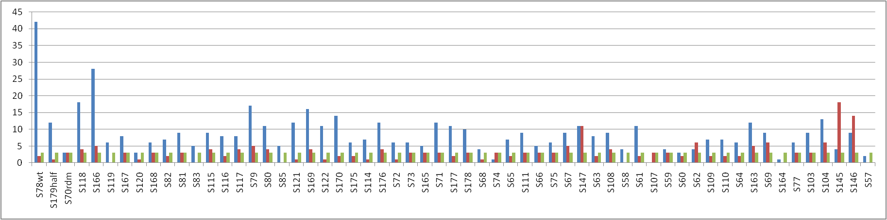
S122 GTTTCaaGCttgaaac 11 ± 5 1 ± 1
S170 GTTTCaaTAttgaaac 14 ± 1 2 ± 1
S175 GCTTCCACgtggaaGc 6 ± 1 2 ± 1
S114 GTTGCTACGTAGCAAC 7 ± 4 1 ± 1
S176 GTTCCCACgtggGaac 12 ± 4 4 ± 1
S72 GttgCcacgtgGcaaC 6 ± 3 1 ± 1
S73 GttgtAacgtTacaaC 6 ± 4 3 ± 3
S165 GttTtTacgtAaAaaC 5 ± 4 3 ± 6
S71 GttTtcacgtgaAaaC 12 ± 5 3 ± 1
S177 GTTTCCGCgCggaaac 11 ± 3 2 ± 5
S178 GTTTCCATAtggaaac 10 ± 5 3 ± 3
S68 GttgtcTcgAgacaaC 4 ± 1 1 ± 0
S74 GttgtTacgtGacaaC 1 ± 2 3 ± 2
S65 GttCtcacgtgaGaaC 7 ± 3 2 ± 2
S111 GTTATCACGTGATAAC 9 ± 3 3 ± 2
S66 GttgAcacgtgTcaaC 5 ± 5 3 ± 2
S75 GttgtTacgtAacaaC 6 ± 3 3 ± 1
S67 GttgtGacgtCacaaC 9 ± 3 5 ± 1
S147 TTTTTCACGTGAAAAA 11 ± 7 11 ± 7
S63 GAtgtcacgtgacaTC 8 ± 4 2 ± 2
S108 GCTGTCACGTGACAGC 9 ± 6 4 ± 3
S58 GttgtcacgtgacaaA 4 ± 2 0 ± 1
S61 GttgtcacgtgacaaG 11 ± 7 2 ± 1
S107 ATTGTCACGTGACAAT 0 ± 2 3 ± 4
S59 TttgtcacgtgacaaA 4 ± 4 3 ± 2
S60 AttgtcacgtgacaaA 3 ± 2 2 ± 1
S62 CttgtcacgtgacaaG 4 ±7 6 ± 4
S109 GTCGTCACGTGACGAC 7 ± 7 2 ± 3
S110 GTGGTCACGTGACCAC 7 ± 1 2 ± 1
S64 GtAgtcacgtgacTaC 6 ± 6 2 ± 4
S163 GttgtcGcgCgacaaC 12 ± 6 5 ± 2
S69 GttgtcaGCtgacaaC 9 ± 7 6 ± 6
S164 GttgtcaTAtgacaaC 1 ± 3 0 ± 2
S77 AGtttcacgtgaaaCg 6 ± 3 3 ± 4
S103 CTTTCACCGGTGAAAG 9 ± 2 3 ± 2
S104 GTTCAACCGGTTGAAC 13 ± 4 6 ± 1
S145 TGTGTCACGTGACACA 4 ± 1 18 ± 8
S146 TGTCTCACGTGAGACA 9 ± 3 14 ± 5
S57 TGACTGATgtgacaaC 2 ± 3 0 ± 0
Figure E (ParBG4)

Probe¹ sequence² BS ParB+ Sign³ BS ParB-

S89wt ATCTccacgtggagat 63 ± 6 ** 0 ± 3
S181half TCACCTCAgtggagat 24 ± 3 na
S70rdm TGACTGACTGACTGAC 27 ± 9 3 ± 3
S99 ATCGTcacgtggagat 38 ± 3 6 ± 0
S98 ATTGccacgtggagat 36 ± 5 3 ± 3
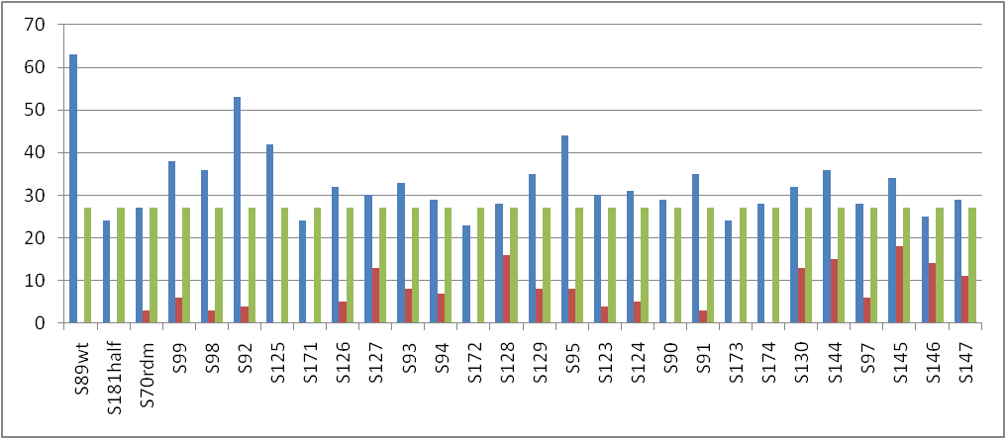
S92 GTCTccacgtggagaC 53 ± 4 ** 4 ± 2
S125 TTCTccacgtggagaA 42 ± 2 * 0 ± 1
S171 ACCTccacgtggagGt 24 ± 6 na
S126 AACTccacgtggagTt 32 ± 1 5 ± 2
S127 ATGTccacgtggaCat 30 ± 2 13 ± 1
S93 ATTTccacgtggaAat 33 ± 4 8 ± 2
S94 ATCGccacgtggCgat 29 ± 3 7 ± 0
S172 ATCCccacgtggGgat 23 ± 5 na
S128 ATCAccacgtggTgat 28 ± 7 16 ± 3
S129 ATCTGcacgtgCagat 35 ± 7 8 ± 4
S95 ATCTTcacgtgAagat 44 ± 6 * 8 ± 2
S123 ATCTCTACGTAGAGAT 30 ± 4 4 ± 1
S124 ATCTCGACGTCGAGAT 31 ± 5 5 ± 2
S90 ATCTcAacgtTgagat 29 ± 1 0 ± 4
S91 ATCTccTcgAggagat 35 ± 2 3 ± 2
S173 ATCTccGcgCggagat 24 ± 6 na
S174 ATCTccaTAtggagat 28 ± 2 na
S130 ATCTccaGCtggagat 32 ± 3 13 ± 4
S144 GTTTCCAGCtggaaac 36 ± 2 15 ± 5
S97 GTCGccacgtggCgaC 28 ± 2 6 ± 2
S145 TGTGTCACGTGACACA 34 ± 6 18 ± 8
S146 TGTCTCACGTGAGACA 25 ± 5 14 ± 5
S147 TTTTTCACGTGAAAAA 29 ± 4 11 ± 7

Figure F (ParB12J; changes relative to probe S56, i.e. parSc3)

probe¹ sequence² BS ParB+ Sign³ BS ParB-

S56 GttgtcacgtgacaaC 69 ± 8 * 0 ± 3
S86wt GTTgTcacgtggaaac 54 ± 22 * 3 ± 0
S57half TGACTGATgtgacaaC 25 ± 22 0 ± 0
S70rdm TGACTGACTGACTGAC 11 ± 11 3 ± 3
S88 GTTTCCACgtggaaac 41 ± 17 5 ± 1
S58 GttgtcacgtgacaaA 23 ± 21 0 ± 1
S61 GttgtcacgtgacaaG 20 ± 15 2 ± 1
S74 GttgtTacgtGacaaC 37 ± 22 3 ± 2
S59 TttgtcacgtgacaaA 22 ± 21 3 ± 2
S60 AttgtcacgtgacaaA 24 ± 13 2 ± 1
S62 CttgtcacgtgacaaG 21 ± 13 6 ± 4
S63 GAtgtcacgtgacaTC 21 ± 14 2 ± 2
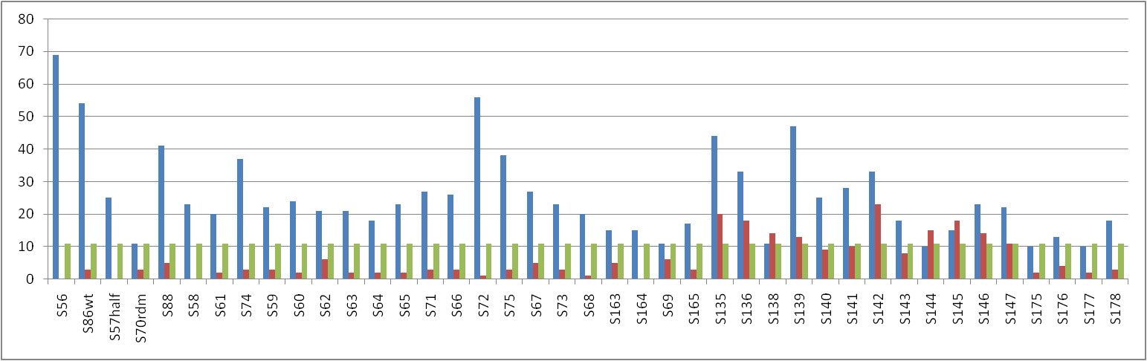
S64 GtAgtcacgtgacTaC 18 ± 12 2 ± 4
S65 GttCtcacgtgaGaaC 23 ± 16 2 ± 2
S71 GttTtcacgtgaAaaC 27 ± 21 3 ± 1
S66 GttgAcacgtgTcaaC 26 ± 15 3 ± 2
S72 GttgCcacgtgGcaaC 56 ± 23 * 1 ± 1
S75 GttgtTacgtAacaaC 38 ± 30 3 ± 1
S67 GttgtGacgtCacaaC 27 ± 17 5 ± 1
S73 GttgtAacgtTacaaC 23 ± 15 3 ± 3
S68 GttgtcTcgAgacaaC 20 ± 17 1 ± 0
S163 GttgtcGcgCgacaaC 15 ± 8 5 ± 2
S164 GttgtcaTAtgacaaC 15 ± 3 0 ± 2
S69 GttgtcaGCtgacaaC 11 ± 1 6 ± 6
S165 GttTtTacgtAaAaaC 17 ± 5 3 ± 6
S135 GTTGCCACGTGGAAAC 44 ± 23 20 ± 2
S136 GTTTTCACGTGGAAAC 33 ± 23 18 ± 1
S138 CTTTCCACgtggaaaG 11 ± 8 14 ± 0
S139 GATTCCACgtggaaTc 47 ± 31 * 13 ± 1
S140 GTATCCACgtggaTac 25 ± 15 9 ± 1
S141 GTTACCACgtggTaac 28 ± 11 * 10 ± 4
S142 GTTTGCACgtgCaaac 33 ± 7 23 ± 5
S143 GTTTCCTCgAggaaac 18 ± 8 8 ± 2
S144 GTTTCCAGCtggaaac 10 ± 5 15 ± 5
S145 TGTGTCACGTGACACA 15 ± 8 18 ± 8
S146 TGTCTCACGTGAGACA 23 ± 8 14 ± 5
S147 TTTTTCACGTGAAAAA 22 ± 15 11 ± 7
S175 GCTTCCACgtggaaGc 10 ± 5 2 ± 1
S176 GTTCCCACgtggGaac 13 ± 6 4 ± 1
S177 GTTTCCGCgCggaaac 10 ± 7 2 ± 5
S178 GTTTCCATAtggaaac 18 ± 10 3 ± 3

Figure G (ParB12J ; changes relative to probe S88, i.e. “non-parSc3”)

Probe¹ sequence² BS ParB+ Sign³ BS ParB-

S88 GTTTCCACgtggaaac 41 ± 17 5 ± 1
S86wt gTTgTcacgtggaaac 54 ± 22 * 3 ± 0
S180halfTACCTGCTgtggaaac 14 ± 4 na
S70rdm TGACTGACTGACTGAC 11 ± 11 3 ± 3
S56 GttgtcacgtgacaaC 69 ± 8 * 0 ± 3
S136 GTTTTCACGTGGAAAC 33 ± 23 18 ± 1
S135 GTTGCCACGTGGAAAC 44 ± 23 20 ± 2
S143 GTTTCCTCgAggaaac 18 ± 8 8 ± 2
S138 CTTTCCACgtggaaaG 11 ± 8 14 ± 0
S175 GCTTCCACgtggaaGc 10 ± 5 2 ± 1
S139 GATTCCACgtggaaTc 47 ± 31 * 13 ± 1
S140 GTATCCACgtggaTac 25 ± 15 9 ± 1
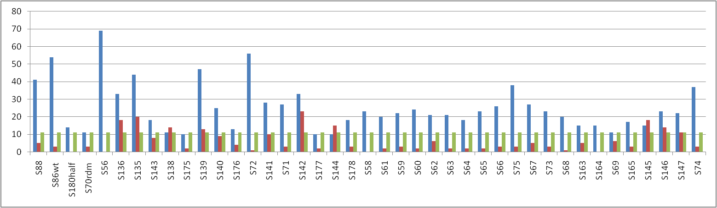
S176 GTTCCCACgtggGaac 13 ± 6 4 ± 1
S72 GTTGCCACGTGGCAAC 56 ± 23 * 1 ± 1
S141 GTTACCACgtggTaac 28 ± 11 * 10 ± 4
S71 GttTtcacgtgaAaaC 27 ± 21 3 ± 1
S142 GTTTGCACgtgCaaac 33 ± 7 23 ± 5
S177 GTTTCCGCgCggaaac 10 ± 7 2 ± 5
S144 GTTTCCAGCtggaaac 10 ± 5 15 ± 5
S178 GTTTCCATAtggaaac 18 ± 10 3 ± 3
S58 GttgtcacgtgacaaA 23 ± 21 0 ± 1
S61 GttgtcacgtgacaaG 20 ± 15 2 ± 1
S59 TttgtcacgtgacaaA 22 ± 21 3 ± 2
S60 AttgtcacgtgacaaA 24 ± 13 2 ± 1
S62 CttgtcacgtgacaaG 21 ± 13 6 ± 4
S63 GAtgtcacgtgacaTC 21 ± 14 2 ± 2
S64 GtAgtcacgtgacTaC 18 ± 12 2 ± 4
S65 GttCtcacgtgaGaaC 23 ± 16 2 ± 2
S66 GttgAcacgtgTcaaC 26 ± 15 3 ± 2
S75 GttgtTacgtAacaaC 38 ± 30 3 ± 1
S67 GttgtGacgtCacaaC 27 ± 17 5 ± 1
S73 GttgtAacgtTacaaC 23 ± 15 3 ± 3
S68 GttgtcTcgAgacaaC 20 ± 17 1 ± 0
S163 GttgtcGcgCgacaaC 15 ± 8 5 ± 2
S164 GttgtcaTAtgacaaC 15 ± 3 0 ± 2
S69 GttgtcaGCtgacaaC 11 ± 10 6 ± 6
S165 GttTtTacgtAaAaaC 17 ± 5 3 ± 6
S145 TGTGTCACGTGACACA 15 ± 8 18 ± 8
S146 TGTCTCACGTGAGACA 23 ± 8 14 ± 5
S147 TTTTTCACGTGAAAAA 22 ± 15 11 ± 7
S74 GttgtTacgtGacaaC 37 ± 22 3 ± 2

¹ Wild-type (wt), random (rdm) and half-parS (half) sequences are mentioned for clarity

² Red-highlited nucleotides in the parS sequences are those changed relative to the cognate wt parS (Figures A-E) or to parSc3 (Figure F) or to “non-parSc3” (Figure G)

³ Levels of significance are indicated in the “Sign” columns as follows:
* (P value < 0.05), ** (P value < 0.01), *** (P value <0.001).

